**Knee Reconstruction**

Cartilage Repair Surgery/Microfracture

Patellar-Femoral Re-Alignment Knee Surgery (MPFL reconstruction, Tibial Tubercle / Fulkerson Osteotomy)

Posterior Cruciate Ligament Reconstruction/

Multiple Ligament Reconstruction

Anterior Cruciate Ligament Reconstruction/Revision

Tibial or Femoral Osteotomy

**Patient Information Booklet**

**Please bring this book to your admission to the Hospital and to all of your appointments**

For information call

613-721-2000, extension 2920

between 8:00 a.m. and 4:00 p.m.

Monday to Friday

Table of Contents

Introduction 3

Your physiotherapy restrictions are: 5

Preparing for your surgery 6

Arrival at Hospital 8

After surgery 9

Leg exercises 9

Deep breathing and coughing exercises 9

General post-operative instructions 10

Pick up information 11

Post-operative dressing 12

Pain scale ruler 13

Cartilage repair surgery of the knee/microfracture 14

Patellar-Femoral re-alignment knee surgery (Fulkerson osteotomy/Medial Patella-Femoral Ligament reconstruction 16

Posterior Cruciate Ligament / Multiple Ligament Reconstruction Surgery 18

Anterior Cruciate Ligament Reconstruction 24

Osteotomy Tibial / Femoral Rehabilitation Protocol 31

# Introduction

Welcome to Queensway Carleton Hospital.

You are having an outpatient day surgery procedure unless otherwise specified by your surgeon. If your procedure is a: Posterior Cruciate Ligament or Multiple Ligament Reconstruction or an Osteotomy plan to stay 1 day. The plan is for you to be discharged home on the same day as your surgery unless otherwise specified by your surgeon.

Please use this booklet as a reference tool. Bring this booklet with you to all your appointments and on your day of surgery. Ask questions if there is anything you don’t understand.

**PLEASE BRING YOUR BOOKLET TO THE HOSPITAL** as the healthcare team members will refer to these instructions throughout your hospital stay.

## 

This sheet will provide information about your surgery to your Physiotherapist and/or doctor. Your surgeon will complete the information below in a separate handout. A copy will be provided to you, please keep this copy for your records.

Surgery date:

Your surgery is:

🞎 **Knee Arthroscopy**

🞎 Partial meniscectomy Medial Lateral

🞎 Meniscus repair

🞎 Debridement (chondropathy grade)

* Medial ( )
* Lateral ( )
* Patello-femoral ( )

🞎 Excision of loose body

🞎 Excision of plica

🞎 Lateral release

🞎 Medical patellofemoral ligament repair or plication

🞎 **Anterior Cruciate Ligament Reconstruction (ACL)**

🞎 Hamstring tendon autograft

🞎 Patellar tendon autograft

🞎 Allograft

🞎 Revision

🞎 Posterolateral corner reconstruction

🞎 Posteromedial corner reconstruction

🞎 **Posterior Cruciate Ligament Reconstruction (PCL)**

🞎 Allograft

🞎 Revision

🞎 Posterolateral corner reconstruction

🞎 Posteromedial corner reconstruction

🞎 **Medial Patellofemoral Ligament Reconstruction**

🞎 **Tibial Tubercle Osteotomy (Fulkerson)**

🞎 **Tibial or Femoral Osteotomy**

🞎 **Other**

## Your physiotherapy restrictions are:

**🞎 Weight bearing**

🞎 Full

🞎 Partial for then progress to

🞎 None for then progress to

**🞎 Motion**

🞎 No restrictions

🞎 No range of motion (ROM) for then

🞎 0–45 degrees for then

🞎 0–60 degrees for then

🞎 0–90 degrees for then

**🞎 Strengthening**

🞎 No restrictions

🞎 As tolerated

🞎 As per standard Anterior Cruciate Ligament (ACL) protocol

🞎 None

**🞎 Modalities**

🞎 As tolerated

🞎 None

**🞎 Comments:**

**Your date of surgery is:**

The day before surgery, call the Queensway Carleton Hospital, Patient Scheduling Department at **613-721-4840** **between 11:00 a.m. and 3:00 p.m.** to have your admission time confirmed.

# Preparing for your surgery

You must follow these rules, or your surgery may be cancelled:

1. **Do not eat any solid food after midnight the night before your surgery.**
2. **If you are thirsty, you may drink clear fluids apple juice, water or ginger-ale™ until you leave to come to the hospital.**
3. **Please drink one cup (250 mLs or 8 oz) clear fluid either apple juice, water or ginger-ale™, before leaving to come to hospital.**

You should take your regular prescription medications (no vitamins or herbal products) with water the morning of surgery as advised by the nurse or doctor you spoke with in POAC. **Bring your medications including any inhalers with you to the Hospital.**

You **must** stoptaking all supplements **except** vitamin D, calcium, or iron/iron supplements one week before surgery.

If you are taking Aspirin or other blood thinners, please inform your surgeon or nurse. You will be given specific instructions.

Other pre-operative instructions:

**On the day of your Pre-Operative Assessment Clinic visit we advise you to purchase Endure 420 -Chlorhexidine 2% wash. This can be purchased at the Queensway Carlton Hospital Gift Box on the main floor next to the front lobby.**

Gift Box Hours

Monday to Friday 9 a.m. to 8 p.m.

Weekends 12 p.m. to 4 p.m.

**Skin preparation:**

Stop shaving in the operative area one week (7 days) before your surgery date. Shaving can cause tiny nicks in the skin that may allow germs to enter your body and cause an infection. **Do not use bath scents, powders, or body lotions.**

1. The night before surgery bathe or shower and wash your entire body using the Chlorhexidine, 2% wash (ENDURE) 420. Pat yourself dry with a fresh clean, soft towel, put on clean pajamas or clothes and put freshly laundered bed linens on your bed.
2. The morning of surgery repeat your bath or shower using the Chlorhexidine 2% wash.

**(Endure 420 -Chlorhexidine 2% wash is available at the QCH Gift Box)**

**Body shaded from the neck down**

* If you are a smoker, stop smoking before your surgery. We can provide you with smoking cessation support to prevent nicotine withdrawal during your hospitalization.
* Do not drink alcohol for at least 24 hours before surgery.
* On the day of surgery **do not** wear make-up, any jewelry, body piercings, nail polish, deodorant or contact lenses. If you are unable to remove rings from operative site, you must have them removed by a jewelry. Remove body piercing and replace with plastic plugs.
* QCH is scent-free. **Please do not wear any scented products to the hospital.**
* Please bring your Ontario Health Card with you.
* **Do not** bring valuables (i.e. jewellery, credit cards, money) to the Hospital. **WE DO NOT ASSUME RESPONSIBILITY FOR ANY LOST OR STOLEN ARTICLES.**
* **Do not** drive your car to the Hospital the day of surgery. You must arrange for a responsible person who can drive or accompany you home after discharge. **Your drive must be available throughout the day of your surgery.**

Please indicate the name and phone number of the person taking you home below:

**Name**:

**Home phone #:**

**Work phone #:**

**Cell phone #**:

**NOTE: If you develop a cold or other illness, notify your surgeon before your operation.**

# Arrival at Hospital

Report to Patient Registration on the main floor. Bring your Ontario Health Card with you.

* From Patient Registration, you will be taken to the Day Surgery Unit.
* You may be accompanied to the Day Surgery Unit by one care partner/family member who may remain with you until you go to surgery.
* You will be required to change into a hospital gown.
* A nurse will complete your preparation for surgery.
* You will talk to your anesthesiologist about types of anesthesia for your procedure and your surgeon in the Day Surgery Unit. The nurse, anesthesia assistant or anesthesiologist will start an intravenous by inserting a small needle into your arm or hand.
* An Operating Room nurse or patient care assistant will accompany you to the Operating Room**.**

# After surgery

* After your surgery, you will go to the Recovery Room for monitoring.
* The nurse will check your blood pressure, pulse and operative site frequently.
* You will have an intravenous (IV).
* You may have an oxygen mask on temporarily.
* If you feel any pain or nausea, inform the nurse. You will be given medication to help this.
* You will be transferred to the Day Surgery Unit when the nurse determines it is safe to move you.
* You should have one designated care partner/family member stay at your bedside in the Day Surgery Unit. You and your care partner will receive your post-operative instructions together for your discharge preparation.
* If your care partner has not remained at the hospital, they will be notified when you are ready for discharge.
* The Day Surgery nurse will give you all your post-operative instructions before you leave the Hospital.
* A Day Surgery nurse may call you the day after your surgery.

## Leg exercises

You may be drowsy after the surgery, as you become more alert we will encourage you to exercise. **The following leg exercises will help to prevent complications.**

Point your toes towards your head, then towards the foot of the bed. Make your feet go around in circles 5 times.

**This is done 4-5 times a day until you are walking.**

## Deep breathing and coughing exercises

Take a deep breath in through your nose and blow out through your mouth. Repeat this 3 times. On the third breath, cough 2 to 3 times.

**This is done every 2 hours for the first day and then every 4 hours for the next 1-2 days.**

# General post-operative instructions

**(Day Surgery patients)**

We want your recovery to be safe and as comfortable as possible. For this reason, we suggest that you comply with the following advice:

* You should have someone available to stay with you overnight upon returning home.
* Your surgeon will instruct you as to when you can drive a car or operate machinery but in the absence of such instructions, not for at least 24 hours after the procedure.
* You should limit activity requiring full concentration for 24 hours; e.g. making important personal or business decisions, as full mental alertness may not return for several hours.
* You should not drink any alcoholic beverages for at least 24 hours following your procedure as alcohol may influence the effects of the drugs you have been given.
* You should eat lightly for the first meal following your procedure.
* You should take it “easy” for a day or two.
* If you have any problems or are concerned about your condition for any reason, please contact your surgeon through his/her office or follow the directions on your surgeon’s message machine regarding reaching another surgeon.
* If you are unable to contact your surgeon or the surgeon covering his/her practice, come to the Emergency Department of the hospital where you will be seen by an emergency physician.

Deep Vein Thrombosis (DVT) is a blood clot in a deep vein and is a major health concern that should be discussed with your physician.

You may be at risk for developing a DVT for any of the following reasons:

* Recent surgery
* Immobility
* Previous DVT
* Problems with circulation
* Obesity
* Increasing age
* Acute medical illness

DVT’s most commonly occur in the legs, usually the calf. Signs and symptoms to watch for include: calf pain or swelling, redness or discolouration, a knot in the calf that you can feel and that is warm to touch, fever, shortness of breath, rapid heart rate or chest pain.

If you experience any of these symptoms go to the Emergency Department or call 911 for immediate assistance.

**Return appointment reminder**

DATE:

TIME:

LOCATION: □ QCH Admitting Department

□ Doctor’s office

□ Other:

YOUR DRIVE HOME ***MUST*** BE AVAILABLE FOR THE ENTIRE DAY OF YOUR SURGERY

**Please give these instructions to your designated driver.**

Please remind your designated driver they are to be available for the entire day of your surgery and to ensure they keep their phone on and ready to receive the call from the Day Surgery Unit informing them of the time to pick you up.

## Pick up information

The care partner/family members are encouraged to remain at the hospital.

Inside the James Beach Health Care Centre entrance door is a wall mounted telephone on the right hand side with the phone number to the Day Surgery Unit. Please pick up the phone and dial 2912 to let them know you have arrived. You may then return to your car.

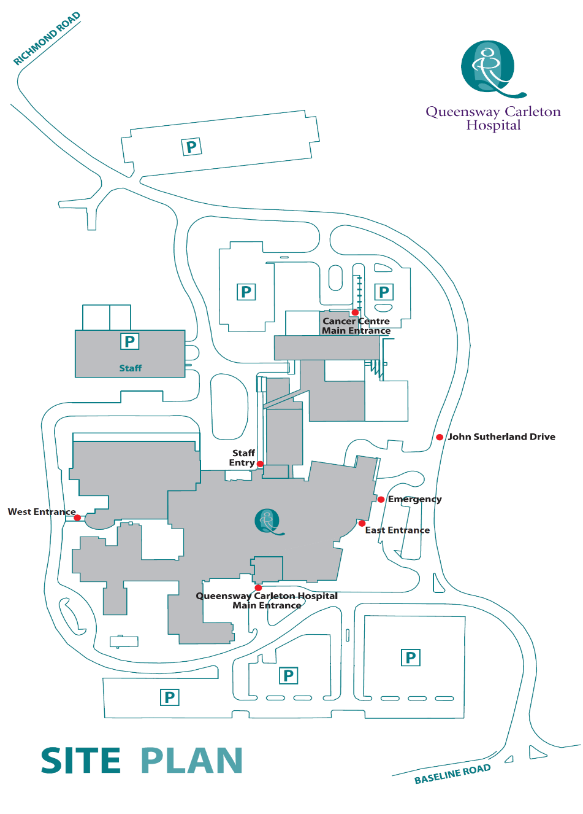

**James Beach Health Care West Entrance (patient pickup)**

**Main Entrance** **(patient drop off)**

## Post-operative dressing

If you are a Day Surgery patient, you will probably need some sterile dressings and tape at home after your surgery.

1. We advise you to purchase these supplies before your surgery.
2. We suggest that you get a small package of sterile 4” X 4” gauze pads and a roll of tape at the drugstore before your surgery.
3. Other:

If you have any questions about the dressing type to purchase, please check with your nurse in the Pre-Operative Assessment Clinic.

## Pain scale ruler

Your nurse will ask you to rate your pain on either the number or FACES scale (see below). Pain is rated from 0 (no pain) to 10 (worst pain).

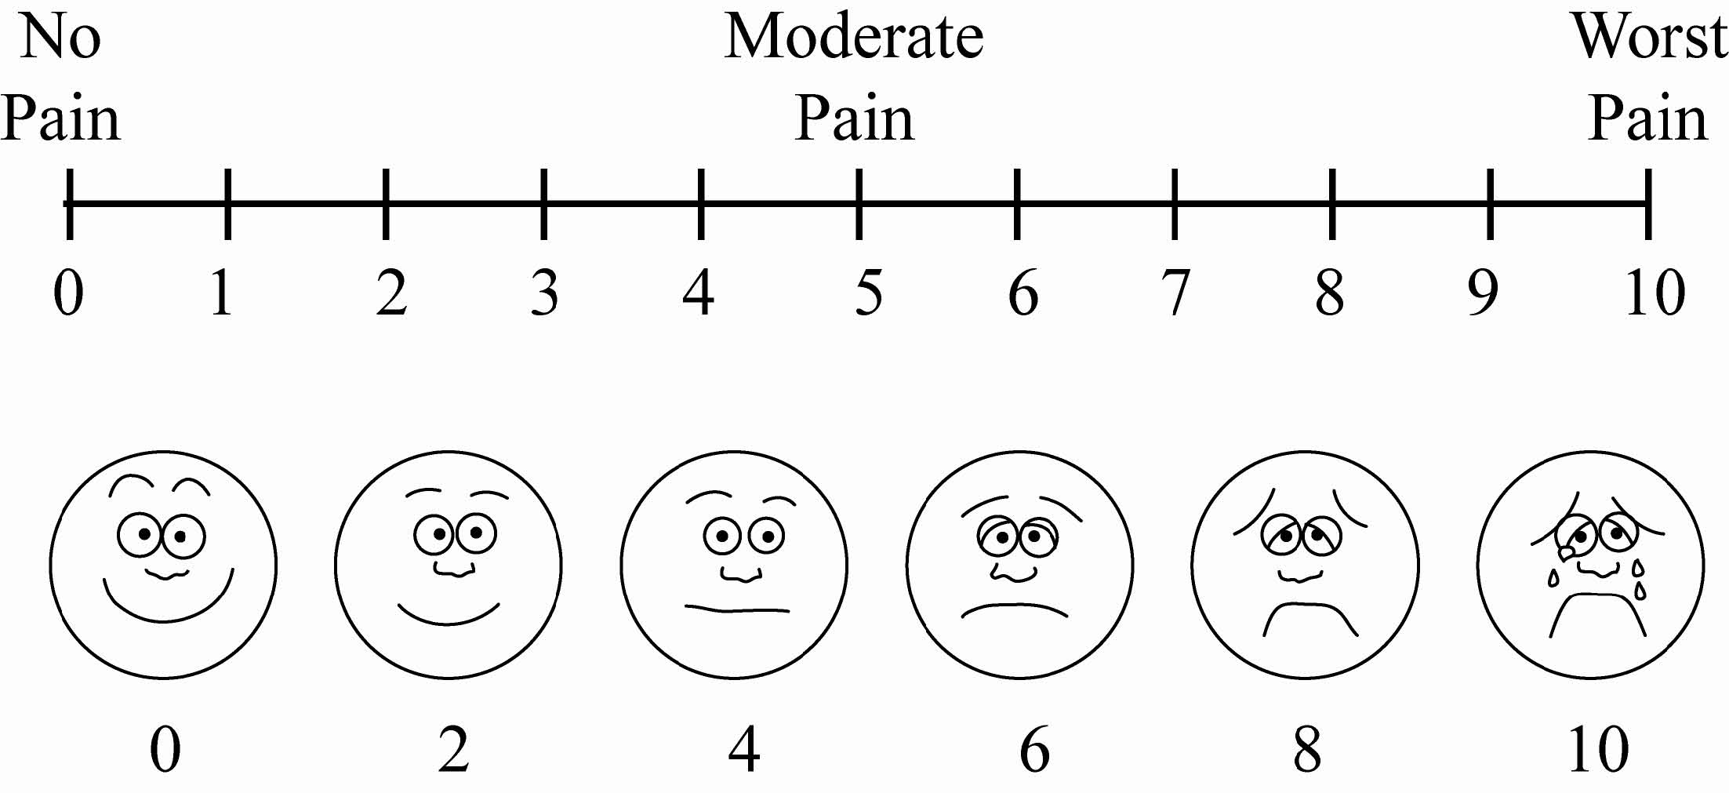

**🞎**

# **Cartilage repair surgery of the knee/microfracture**

**Pain:**

Upon discharge, you will be given a prescription for pain medication(s). Please take the pain medication with food and as directed. Elevate the leg and apply ice pack, cold gel pack or use a commercial cooling device (Cryro-cuff™) regularly (keeping dressing dry). **Do not drink alcoholic beverages or drive if you are using pain medications.**

**Operative site:**

A dressing has been applied to your incision which consists of bandage, gauze, and/or skin tapes next to the skin itself. Keep the dressing dry. You may shower 4 days after your surgery, during which the outer dressing may be removed. Do not remove the tapes on the skin. Rewrap the tensor bandage snugly after showering.

Follow the activity directions below **UNLESS OTHERWISE SPECIFIED BY YOUR SURGEON:**

**Activity:**

* Prior to weight bearing check your physio referral to make sure its permitted
* You are not permitted to put weight on the leg for up to 6 weeks
* Use crutches to walk
* Gently bend and straighten the knee as often as possible
* Start physiotherapy as directed by your surgeon
* Your surgeon will determine whether you require the use of a CPM (continuous passive motion) machine

**Diet:**

Restrict yourself to a light diet the day of the surgery. Resume your usual diet the day following surgery. Increase the amount of fiber in your diet and drink plenty of fluids to avoid constipation.

**Follow up:**

Your follow-up appointment with your surgeon will be made approximately 1 to 2 weeks after your surgery. Your surgeon will advise you regarding physiotherapy.

**Additional information:**

Call your surgeon **immediately** or go to the nearest Emergency Department if you have any of the following:

* Excessive drainage through your bandage
* Severe pain not relieved with your pain medication
* Signs and symptoms of infection
* the incision is red
* the knee is hot and swollen
* yellow/green or foul-smelling discharge from the incision
* Elevated temperature (38ºC or 100.4ºF) and/or chills lasting more than 24 hours
* Sudden shortness of breath, rapid heart rate or chest pain/chest discomfort.
* Increased calf or leg pain, soreness or tenderness and/or swelling
* Unusual dizziness or light headedness

**🞎**

# **Patellar-Femoral re-alignment knee surgery (Fulkerson osteotomy/Medial Patella-Femoral Ligament reconstruction**

**Pain:**

Upon discharge, you will be given a prescription for pain medication(s). Please take the pain medication with food and as directed. Elevate the leg and apply ice pack, cold gel pack or use a commercial cooling device (Cryro-cuff™) regularly (keeping dressing dry). **Do not drink alcoholic beverages or drive if you are using pain medications.**

**Operative site:**

A dressing has been applied to your incision which consists of bandage, gauze, and/or skin tapes next to the skin itself. Keep the dressing dry. You may shower 4 days after your surgery, during which the outer dressing may be removed. Do not remove the tapes on the skin and rewrap the tensor bandage snugly after showering.

Follow the activity directions below **UNLESS OTHERWISE SPECIFIED BY YOUR SURGEON:**

**Activity:**

**Fulkerson Osteotomy (usually performed with MPFL reconstruction)**

* + You are not permitted to put weight on your leg for up to 6 weeks
  + Use the splint for all activity and sleeping for 6 weeks. You may remove splint for physio and range of motion exercises

**Medial Patello-femoral Ligament Reconstruction only (no osteotomy)**

* + You are allowed to walk with full weight on your operated leg while using crutches for balance
  + Use crutches to walk
  + Start physiotherapy as directed by your surgeon
  + Remove the splint when you get home from the hospital
  + Other:

**Diet:**

Restrict yourself to a light diet the day of the surgery. Resume your usual diet the day following surgery. Increase the amount of fiber in your diet and drink plenty of fluids to avoid constipation.

**Follow up:**

Your follow-up appointment will be made approximately 1 to 2 weeks after your surgery. Physiotherapy may be started prior to your appointment depending on swelling, pain, and surgery performed. Your surgeon will advise you regarding physiotherapy.

**Additional information:**

Call your surgeon **immediately** or go to the nearest Emergency Department if you have any of the following:

* Excessive drainage through your bandage
* Severe pain not relieved with your pain medication
* Signs and symptoms of infection
* the incision is red
* the knee is hot and swollen
* yellow/green or foul-smelling discharge from the incision
* Elevated temperature (38ºC or 100.4ºF) and/or chills lasting more than 24 hours
* Sudden shortness of breath, rapid heart rate or chest pain/chest discomfort
* Increased calf or leg pain, soreness or tenderness and/or swelling
* Unusual dizziness or light headedness

**🞎**

# **Posterior Cruciate Ligament / Multiple Ligament Reconstruction Surgery**

**While waiting for surgery:**

* Do quadriceps and hamstrings strengthening daily
* Maintain good knee range of motion
* Achieve full knee extension (straightening) and as much flexion (bending) as possible

**Before surgery checklist:**

* Crutches
* Zimmer™ splint
* Hinged knee brace (Dynamic PCL brace only if Posterior Cruciate ligament is injured)
  + Dynamic PCL brace allows rehabilitation of the knee while minimizing the stretching of the PCL graft due to gravity and the force of hamstring tendons
* Elevate the leg and apply ice pack, cold gel pack or a commercial cooling device (Cyro-cuff™) regularly (keeping dressing dry)
* Arrange a ride home following surgery
* Arrange for someone to stay with you for the first 24-48 hours

**Day of surgery:**

* Take crutches and splint to the Hospital
* You will be discharged home the following day after your surgery with a prescription for pain medication

**Pain:**

Some pain is normal after your surgery. Your surgeon has given you a prescription for pain medication. Please use as instructed.

**Operative site:**

After surgery, the affected joint will be padded with gauze. Do not allow your bandage to become wet. You may loosen the dressing if it becomes too tight. Commercial cooling devices should be used on a regular basis until pain and swelling have been controlled.

Bring your splint to the hospital on the day of your surgery.

**Rehabilitation information after surgery**

* Strive to obtain full extension to 0 degrees (full straightening of the knee by week 1-2)
* Match the extension or hyper extension of your operated leg to the other knee
* Be vigilant with use of ice pack/cold gel pack/commercial device (Cryo-Cuff™ or others) and elevate the operative leg
  + To minimize swelling to allow knee motion
  + For PCL reconstructions goal is to minimize swelling to allow fitting and use of PCL dynamic brace as soon as possible
* Knee bending to 90 degrees by week 6
* Knee bending to 100 degrees by week 8
* Knee bending to 110 degrees by week 10
* Knee bending to 120 degrees by week 12
* Maximum knee motion (bending and straightening) as close to non-operated knee 12-16 weeks after surgery
* Rehabilitation after PCL surgery attempts to counter the force of gravity on the tibia. Gravity pulls the shin bone back and puts stress on the reconstructed PCL graft

This is done by:

* + Doing knee motion exercises prone (lying on your stomach)
  + Having a bump under your calf inside your Zimmer™ splint
  + Using a custom hinged PCL brace when swelling has gone down enough for brace to fit
  + Avoiding hamstring strengthening on the operated leg

**Goals of rehabilitation after surgery and follow up requirements**

|  |  |
| --- | --- |
| **Week 1** | Goals - decrease pain and swelling and to facilitate rehab and brace fitting   * Make your knee straighten fully (just like other knee) * Perform deep breathing and drink fluids to stay hydrated * Resume usual diet following surgery- increase fiber to avoid constipation * You are not permitted to put weight on your leg for 6 weeks, use crutches to help you walk during this time * Use Zimmer™ splint at all times, including when sleeping * If PCL surgery put folded towel under your calf inside the splint and switch to PCL brace as soon as swelling has gone down and brace fits * Elevate the leg and apply ice pack, cold gel pack or commercial cooling device (Cyro-cuff™) regularly (keeping dressing dry) * Expect bruising of the calf and leg, this usually resolves 2–4 weeks after surgery * Avoid any strenuous activity or heavy lifting (greater than 10 pounds) * Make appointment with surgeon at 1-2 weeks after surgery * Make an appointment with Physiotherapy Department when your surgeon tells you to |
| **Week 2** | * Make your knee straighten fully (just like other knee) * Skin incisions should be healed * You are not permitted to put weight on your leg for 4-6 weeks; use crutches * After 2-3 weeks Zimmer™ splint may be switched to hinged knee brace |
| **Week 3-4** | * You are not permitted to put weight on your leg for 4-6 weeks, use crutches * Continue working on range of motion exercises with physiotherapist as directed by your surgeon * Do not skip physiotherapy appointments. It is also critical to continue with prescribed Physiotherapy exercises every day |
| **Week 6-12** | * Make appointment with surgeon to check progress * Progress to full weight bearing with brace at Surgeon’s discretion * Work with physiotherapist to meet your range of motion goals |
| **Month 3-6** | * Make appointment with surgeon to check progress * Continue working with physiotherapy on range of motion, start working with physiotherapist on strengthening |
| **Month 6-12** | * Make appointment with surgeon to check progress * Start running in a forward direction and progress (no twisting or turning) * Month 9-12 begin cutting movements lateral side to side * Gradual return to sporting activity at discretion of your surgeon, usually after 12 months * Use brace for activities for 1 year following surgery and for sports thereafter * Requirements for return to sports: * Stable knee * No swelling * Full range of motion * Strength 85% of opposite side * Always wear brace |

**Follow up:**

Your surgeon will advise you of your follow-up appointment the day of your surgery. If you are a Day Surgery patient, a nurse from the Day Surgery Unit will call you the day after your surgery to discuss any concerns. The first visit will be approximately 10 days after your surgery. The stitches will be removed at that time.

**Activity:**

You may shower 48 hours after your surgery. Clean and dry the incision and reapply dressing.

**Diet:**

Restrict yourself to a light diet the day of the surgery. Resume your usual diet the day following surgery. Increase the amount of fiber in your diet and drink plenty of fluids to avoid constipation.

**Additional information:**

There may be some oozing of blood from the incision. Some pain and swelling are expected after surgery.

**Crutches**

Used after surgery to assist with walking. You will not be permitted to put weight on your leg for 4-6 weeks after surgery. You will need crutches to help you walk during this time.

**Zimmer™ splint**

Used after surgery to protect the ligament reconstruction. The splint is worn at all times, even while sleeping. The Zimmer™ splint is usually exchanged for a hinged brace after approximately 2-3 weeks when the incision is healed. The splint may have a bump (folded towel) in the calf area designed to push the tibia forward and take pressure off the PCL graft. It can be purchased at Kinemedics (see contact information on next page) or at Queensway Carleton Hospital.

**Hinged knee brace/PCL brace**

A hinged knee brace may be used in the early post-operative period to protect the knee reconstruction. The brace is usually worn after the Zimmer™ splint has been discontinued, provided that it does not irritate the surgical incision and that knee swelling allows it to be put on without too much pressure on the shin.

Your surgeon will advise you which brace you should consider if any. If having PCL surgery you may benefit from having a special PCL brace to protect your knee after surgery.

You will continue using the brace during the first year after surgery, and for all sports activities.

Call your surgeon **immediately** or go to the nearest Emergency Department if you have any of the following:

* Excessive drainage through your bandage
* Severe pain not relieved with your pain medication
* Signs and symptoms of infection
* the incision is red
* the knee is hot and swollen
* yellow/green or foul-smelling discharge from the incision
* Elevated temperature (38ºC or 100.4ºF) and/or chills lasting more than 24 hours
* Sudden shortness of breath, rapid heart rate or chest pain/chest discomfort.
* Increased calf or leg pain, soreness or tenderness and/or swelling
* Unusual dizziness or light headedness.

#### Locations for renting/purchasing equipment:

1.Kinemedics: [www.kinemedics.com](http://www.kinemedics.com) 613-745-9797

2.Wellwise by Shoppers Home Health 613-831-6505

Please note: This location is a suggestion only. You may go to any location you choose. We suggest calling ahead to book an appointment and/or make sure they have stock available.

**PCL Post-Op Exercises weeks 1-2**

Do each exercise 3x a day repeating each one 10-20 times.

[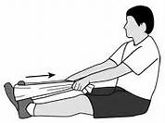](http://www.bing.com/images/search?q=seated+towel+calf+strecth&view=detailv2&&id=9F0F4B3A1F422C8DC50CEB86494BE090C7A8306D&selectedIndex=5&ccid=CF8b8Hc6&simid=607988282711933747&thid=OIP.M085f1bf0773a2bc65de0d07ffa46bc53o0)

Wrap a towel around your foot and gently stretch your calf

[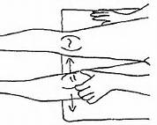](http://www.bing.com/images/search?q=patellar+mobilizations&view=detailv2&&id=3AE22A518152DDE7C6FE78BD50CF77D55FD322F2&selectedIndex=12&ccid=isfKdYwz&simid=608011544260971497&thid=OIP.M8ac7ca758c339d5b132b8e7030e3482ao0)

Slide the kneecap side to side

**🞎**

# **Anterior Cruciate Ligament Reconstruction**

**While waiting for surgery:**

* Do quadriceps and hamstrings strengthening daily
* Maintain good knee range of motion
* Achieve full knee extension (straightening) and as close to full flexion (bending) as possible

**Before surgery checklist:**

* Crutches
* Zimmer™ splint
* Ice pack (for example: ice pack, cold gel pack, or commercial cooling devices)
* Arrange a ride home following surgery
* Arrange for someone to stay with you for the first 24-48 hours

**Day of surgery:**

* Take crutches, splint, and cooling device to hospital
* You will be discharged home the same day as your surgery with a prescription for pain medication

**Pain:**

Some pain is normal after your surgery. Your surgeon has given you a prescription for pain medication. Please use as instructed.

**Operative site:**

After surgery, the affected joint will be padded with gauze. Do not allow your bandage to become wet. You may loosen the dressing if it becomes too tight. Use ice or a commercially available cooling device regularly.

Bring your Zimmer™ splint with you the day of surgery.

**Rehabilitation information after surgery**

* Early restoration of knee range of motion is essential for a good outcome
* Remove your Zimmer™ splint and start moving your knee on the day following your surgery. The splint is for comfort only
* Full knee extension (straightening – just like your other knee) by day 1 is encouraged and is your priority by the end of week 1
* Some knee hyperextension (if the other knee hyperextends) is ok and is expected by the 2nd week after surgery
* Knee flexion (bending) is encouraged by day 1 and should be at 90 degrees by week 1
* Quadriceps lag should be eliminated by week 2
* Full knee range of motion (straightening and bending) just like the other knee is expected by week 6

**ACL Graft**

The ACL graft changes from a tendon to a ligament in the first few months following surgery. As a result of these changes the graft is weakest 6 weeks from your operation and strengthens by 3 months. It takes a full year to complete the transformation.

It is important to follow the physiotherapy rehabilitation instructions during this time and not over exert your knee.

**Goals of rehabilitation after surgery and follow up requirements**

|  |  |
| --- | --- |
| **Week 1** | * Make your knee straighten fully (just like other knee) * Make your knee bend to 90 degrees (let it hang over the edge of the bed and gravity will do the work for you!) * The splint is for comfort only. Remove it and start bending and straightening your knee on day 1. You can safely walk without the splint and can sleep at night without it * Deep breathing exercises are important and staying hydrated is beneficial * Resume usual diet following surgery. Increase fiber to avoid constipation * You can put full weight on your leg unless otherwise specified by your surgeon   + - UNLESS your meniscus was **repaired,** or other ligaments in addition to your ACL were also reconstructed at the time of your surgery * Use crutches for comfort * Use ice or cooling device regularly (on for 15 minutes, off for 15 minutes) during first week, and then after exercise or when pain and swelling occur * Expect bruising on your calf and leg. This usually resolves 2–4 weeks after surgery * Plan to take it easy around the house * Make appointment with surgeon for 1 to 2 weeks after surgery * Make an appointment with Physiotherapy Department when your surgeon tells you to |
| **Week 2** | * Make sure your knee has full extension (straightens fully) and bends at least 90 degrees * Skin incisions should be healed * Do not take a tub bath until given permission by your Surgeon * You should be off crutches * Return to work may occur between 2-12 weeks following surgery and is based on   + the general condition of the knee   + time from surgery   + progress of rehab   + type of work demands |
| **Week 3-4** | * You will begin to feel generally better (more strength, less pain and swelling) * Do not skip Physiotherapy appointments. It is also critical to continue with prescribed Physiotherapy exercises every day * Make sure your knee is straightening fully and bending almost as much as the other knee |
| **Week 6+** | * Make an appointment with surgeon to check progress * Weeks 4-8 is when your new graft is the weakest, so be careful and follow instructions and restrictions * Goals: * full range of motion * walk with normal gait * follow physiotherapy rehab instructions as directed |
| **Month 3-5** | * Make an appointment with your surgeon to check progress * Goals   + regain strength   + jog in a forward direction on a treadmill (no twisting or turning)   + follow physiotherapy rehabilitation instructions as directed |
| **Month 6-12** | * Make an appointment with surgeon to check progress * Requirements for return to sports: * Stable graph * No swelling * Full range of motion * Strength 85% of uninjured side |

**Follow up:**

Your surgeon will advise you to make your first follow-up appointment the day of your surgery. If you are a Day Surgery patient, a nurse from the Day Surgery Unit will call you the day after your surgery to discuss any concerns. The first visit will be 1 to 2 weeks after your surgery. The stitches will be removed at that time.

**Activity:**

Gentle knee flexion and extension exercises (bending and straightening of knee) should be carried out from the day after surgery. Crutches should be used until your first clinic visit. You may shower 4 days after your surgery. During the shower clean the incision. After shower pat incision dry and apply new clean dressing. Do not take a tub bath until your surgeon gives you permission.

**Diet:**

Restrict yourself to a light diet the day of the surgery. Resume your usual diet the day following surgery. Increase the amount of fiber in your diet and drink plenty of fluids to avoid constipation.

**Additional information:**

There may be some oozing of blood from the incision. Some pain and swelling are expected after surgery.

**Crutches**

Used after surgery to assist with walking, and usually discarded during the first week.

**Zimmer™ splint**

Used after surgery to protect your knee. The splint is worn for comfort. It can be removed while sitting, lying down. The Zimmer™ splint is usually removed the day after surgery. It can be purchased at Kinemedics or at Queensway Carleton Hospital.

**Cryo-cuff™/Game Ready Machine/ Ice Man - other commercially available cooling systems**

This is used to minimize pain and swelling. The device is generally used intermittently up to 3 months following surgery to assist control of swelling/aching associated with rehabilitation exercises. Do not put ice directly to the skin. Do not apply the device so tight as to cause leg swelling. See below for locations for renting/purchasing.

Call your surgeon **immediately** or go to the nearest Emergency Department if you have any of the following:

* Excessive drainage through your bandage
* Severe pain not relieved with your pain medication
* Signs and symptoms of infection
* the incision is red
* the knee is hot and swollen
* yellow/green or foul-smelling discharge from the incision
* Elevated temperature (38ºC or 100.4ºF) and/or chills lasting more than 24 hours
* Sudden shortness of breath, rapid heart rate or chest pain/chest discomfort
* Increased calf or leg pain, soreness or tenderness and/or swelling
* Unusual dizziness or light headedness.

#### Locations for renting/purchasing equipment:

1.Kinemedics: [www.kinemedics.com](http://www.kinemedics.com) 613-745-9797

2.Wellwise by Shoppers Home Health 613-831-6505

Please note: This location is a suggestion only. You may go to any location you choose. We suggest calling ahead to book an appointment and/or make sure they have stock available.

**ACL post-op exercises weeks 1**

Do each exercise 3x a day repeating each one 10-20 times.

[](http://www.bing.com/images/search?q=seated+towel+calf+strecth&view=detailv2&&id=9F0F4B3A1F422C8DC50CEB86494BE090C7A8306D&selectedIndex=5&ccid=CF8b8Hc6&simid=607988282711933747&thid=OIP.M085f1bf0773a2bc65de0d07ffa46bc53o0) [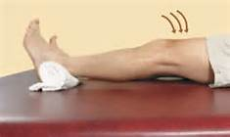](http://www.bing.com/images/search?q=+knee+extension+with+roll+under+heel&view=detailv2&&id=20C86CAC554204022D82C06D39383DD09EB8845B&selectedIndex=51&ccid=kq/vElLS&simid=608054133159167456&thid=OIP.M92afef1252d20cd77454edb7bddf5156o0)

Wrap a towel around your foot Put a rolled towel under your heel and and gently stretch your calf. get the back of the knee on the bed.

[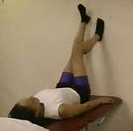](http://www.bing.com/images/search?q=images+of+knee+flexion+while+lying+on+back+and+foot+sliding+down+wall&view=detailv2&&id=78EE130CF19AD0770FEAFA366D43C93AB6CC0A18&selectedIndex=1&ccid=YJRO8J1s&simid=608033384166981912&thid=OIP.M60944ef09d6c3af9675bc5970a17cc4bo0) [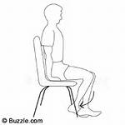](http://www.bing.com/images/search?q=images+of+passive++knee+flexion+while+sitting&view=detailv2&&id=237BA5E9FC5DC6013970D2DF2F336734925E0C38&selectedIndex=0&ccid=TXVEcflx&simid=608007167687330052&thid=OIP.M4d754471f9717b69bbe039d97c2804b8o0)

Try to bed knee by sliding Bend the knee by pushing it with foot down the wall. the un-operated leg.

[](http://www.bing.com/images/search?q=patellar+mobilizations&view=detailv2&&id=3AE22A518152DDE7C6FE78BD50CF77D55FD322F2&selectedIndex=12&ccid=isfKdYwz&simid=608011544260971497&thid=OIP.M8ac7ca758c339d5b132b8e7030e3482ao0)

Slide the kneecap from side to side

[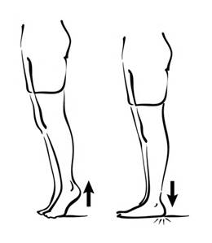](http://www.bing.com/images/search?q=heel+raises&view=detailv2&&id=5BCB482F6618B690442A8197A539136C5B114D7E&selectedIndex=12&ccid=1bZd9DA5&simid=608003126130642842&thid=OIP.Md5b65df4303927996dfe83b6538114c8H0) [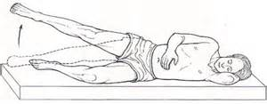](http://www.bing.com/images/search?q=hipe+abductor+stregh=thenig+in+side+lying&view=detailv2&&id=8FE83B657B8273AEC479073AE7D0784F9CFFF837&selectedIndex=7&ccid=XKfzIo6f&simid=607988248353442781&thid=OIP.M5ca7f3228e9f7a982375c6b633561fbco0)

Rise up and down onto your toes. Lie on your side and lift your operated . leg up.

**Post-op weeks 2-6**

[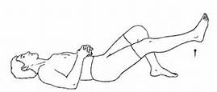](http://www.bing.com/images/search?q=straight+leg+raise+with+bent+knee&view=detailv2&&id=C5BD0B8DD9A17D768C85FFBF9A326BA40A78B691&selectedIndex=57&ccid=xPglBqui&simid=608041213891643600&thid=OIP.Mc4f82506aba2ff13b60519d75e6b7204o0) [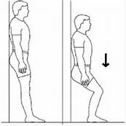](http://www.bing.com/images/search?q=wall+slide&view=detailv2&&id=E874FDEAC0A2ED96589DC1869E0A42D20E7AC5B3&selectedIndex=18&ccid=o80pQiXg&simid=608046707157305462&thid=OIP.Ma3cd294225e0e36726fff6b3c8133826o0)

Keeping your knee straight, lift Slide down a wall to 45-degree angle. the leg off the bed.

Person putting left foot on step beside right foot Person putting weight on right foot on first step Person putting one foot on first step

Go up and down slowly. Lean forward slightly. Repeat 10 times

**🞎**

# **Osteotomy Tibial / Femoral Rehabilitation Protocol**

**While waiting for surgery:**

* Do quadriceps and hamstrings strengthening daily
* Maintain good knee range of motion

**Before surgery checklist:**

* Arrange for someone to stay with you for the first 24-48 hours

**Hospital stay:**

* You will be discharged home 1 to 2 days after your surgery unless otherwise specified by your surgeon
* At discharge you will be given a prescription for pain medication

**Pain:**

Some pain is normal after your surgery. Your surgeon has given you a prescription for pain medication. Please use as instructed.

**Operative site:**

After surgery, the affected joint will be padded with gauze. Do not allow your bandage to become wet. You may loosen the dressing if it becomes too tight. Use ice or a commercially available cooling device regularly. Bring your Zimmer™ splint with you the day of surgery.

**Rehabilitation information after surgery**

Week 1

* Weight bearing toe-touch only with crutches
* Start gentle range of motion
* Try to straighten your knee fully just like the other knee

Week 2

* Weight bearing toe-touch only with crutches
* Range of motion exercises. Active and passive to hip, knee and ankle
* Patellar-femoral mobilization when incision healed
* Modalities
* Stationary bike with no resistance
* Strengthening with no resisted exercises for quadriceps or hamstrings

Week 6+

* Weight bearing progressed by surgeon
* Range of motion exercises
* Mobilizations for flexion or extension as indicated
* Modalities
* Stationary bike gradually increasing resistance
* Strengthening gradually increase resistance to quadriceps and hamstrings
* Can use whirlpool when incision is healed

**Goals of rehabilitation after surgery and follow up requirements**

|  |  |
| --- | --- |
| **Week 1** | * Goal is to decrease pain and swelling * Make your knee straighten fully just like your other knee * Deep breathing exercises are important and staying hydrated is beneficial * Resume usual diet following surgery. Increase fiber to avoid constipation * You are not permitted to put weight on your leg for 6 weeks * Use crutches to ambulate * Use Zimmer™ splint for walking, weight bearing, and sleeping * Use ice or cooling device regularly (on for 15 minutes, off for 15 minutes) during first week * Plan to take it easy around the house * Start range of motion exercises to make sure your knee doesn’t get to stiff * Make appointment with surgeon for 1 week after surgery * Make an appointment with Physiotherapy Department when your surgeon tells you to |
| **Week 2-6** | * Skin incisions should be healed * You are permitted to take a bath if preferred * You are not permitted to put weight on your leg for 6 weeks * Continue to use crutches to ambulate * Take off Zimmer™ splint while awake * Continue working with physiotherapy on range of motion * Return to work may occur between 6-12 weeks following surgery and is based on:   + the general condition of the knee   + time from surgery   + progress of rehab   + type of work demands |
| **Week 6-12** | * Make an appointment with surgeon to check progress * Progress to full weight bearing after 6 weeks at the discretion of your Surgeon * Gradually stop using crutches * Stop using Zimmer™ splint for sleeping after 6 weeks * Continue working with physiotherapy on range of motion and start strengthening |
| **Month 3** | * Make an appointment with surgeon to check progress * Requirements for return to sports: * X-ray showing healed osteotomy * No swelling * Full range of motion * Strength 85% of uninjured side |

**Crutches**

Used after surgery to assist with walking. You will be allowed to put weight on your leg after 6 week and will need crutches to help you walk during this time.

**Zimmer™ splint**

Used after surgery to protect your knee. The splint is worn at all times, including during sleep. The splint may be taken off while showering. After 1 week the splint is taken off for daily activities and work only for sleeping. After 6 weeks the splint can be discarded. It can be purchased at Kinemedics or at Queensway Carleton Hospital.

**Cryo-cuff™/Game Ready Machine/ Ice Man - other commercially available cooling systems**

This is used to minimize pain and swelling. The device is generally used intermittently up to 3 months following surgery to assist control of swelling/aching associated with rehabilitation exercises. Do not put ice directly to the skin. Do not apply the device so tight as to cause leg swelling. See below for locations for renting/purchasing.

Call your surgeon **immediately** or go to the nearest Emergency Department if you have any of the following:

* Excessive drainage through your bandage
* Severe pain not relieved with your pain medication
* Signs and symptoms of infection
* the incision is red
* the knee is hot and swollen
* yellow/green or foul-smelling discharge from the incision
* Elevated temperature (38ºC or 100.4ºF) and/or chills lasting more than 24 hours
* Sudden shortness of breath, rapid heart rate or chest pain/chest discomfort
* Increased calf or leg pain, soreness or tenderness and/or swelling
* Unusual dizziness or light headedness.

#### Locations for renting/purchasing equipment:

1.Kinemedics: [www.kinemedics.com](http://www.kinemedics.com) 613-745-9797

2.Wellwise by Shoppers Home Health 613-831-6505

Please note: This location is a suggestion only. You may go to any location you choose. We suggest calling ahead to book an appointment and/or make sure they have stock available.