Total Abdominal Hysterectomy/Laparotomy

Patient Information Booklet

Please bring this book to your admission to the Hospital and to all of your appointments

For Information Call

613-721-2000 extension 2920

Between 8:00 a.m. and 4:00 p.m.

Monday to Friday

This booklet is intended to provide you with information to prepare you for your hospital stay and discharge. Your safety and complete recovery is our priority following your surgery. For this reason, we ask you to follow these instructions. Please use this booklet as a reference tool for all dates and times and **bring this booklet with you to all your appointments** **and on your day of surgery.**

Your hospital stay will follow a plan of care called a “Clinical Pathway”. In this booklet you will find information about your surgery and the patient version of the Total Abdominal Hysterectomy Clinical Pathway. It has been prepared so that you, your family, and all members of your healthcare team know your plan of care, including what tests, treatments and diet you require as well as the education and planning necessary for discharge.

The patient version of the Total Abdominal Hysterectomy Clinical Pathway gives you an idea of what to expect when you arrive at the hospital until your discharge (see pages 20 through 23). The diagram below shows the location of the surgery.

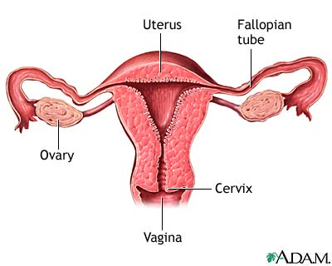

After you and/or your family have read the information, please feel free to ask your Nurse or other members of the healthcare team any questions.

What happens at the pre-operative assessment visit?

Your visit to the Pre-operative Assessment Clinic (POAC) may involve a 4 to 6 hour visit to the hospital. It is important and mandatory to attend this appointment or your surgery will be postponed or cancelled. In the clinic you will be officially registered for your hospital admission and a nursing assessment and pre-operative tests will be performed. These tests may include:

* X-rays
* Blood and urine tests
* ECG (electrocardiogram)

You will be given information about your hospital stay. The Nurse will take your health history and ask you to review your consent for surgery. The most important things you will learn during your visit to Pre-operative Assessment Clinic (POAC) are:

* The date and place for your hospital admission
* How to prepare for your surgery
* Deep breathing exercises and ankle exercises

You may see other healthcare professionals during your Pre-operative Assessment Clinic (POAC) visit, if requested by your Surgeon. These may include:

* Anesthesiologist
* Medical Doctor
* Community Care Case Manager
* Social Worker
* Dietician

Please bring the following to your Pre-operative Assessment Clinic (POAC) appointment:

* All your current medications in the proper bottles, including non-prescription medications (creams, eye drops, puffers, lotions, vitamins and herbal products)
* A list of allergies including type of reaction
* Provincial health insurance card and proof of any additional health insurance
* Your substitute decision maker if they have signed the consent for you
* Your reading glasses if required
* A translator if you have difficulty understanding or speaking English
* We recommend that you bring one family member or friend with you to your appointment who will assist you in your care. This person has to be able to accompany you to your various appointments in the hospital. There is some walking involved.

You will be asked if you smoke or consume alcohol on a regular basis.

MRSA (Methicillin - Resistant Staph Aureus)

Today, many hospitals in Canada and around the world are dealing with bacterium which no longer responds to many antibiotics. Queensway Carleton Hospital is taking steps to prevent and control antibiotic resistant bacterium. This bacterium does not cause problems in healthy people, but it can cause infections in people who have weakened immune systems or have had major surgery. If you have stayed overnight in a health care facility within the last year, you will be screened for this at the time of your POAC visit.

Family contact:

Please discuss and decide with your family who will be the primary “contact” person. This should be the only person to phone the hospital staff regarding your condition. This person can further contact the rest of your family and/or friends. This name will be written on the chart. Please let your family and friends know who this person is.

**My family contact is: ____________________________________**

Phone numbers: Home: ____________________________________

Work: ____________________________________

Cell: ____________________________________

Where do I go for my pre-operative assessment visit?

Report to Queensway Carleton Hospital main lobby Information Desk. You will be directed to the Patient Registration Department to be registered and then to Pre-operative Assessment Clinic (POAC).

When is my appointment?

The Queensway Carleton Hospital Operating Room Scheduling Department will notify you at home of your appointment at Pre-operative Assessment Clinic (POAC).

If you have any questions about your appointment please call the Operating Room Scheduling Department, Monday to Friday, 8 a.m. to 4 p.m. at (613) 721-2000, ext. 2614.

Your date of surgery is: ________________________________________

Call the Queensway Carleton Hospital Operating Room Scheduling Department on the day before your surgery is scheduled to get the time for your admission. The number to call is (613) 721-4840 between 11 a.m. and 3 p.m., Monday through Friday.

Call for your admission time on: _________________________________

(yy/mm/dd)

**On the day of your Pre-Operative Assessment Clinic visit we advise you to purchase 2 scrub brushes of Chlorhexidine 4% soap. They can be purchased at the Queensway Carlton Hospital Gift Box on the main floor next to the front lobby.**

QCH Gift Box Hours

Monday to Friday 9 a.m. to 8 p.m.

Weekends 12 p.m. to 4 p.m.

Health tips before surgery

We ask that you check your temperature regularly during the last three days before the date that you are scheduled for your operation. If you feel feverish (temperature 38ºC or 100.4ºF) or develop a respiratory infection during this period, you should notify the Surgeon performing your surgery. This is important for your well being and the safety of others because there is a risk for everyone if you go into surgery with an infectious process in progress. Should your surgery be delayed, every effort will be made to have you rescheduled as soon as possible.

**NOTE:** Notify your surgeon before your surgery if you develop a cold or any other illness.

Will I need to see a social worker?

A social worker may call if you feel there are any issues that make it difficult for you to manage at home on discharge. If you are already on Home Care through the Local Health Integration Network Home and Community Care (LHIN HCC), please make sure that your care coordinator knows the date of your surgery.

If you live alone, you should plan to have someone stay with you overnight and to help make meals for a few days. You could also make meals ahead of time and freeze them. If you are worried about being alone, you may want to think about convalescent care in a retirement home. You can make these arrangements yourself or we can guide you to do it when you come to Pre-operative Assessment Clinic (POAC).

If you are the caregiver for someone else, please let us know at the time of your pre-operative visit.

What should I bring to the hospital?

PLEASE BRING:

* A knee length dressing gown which opens all the way down the front
* Non-skid slippers
* Comfortable clothing. For example: jogging pants or shorts and a shirt, to wear home
* Toothbrush, toothpaste, soap, shampoo, deodorant, tissue. These items are not supplied by the hospital
* Please label any equipment brought from home with your name
* All your current medications in the proper bottles, including non‑prescription medications
* A list of allergies including the type of reaction

Enhanced Recovery Program for Open Gynecological Surgeries

Patient Information

At the Queensway Carleton Hospital, our goal is to improve pain management and nausea after your gynecological surgery. Enhanced recovery means that you are able to eat and move around sooner and may help to reduce the possibility of lung infections and blood clots. Many patients feel well enough to go home after one day in hospital and may be able to return to work sooner.  
  
Before surgery:

* You should be eating healthy foods up to bedtime on the day before surgery
* Have a high protein snack at 11 pm the night before surgery (ie crackers and cheese, toast and peanut butter, egg and toast)
* **DO NOT** eat solid food (anything you have to chew) after midnight
* **DO** drink 1 cup (250 mL or 8 ounces) of clear fluids (anything you can see through) before you get to hospital (ie Gatorade™, ginger-ale ™, apple juice, water). Do not drink coffee, Coke™, or orange juice
* You may be given Tylenol ™ and Celebrex™ at the hospital while waiting for your surgery

During surgery:

* You will be offered a spinal anesthetic (freezing medicine that is put into your back)
* You will be given an anesthetic through your intravenous

After surgery:

* You will be encouraged to eat small amounts if you are hungry
* You will be given pain medications (Tylenol™ and Celebrex™) that should be taken on a regular schedule whether you have pain or not
* You will be given other pain or nausea medications if you need them
* You will likely feel well enough to go home on the first day after surgery

After discharge from hospital:

* Continue to use Tylenol ™and Celebrex ™on a regular basis for the first few weeks
* If you have a prescription for a narcotic medication, use this as needed if the Tylenol ™and Celebrex ™are not managing your pain
* Eat and move around based on how you feel. Do what you can but don’t push it with any heavy lifting or driving in the first few weeks
* You will need about 4 to 6 weeks to feel like you did before your surgery
* Drink fluids and help to prevent constipation by eating fruits and vegetables
* Refrain from sexual intercourse until after your post operative follow up appointment with your Surgeon
* Call your Doctor or come to the Emergency Department if you have a fever or increased pain

**How do I prepare for my surgery?**

You must follow these rules or your surgery may be cancelled:

* **Do not eat any solid food after midnight the night before your surgery.**
* **If you are thirsty, you may drink clear fluids until you leave to come to the hospital.**
* **Please drink one cup (250 mLs or 8 oz) clear fluid either apple juice, water or ginger-ale™, before leaving to come to hospital.**

You should take your regular prescription medications (no vitamins or herbal products) with water the morning of surgery as advised by the nurse or doctor you spoke with in POAC. **Bring your medications including any inhalers with you to the Hospital.**

You **must** stoptaking all supplements **except** vitamin D, calcium, or iron/iron supplements one week before surgery.

If you are taking Aspirin or other blood thinners, please inform your surgeon or nurse. You will be given specific instructions.

**Image of body with shaded area showing areas to cleanSkin preparation:**

Stop shaving in the operative area one week (7 days) before your surgery date. Shaving can cause tiny nicks in the skin that may allow germs to enter your body and cause an infection. **Do not use bath scents, powders or body lotions.**

* The night before surgery bath or shower and wash your entire body using the Chlorhexidine sponge. Pat yourself dry with a fresh clean soft towel, put on clean pajamas or clothes and put on freshly laundered bed linens on your bed if you are able.
* The morning of surgery repeat your bath or shower using the Chlorhexidine 4% soap sponges.   
  **(Chlorhexidine 4% soap sponges are available at the QCH Gift Box)**
* If you are a smoker, stop smoking at least 24 hours before your surgery. We can provide you with smoking cessation support to prevent nicotine withdrawal during your hospitalization.
* Do not drink alcohol at least 24 hours before surgery.
* On the day of surgery do not apply deodorant, powders, and body lotions or insert contact lenses. **Please do not wear any scented products because some people are allergic to them.**
* Do not bring valuables (jewellery, credit cards, and money) to the Hospital. We do not assume responsibility for lost or stolen articles.
* Arrange for someone to drive you to the Hospital the day of surgery, and drive you home on your discharge day.

What happens the day of my surgery?

On arrival to the hospital please report to the Patient Registration Department on the main floor. Please bring your health card.

* From Patient Registration you will be taken to the Day Surgery Unit (DSU). A friend or family member can accompany you.
* After you arrive at the changing area in Day Surgery, you will change into a hospital gown. Your clothes will be placed in a bag for later transfer to your room.
* A nurse will complete the paperwork for your admission to the hospital.
* A nurse or ward assistant will take you to the Operating Room.
* You will talk to your anesthesiologist and surgeon in the waiting area. The nurse, anesthesia assistant, or anesthesiologist will start an intravenous by inserting a small needle into your arm or hand. Medication and intravenous fluids are given through this needle. You may receive a spinal anesthetic.
* Your operation can last 1 1/2 hours.
* After your surgery, you will go to the Post Anesthetic Care Unit (PACU) for monitoring.
* The nurse will check your blood pressure, pulse and operative site frequently.
* You may have oxygen provided.
* If you feel any pain or nausea, inform the nurse. You will be given medication to help this.
* You may be drowsy after the surgery, as you become more alert we will encourage you to do deep breathing and ankle exercises. These exercises will help to prevent complications
* You will be transferred to your room when the nurse determines it is safe to move you.
* After your surgery you will awaken in the Post Anesthetic Care Unit (PACU) where you will stay until your condition is stable. Visitors are not permitted in Post Anesthetic Care Unit (PACU)**.**
* Your family will be able to visit you after you are admitted to your room. They can also bring any extra personal toiletries and clothing at this time.
* Flowers should be kept to a minimum and exclude lilies or other strong scented flowers.

What are ankle exercises and deep breathing exercises?

Ankle exercises:

Point your toes toward your head, then towards the foot of the bed. Make your feet go around in circles 5 times. This should be at least every hour while you are awake.

Deep breathing exercises:

Take a deep breath in through your nose and slowly blow out through your mouth. Repeat this 3 times. This should be done every hour while you are awake for the first day, then every 2 hours for the next 1-2 days.

What happens after my surgery?

You will come back to your room. You will have an IV (intravenous) in your arm to give you fluids for approximately 24 hours.

You will have a small bandage on your lower abdomen. The incision is approximately 10 centimetres or 4 inches long. You may have a tube, which will drain blood away from the incision. This will be removed in approximately 24 hours.

How long will I stay in bed?

You will be getting out of bed the evening of your surgery. Walking and exercise are a vital part of your recovery.

The nurse call button will be within your reach so you can push the button if you need assistance.

What do I do about the pain?

Pain management is very important to your quick and speedy recovery.

**Intravenous Patient controlled analgesia** (IV PCA) may be used. The Intravenous patient controlled analgesia (IV PCA) pump allows you to participate in your own pain management. The pain medication is delivered through a special pump that is connected to your intravenous and is controlled by a button that looks like a call bell. When you start to feel some discomfort, you simply push a button and receive a small dose of medication. This medication will start to work in just a few minutes. The Intravenous patient controlled analgesia (IV PCA) will be discontinued on the day after your surgery. Once the Intravenous patient controlled analgesia (IV PCA) is discontinued, you can have pills for pain. If you are uncomfortable, ask your nurse for them. If required, you will be discharged home with a prescription for medication to manage your pain.

**It is very important to take your pain medication for the first few days so you are comfortable enough to move about as required.**

Pain scale ruler

Your nurse will ask you to rate your pain on either the number or FACES scale (see below). Pain is rated from 0 (no pain) to 10 (worst pain).

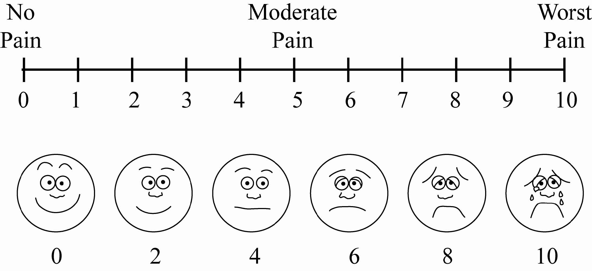

What is intravenous patient controlled analgesia? (IV PCA)

Here are some frequently asked questions about Intravenous patient controlled analgesia (IV PCA)

When will Intravenous patient controlled analgesia (IV PCA) therapy be started?

The Intravenous patient controlled analgesia (IV PCA) pump will be started in the Post Anesthetic Care Unit (PACU) and when you’re fully awake the nurse will remind you how to use it. The pump will go to your room with you when you are ready to leave the recovery area.

How much medication will I receive?

The button may be pushed as often as required in order to make you comfortable enough so that you will be able to deep breath and move with minimal discomfort. Continue to give yourself more medication as needed to maintain this level of comfort once you have reached it.

Can I give myself too much medication?

No. The Intravenous patient controlled analgesia (IV PCA) pump is designed so that you cannot give more medication than your doctor thinks is right for you.

What if I start to feel sleepy?

The pain medication you’ll be receiving has that effect on many people. If you feel sleepy just decrease the number of times you push the Intravenous patient controlled analgesia (IV PCA) button until you feel more awake again.

What if I become uncomfortable?

If your pain medication seems to stop working, even after pushing the button several times and giving the medication a few minutes to work, just call your nurse to check the intravenous (IV). If you are still uncomfortable after the nurse has checked the intravenous (IV), your nurse will notify your doctor and your dose will be adjusted as required.

How long will I be using the Intravenous patient controlled analgesia (IV PCA) pump?

Most patients use the Intravenous patient controlled analgesia (IV PCA) pump for up to 24 hours following surgery. Just remember that everyone wants you to be as comfortable as possible.

Special things you should know while using the Intravenous patient controlled analgesia (IV PCA) pump:

**DO NOT** ask or permit family and friends to push the Intravenous patient controlled analgesia (IV PCA) button for you. It is important that only **YOU** give yourself the medication when you feel you need it.

The medication will be delivered right away and will start to work in a few minutes … please be patient, give it time to work.

When it is time for the Intravenous patient controlled analgesia (IV PCA) to be stopped, you will be switched to pain pills. Ask your nurse for something for pain when you need it.

What should I eat?

Good nutrition promotes healing, helps fight infection and ensures a smooth recovery.

* Eat well with Canada’s Food Guide
* Enjoy a variety of food from all four food groups:
* Vegetables and fruits
* Grain products
* Milk and alternatives
* Meat and alternatives
* Emphasize whole grain cereals and breads.
* Choose **iron-rich foods and a Vitamin C source** at every meal:
* The Vitamin C in juice or citrus fruit helps iron be better absorbed. Iron comes from lean meat (liver, beef and poultry), green vegetables, dried fruit, whole grain breads and cereals.
* Choose iron boosters such as: Cream of Wheat™, All-Bran™, Shreddies™, Shredded Wheat™, prune juice, poultry and eggs.
* For healing, include a proteinchoice & a milk product at each meal:
* Protein choices include meat, fish, poultry, eggs, dried beans (baked beans) and nuts (peanut butter).
* Dairy products contain protein and calcium for healing bones: choose from milk, yogurt, cheese & pudding.
* For regular bowels, eat high fiber foods at every meal and plenty of fluids between meals:
* Good sources of fiber are fruits, vegetables and whole grain breads and cereals (All Bran™, Bran Flakes, Shreddies™ and Shredded Wheat).
* Drink 6-8 glasses per day of fluids (not counting tea and coffee) such as water, juice or milk.

What if I’m on a special diet?

Tell your nurse if you have special dietary restrictions and she will ensure your needs are noted on the chart. She can also contact the dietitian if necessary.

What happens when I go home?

Discharge home, according to the Clinical Pathway, is planned for Day 1 which is the day after your operation. You are responsible for your own transportation home. You may require help to do your shopping and house chores from a family member or friend for 4 to 6 weeks after surgery. The social worker is available through the Social Work office (613) 721-4723 to help with arrangements if necessary.

If your staples are not removed prior to going home we will provide you with a staple remover at discharge for you to take to your physician’s office for follow up. You may shower with the dressing on. Once you have finished your shower, remove the dressing and pat the incision dry with a fresh, clean towel. Place a new dry dressing over the incision. You may require a dry dressing for one day, and then leave the incision line uncovered.

Be sure to continue to control your pain with medication. For the first few months you may need more rest than usual. Your body is recovering and the fatigue will lessen as you improve.

What do I do for constipation or gas pains?

Constipation and gas pains may persist for several weeks after the surgery. This is due to certain medications that you were given during and after your surgery. The most effective measures to correct constipation are:

* Gradual increase in dietary fiber intake.
* Make sure that you have adequate fluid intake.
* Be as active as possible.

There are laxatives ordered for you and they can be purchased without prescription once you are discharged. Talk to your Nurse, Pharmacist or Physician.

When should I call the doctor?

Call the doctor promptly if you have any of the following:

* Fever higher than 38oC or 100.4oF for more than 24 hours. Check your temperature daily for the first 2 weeks.
* Increased pain, redness or swelling around your incision.
* Calf tenderness, chest pain or difficulty breathing.
* Any infection. For example: tooth abscess, urinary or vaginal infection. Antibiotics will be ordered to prevent the infection from affecting your abdomen.

If you see your family doctor, be sure they notify your surgeon if the family doctor recommends a treatment for you.

What is deep vein thrombosis?

Deep Vein Thrombosis (DVT) is a blood clot in a deep vein and is a major health concern that should be discussed with your physician.

You may be at risk for developing a DVT for any of the following reasons:

* Recent surgery
* Immobility
* Previous DVT
* Problems with circulation
* Obesity
* Increasing age
* Acute medical illness

DVT’s most commonly occur in the legs, usually the calf. Signs and symptoms to watch for include: calf pain or swelling, redness or discolouration, a knot in the calf that you can feel and that is warm to touch, fever, shortness of breath, rapid heart rate or chest pain.

If you experience any of these symptoms go to the Emergency Department or call 911 for immediate assistance.

What is a urinary catheter?

Your urinary catheter is a thin tube that enters the bladder and is held in place by a tiny balloon filled with water. The urinary catheter continually drains urine from your bladder.

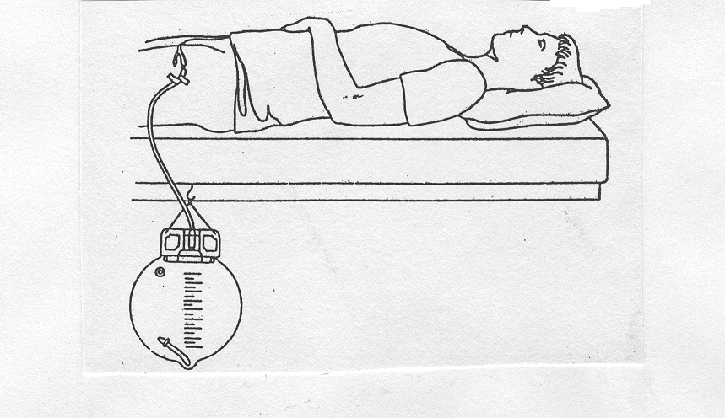

What is a Jackson-Pratt drain?

A Jackson-Pratt is a small rubber bulb which drains fluid from your operative site keeping your bandage dry and clean.

