Gastric Surgery

Patient Information Booklet

Please bring this book to your admission to the Hospital and to all of your appointments

For Information Call

613-721-2000 extension 2920

Between 8:00 a.m. and 4:00 p.m.

Monday to Friday

Introduction

Welcome to Queensway Carleton Hospital.

You are being admitted for Gastric Surgery. The length of your Hospital stay is planned for about 5-7 days.

This booklet is intended to provide you with information to prepare you for your hospital stay and discharge. Your safety and complete recovery is our priority following your surgery. For this reason, we ask you to follow these instructions.

Please use this booklet as a reference tool. Bring this booklet with you to all your appointments and on your day of surgery. Ask questions if there is anything you don’t understand.

The Healthcare Team

Surgeon

Your Surgeon will discuss all aspects of your care including your surgery, recovery, discharge and follow-up. He/She will answer any questions you might have. Your Surgeon will oversee your care with the other healthcare providers.

Anesthesiologist

During your pre-admission appointment, the Anesthesiologist will discuss the anesthetic for your surgery and pain management after surgery.

Nurses

Registered Nurses/Registered Practical Nurses will care for you before, during and after surgery. They will provide emotional support, teaching, medications, and nursing care.

Dietitian

The Dietitian will help you after surgery by reviewing your nutritional needs and teaching you about your post-surgery diet.

Home Care

The Homecare Nurse may meet you a few days before you leave the Hospital to make plans for nursing care at home if needed.

Social Worker

If there are any issues that may make it difficult for you to manage at home a Social worker is available.

All team members involved will assist you with discharge planning.

Gastric Surgery

the gastric systemGastric Cancer

The stomach is a hollow organ that is important for beginning the process of digestion of food. It is located in the upper abdomen and empties into the small intestine. It is surrounded by many lymph nodes.

Cancer of the stomach is a disease in which cancer (malignant) cells are found in the tissues of the stomach. The most common signs of cancer of the stomach are increased fullness with eating and low hemoglobin levels.

Treatment for cancer of the stomach and the chance of recovery (prognosis) depend on several factors. These include, the type of cancer cells, size, location in the stomach, extent of the tumor (whether it is just in the stomach or if it has spread to the lymph nodes or other organs), individual age, general health and feelings about treatment. Cancer of the stomach usually cannot be cured unless it is found in the earliest stages, before it has begun to spread.

**Gastric cancer can be treated by:**

* Surgery (taking out the cancer in an operation)
* Radiation therapy (using high-dose X-rays to kill cancer cells)
* Chemotherapy (using drugs to kill cancer cells)
* Depending on your needs and the extent of the disease, you may have more than one treatment method. You may be referred to Doctors who specialize in different kinds of cancer treatment. Often, specialists work together as a team to plan and carry out your care. The team may include a General Surgeon, Medical Oncologist (chemotherapy specialist), Radiation Oncologist, Nurse, Dietician, and Social Worker.

Surgery

Surgery is a common treatment for cancer of the stomach. The General Surgeon may remove all or part of the stomach in an operation called a Gastrectomy. During the procedure, an incision (cut) will be made in the abdomen. The length of the incision will usually extend from the lower edge of the breast bone to below the belly button. The Surgeon removes the tumor along with a portion of normal stomach, nearby lymph nodes, and other tissue in the area. Usually, it is possible to connect the remaining stomach to the small intestine. If the entire stomach is removed, the small intestine is connected to the esophagus. If a tumor blocks the stomach but cannot be removed, the Surgeon may be able to create a bypass, (a new pathway around the cancer). In some cases, the stomach can be widened and a stent (synthetic tube) placed. This procedure may have to be repeated as the tumor grows.

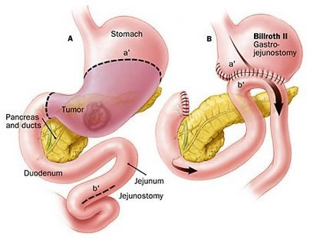

The surgery is performed under a general anesthetic; therefore, you will not be awake. The length of surgery depends on the extent of the disease and may take up to 4 hours.

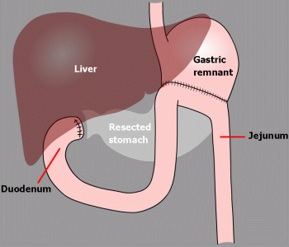 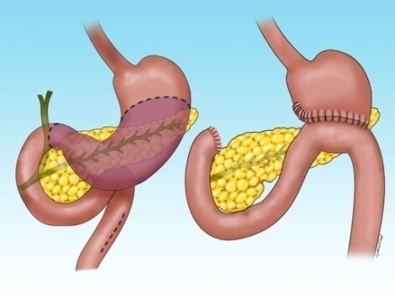

Where do I go for my pre-operative assessment visit?

Report to Queensway Carleton Hospital main lobby Information Desk. You will be directed to the Patient Registration Department to be registered and then to Pre-operative Assessment Clinic (POAC).

When is my appointment?

The Queensway Carleton Hospital Operating Room Scheduling Department will notify you at home of your appointment at Pre-operative Assessment Clinic (POAC).

If you have any questions about your appointment please call the Operating Room Scheduling Department, Monday to Friday, 8 a.m. to 4 p.m. at (613) 721-2000, ext. 2614.

Your date of surgery is: ________________________________________

Call the Queensway Carleton Hospital Operating Room Scheduling Department on the day before your surgery is scheduled to get the time for your admission. The number to call is (613) 721-4840 between 11 a.m. and 3 p.m., Monday through Friday.

Call for your admission time on: _________________________________

(yy/mm/dd)

**On the day of your Pre-Operative Assessment Clinic visit we advise you to purchase 2 scrub brushes of Chlorhexidine 4% soap. They can be purchased at the Queensway Carlton Hospital Gift Box on the main floor next to the front lobby.**

QCH Gift Box Hours

Monday to Friday 9 a.m. to 8 p.m.

Weekends 12 p.m. to 4 p.m.

Two days before surgery

Dietary preparation: Two days before your surgery begin a liquid diet (no solid food). You may have any type of liquid including some oral supplements like: Ensure™, soups, pudding, ice cream, juices, milk, tea and coffee.

Your surgery day

**How do I prepare for my surgery?**

You must follow these rules, or your surgery may be cancelled:

* **Do not eat any solid food after midnight the night before your surgery.**
* **If you are thirsty, you may drink clear fluids until you leave to come to the hospital.**
* **Please drink one cup (250 mLs or 8 oz) clear fluid either apple juice, water or ginger-ale™, before leaving to come to hospital.**

You should take your regular prescription medications (no vitamins or herbal products) with water the morning of surgery as advised by the nurse or doctor you spoke with in POAC. **Bring your medications including any inhalers with you to the Hospital.**

You **must** stoptaking all supplements **except** vitamin D, calcium, or iron/iron supplements one week before surgery.

If you are taking Aspirin or other blood thinners, please inform your surgeon or nurse. You will be given specific instructions.

**Image of body with shaded area showing areas to cleanSkin preparation:**

Stop shaving in the operative area one week (7 days) before your surgery date. Shaving can cause tiny nicks in the skin that may allow germs to enter your body and cause an infection. **Do not use bath scents, powders or body lotions.**

* The night before surgery bath or shower and wash your entire body using the Chlorhexidine sponge. Pat yourself dry with a fresh clean soft towel, put on clean pajamas or clothes and put on freshly laundered bed linens on your bed if you are able.
* The morning of surgery repeat your bath or shower using the Chlorhexidine 4% soap sponges.   
  **(Chlorhexidine 4% soap sponges are available at the QCH Gift Box)**
* If you are a smoker, stop smoking at least 24 hours before your surgery. We can provide you with smoking cessation support to prevent nicotine withdrawal during your hospitalization.
* Do not drink alcohol at least 24 hours before surgery.
* On the day of surgery do not apply deodorant, powders, and body lotions or insert contact lenses. **Please do not wear any scented products because some people are allergic to them.**
* Do not bring valuables (jewellery, credit cards, and money) to the Hospital. We do not assume responsibility for lost or stolen articles.
* Arrange for someone to drive you to the Hospital the day of surgery and drive you home on your discharge day.

What should I bring to the hospital?

PLEASE BRING:

* A knee length dressing gown which opens all the way down the front
* Non-skid slippers
* Comfortable clothing. For example: jogging pants or shorts and a shirt, to wear home
* Toothbrush, toothpaste, soap, shampoo, deodorant, tissue. These items are not supplied by the hospital
* Please label any equipment brought from home with your name
* All your current medications in the proper bottles, including non‑prescription medications
* A list of allergies including the type of reaction

What happens the day of my surgery?

On arrival to the hospital please report to the Patient Registration Department on the main floor. Please bring your health card.

* From Patient Registration you will be taken to the Day Surgery Unit (DSU). A friend or family member can accompany you.
* After you arrive at the changing area in Day Surgery, you will change into a hospital gown. Your clothes will be placed in a bag for later transfer to your room.
* A nurse will complete the paperwork for your admission to the hospital.
* A nurse or ward assistant will take you to the Operating Room.
* You will talk to your anesthesiologist and surgeon in the waiting area. The nurse, anesthesia assistant, or anesthesiologist will start an intravenous by inserting a small needle into your arm or hand. Medication and intravenous fluids are given through this needle. You may receive a spinal anesthetic.
* Your operation can last 1 1/2 hours.
* After your surgery, you will go to the Post Anesthetic Care Unit (PACU) for monitoring.
* The nurse will check your blood pressure, pulse and operative site frequently.
* You may have oxygen provided.
* If you feel any pain or nausea, inform the nurse. You will be given medication to help this.
* You may be drowsy after the surgery, as you become more alert, we will encourage you to do deep breathing and ankle exercises. These exercises will help to prevent complications
* You will be transferred to your room when the nurse determines it is safe to move you.
* After your surgery you will awaken in the Post Anesthetic Care Unit (PACU) where you will stay until your condition is stable. Visitors are not permitted in Post Anesthetic Care Unit (PACU)**.**
* Your family will be able to visit you after you are admitted to your room. They can also bring any extra personal toiletries and clothing at this time.
* Flowers should be kept to a minimum and exclude lilies or other strong scented flowers.

After surgery

Assessments

The Nurse will check you often to ensure that you are comfortable and progressing well. Your temperature, heart rate, blood pressure, and abdominal dressing are checked. The Nurse will also listen to your lungs to check your breath sounds and your abdomen to check your bowel sounds. You will also be asked about “passing gas” and bowel movements.

Intravenous

You will have an intravenous (IV) to replace your fluids until you are able to drink and eat well. Do not pull on the intravenous (IV) tubing. When you are walking, use your hand that does not have the intravenous (IV) to push the pole.

Nasogastric tube (NG)

You will have a tube placed down your nose and into your stomach. This Nasogastric tube (NG) tube drains fluid from your stomach while you are healing and will be connected to a wall suction. The tube is usually removed after a few days.

Urinary catheter

You will have a urinary catheter to drain urine from your bladder. The Nurse will clean the insertion site of the catheter until it is removed. The Nurse will remove the catheter after a couple of days.

Operative site

You will have an incision (cut), which usually extends from the lower part of your breast bone to below your belly button. The incision is usually closed with staples and protected with a dressing. The bandage is usually removed after a few days.

Oxygen

Oxygen is an important part of the air we breathe. Sometimes the body may require extra oxygen. These reasons may include the demands of surgery, lung disease, and heart disease. Extra oxygen can help restore normal oxygen levels in the blood and body tissues and reduce the workload of the heart and lungs. During your Hospital stay, you may receive extra oxygen. This is given through a mask placed over your nose and mouth or small tubes placed in your nostrils (nasal cannulae).

The amount of oxygen in your blood is tested by placing a small clip on your finger. This is called pulse oximetry. This test is used to check that your body is getting the right amount of oxygen. When you no longer need extra oxygen, it will be removed.

Pain management

Pain management is very important for a quick and speedy recovery.

Pain scale ruler

Your nurse will ask you to rate your pain on either the number or FACES scale (see below). Pain is rated from 0 (no pain) to 10 (worst pain).

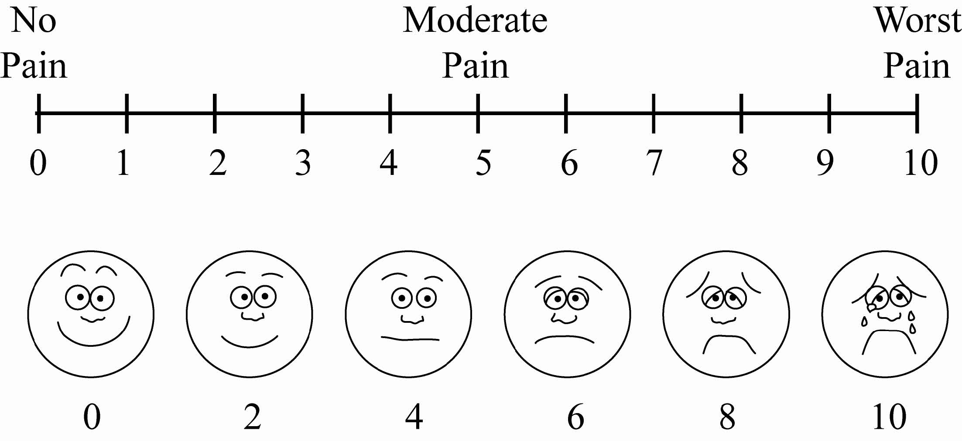

Deep Vein Thrombosis (DVT)

May be a complication of surgery. Deep vein thrombus (DVT) is a blood clot (thrombus) that may develop in a deep vein, usually in the leg. This can happen if the vein is damaged or if the flow of blood slows down or stops. A deep vein thrombus (DVT) can cause pain in the leg and can lead to complications if it breaks off and travels in the blood stream to the lungs. When a clot forms it can either partially or totally block the blood flow in that vein.

Symptoms of a deep vein thrombus (DVT) include:

* Swelling of the leg
* Warmth and redness of the leg
* Pain that is noticeable or worse when standing or walking

These symptoms are not always a sign of a deep vein thrombus (DVT), but anyone who experiences them should contact their Doctor immediately or go to the nearest Emergency Department to be assessed. Your Doctor will take steps to reduce your risk of developing a blood clot while you are in the hospital. These may include one of the following:

* Blood thinning medication in the form of a daily injection
* Walking
* Ankle and leg exercises

Your Doctor will advise you if you are to go home with blood thinners.

Protecting your skin from pressure ulcers

Are you at risk for developing a pressure ulcer (bed sore)? A pressure ulcer is a sore that develops, usually from sitting or lying in the same position for long periods of time or from sliding down in the bed. It is most often seen over the tailbone and heels. Some of the key things that can be done to help prevent these sores are to:

* Avoid sitting in bed with the head of the bed higher than 30 degrees for long periods of time.
* Reposition yourself or ask for help, about every 2 hours.
* Use pillows under your legs, to avoid having your heels directly on the bed.

Moving and positioning

It is important to move and re position yourself while you are in bed. Move every 2 hours while awake.

* Support your incision with a small blanket or pillow.
* Bend your knees and roll from your non-operative side to your back.

Getting out of bed

* Roll onto your side and bring your knees up towards your abdomen.
* Place your upper hand on the bed
* below your elbow**.**
* Raise your upper body off the bed by pushing down on the bed with your hand.
* Swing your feet and legs over the edge of the bed and bring your body to a sitting position.
* Once in the sitting position, take a few breaths and ensure your balance is good before attempting to stand.
* Slide your bottom to the edge of the bed.
* Stand up keeping your back as straight as possible.
* When getting back into the bed, reverse the process.

Person with knees up towards their abdomen  
Person raising upper body from bedPerson sitting upright on bedWhat are ankle exercises and deep breathing exercises?

Ankle exercises:

Point your toes toward your head, then towards the foot of the bed. Make your feet go around in circles 5 times. This should be at least every hour while you are awake.

Deep breathing exercises:

Take a deep breath in through your nose and slowly blow out through your mouth. Repeat this 3 times. This should be done every hour while you are awake for the first day, then every 2 hours for the next 1-2 days.

Arm and shoulder exercises:

* Sit with your hands on the top of your shoulder tips and circle your elbows.
* Sit and lift arms sideways (elbows straight; palms facing ceiling) and reach for the ceiling.
* Lift arms in front of you above your head (elbows straight) while breathing in. Lower arms slowly while breathing out.
* Sit or stand with arms loose or crossed in front of you. Slowly lift arms up, out to the side and back.
* Sit; bend forward moving head toward knees, then return to a sitting position.
* Sit with arms crossed in front of you, hand on shoulders. Turn body to the right and left.

Discharge planning

When you are discharged from the Hospital, you may need some help at home. It would be best to arrange for this before being admitted to the hospital. Arrange for someone to pick you up at 10:00 a.m. on the day of discharge. If you think you will have problems at home, discuss them with your Nurse or Social Worker. You will receive a follow up Doctor’s appointment and a prescription for medication.

Be sure you understand your:

* Medications
* Exercise program
* Diet
* Incision care
* Any restrictions regarding your surgery
* When to call the Doctor for symptoms
* Follow up appointments
* Preventing falls at home

Going home

#### 

Activity

* Continue with the shoulder/arm exercises, deep breathing exercises, and walking as discussed with your Physiotherapist.
* Take frequent rest periods as necessary. Let your body be your guide.
* Do light activities for 2 weeks. Avoid strenuous exercise including heavy lifting, lifting grocery bags, shoveling snow, or pushing a lawn mower until you have seen your Doctor on your follow-up visit.
* Increase your walking distance each day.
* Do not drive a vehicle for at least 2 weeks. You may resume driving after two weeks if you are comfortable with this, and no longer on pain medication.

#### 

Medications

* Take your pain medication as required. It is normal to experience some incision discomfort for a period of time after discharge.
* To avoid constipation (a side effect of many pain medications), add water-soluble fiber to your diet (e.g. bran, whole grains, fruit). If constipation is a problem, you may take a mild laxative.
* Do not drive a vehicle if you are taking narcotics. (e.g. Tylenol #3™, Hydromorphone, Percocet™).
* Resume your regular medications.

Operative site

* Shower or take a bath as you prefer. Avoid hot tubs, Jacuzzis and saunas. Soaking in a tub for long periods may delay healing of your incision. Clean your incision with mild soapy water. Pat incision dry.
* Swelling or bruising may appear around the incision. This may continue for several weeks.
* Observe the incision for increased redness, tenderness, drainage, and open areas. Notify your Doctor if any of these occur.
* Wear loose clothing while incision is still tender.
* Swelling or bruising around the incision is common and will go away with time.

Post-Gastrectomy Diet

When starting to eat, you will begin taking a clear fluid diet for a day and progress to a post-Gastrectomy diet. It is recommended that you follow the post-Gastrectomy diet for 6 to 8 weeks following your surgery.

The following guidelines are provided to help you manage symptoms you may experience after a Gastrectomy.

To control fullness

* Eat small frequent meals for example: 6 small meals per day instead of 3 main meals.
* Drink liquids on their own instead of with meals.

To control diarrhea:

* Eat only until you feel satisfied that you are full.
* Avoid food with large amounts of sugar, for example: ice cream, milk shake etc.
* Avoid foods that are natural laxatives, for example: prunes, fig, flax and licorice.
* Eat slowly, take small bites and chew your good well.
* Drink liquids on their own instead of with meals; i.e. 20-30 minutes after meals.

To control reflux:

* Remain sitting for 45 minutes after eating or drinking.
* Avoid eating or drinking 2 hours before going to bed.
* Do not lie flat when resting or sleeping. Elevate the head of your bed or use pillows.
* Eat smaller amounts of food more often throughout the day to avoid over-filling your stomach.
* Avoid spicy and acidic food; i.e. black pepper, hot peppers, citrus. fruits/juices, tomato-based products.
* Avoid alcohol and smoking.

To avoid weight loss:

Weigh yourself weekly. If you are losing weight, call the Dietitian who followed you during your hospital stay or who is following you in the community to know how to increase your caloric intake.

Post-Gastrectomy diet guidelines

Food should be soft and moist and be cooked thoroughly. Adding sauces and/or gravies to foods is recommended. Take small bites and chew well to turn food into a smooth paste or puree. Avoid eating very hot or very cold food.

Keeping a healthy weight after your gastric surgery

Dumping syndrome can make it hard to keep weight on. If you are losing weight:

* Try sugar-free nutritional supplements. Liquid supplements with added sugar may not be well tolerated.
* Eat protein foods and fats first. If you can’t eat everything at your meal, leave the lower calorie foods.
* Make every bite count: use full fat dairy products, add butter, oil, gravy, cheese sauce, and dressing to foods.
* Drink beverages with calories. While soda and sweet tea will likely make dumping syndrome worse for you, whole milk, and unsweetened juices are great sources of calories to sip. Look for lactose-free versions if needed.
* Discuss your weight loss with your Doctor and Registered Dietitian.

|  |  |  |
| --- | --- | --- |
| Food group | Good choices | Foods to avoid |
| **Breads and grains** | Whole wheat breads, buns, pasta, crackers, unsweetened cereals, rice, pasta | Sweetened cereals, donuts, cakes, sweet rolls, pastries |
| **Meats and other protein foods** | Any meat, poultry, deli meats, eggs, tofu, peanut butter | None |
| **Dairy foods** | Milk, yogurt, cheese, cottage cheese, sugar-free ice cream | Chocolate milk, any flavored milk, ice cream |
| **Fruits** | Fresh fruit, canned fruit without heavy syrup or added sugar, frozen fruit | Dried fruit, fruit canned in sugar/heavy syrup, sweetened fruit juice, canned pie fillings |
| **Vegetables** | Any fresh, frozen, or canned vegetables | None |
| **Drinks** | Water, unsweetened tea, tea made with artificial sweetener, coffee, diet soda, sugar-free beverages | Soda, chocolate milk, fruit drinks, sweetened fruit juice, sweet tea, all beverages at meals. |

Drink fluids 30 minutes before or after meals

Other nutrition issues after stomach surgery

Your body may not be able to use all of the vitamins and minerals that you eat after a partial or complete stomach removal. These may include B12, folate, iron, vitamin D, calcium. You need all of these to stay healthy. Your Doctor or Registered Dietitian may tell you to take vitamin and/or mineral supplements after your surgery, and it is very important that you follow these instructions. Ask your Doctor or Registered Dietitian if you have questions about your nutrition needs.

Post Gastrectomy sample diet

|  |  |
| --- | --- |
| **Breakfast**  ½ grapefruit  ½ whole wheat bagel  1 tablespoon cream cheese  milk  **Snack**  2 slices cheese and six crackers  apple slices  **Lunch**  grilled chicken  ½ cup green beans  fruit cup  sugar-free beverage | **Snack**  ½ turkey sandwich with mayonnaise  **Dinner**  hamburger on small bun  small salad with 2 tablespoons salad dressing  milk  **Snack**  2 tablespoons peanut butter on graham crackers |

**Call your Surgeon if you have any of the following:**

* Chills or fever (temperature greater than 38°C/100.4°F).
* Increased discomfort, redness, swelling, drainage or separation of the incision.
* Nausea, vomiting, constipation, abdominal swelling.
* Difficulty/discomfort passing urine.
* Chest pain, or difficulty breathing.
* New or unexplained symptoms.

**If unable to reach your Doctor, please go to the nearest Emergency Department.**

Follow-up appointment

Expect to see your Doctor in 2-4 weeks. If you are unable to keep your appointment, please telephone in advance. Call to book a follow up appointment unless you have been given one.

**References**

The Ottawa Hospital 2008 Esophageal Surgery Patient Information

[www.ottawahospital.on.ca](http://www.ottawahospital.on.ca)

University of Virginia 2012 Gastrectomy diet

[www.virginia.edu](http://www.helathsystem.virginia.edu)