Post-Operative Instructions for Arthroscopic Knee Surgery

Patient Information Booklet

Please bring this book to your admission to the Hospital and to all of your appointments

For Information Call

613-721-2000 extension 2920

Between 8:00 a.m. and 4:00 p.m.

Monday to Friday

Introduction

Welcome to Queensway Carleton Hospital.

You are having an outpatient day surgery procedure. The plan is for you to be discharged home on the same day as your surgery.

Please use this booklet as a reference tool. Bring this booklet with you to all your appointments and on your day of surgery. Ask questions if there is anything you don’t understand.

**PLEASE BRING YOUR BOOKLET TO THE HOSPITAL** as the healthcare team members will refer to these instructions throughout your hospital stay.

This sheet will provide information about your surgery to your Physiotherapist and/or Doctor. Keep a copy for your records.

Surgery date:

Your surgery was:

🞎 Knee Arthroscopy

🞎 Partial meniscectomy _______ Medial ________ Lateral

🞎 Meniscus repair

*No running, no jumping, no impact activity, no deep squats for 4 months

**🞎 Debridement (chondropathy grade)**

* Medial ( )
* Lateral ( )
* Patello-femoral ( )

🞎 Excision of loose body

🞎 Excision of plica

🞎 Lateral release

🞎 Medical patellofemoral repair/plication

🞎 Other

**Your physiotherapy rehabilitation restrictions are:**

🞎 **Weight bearing**

🞎 Full

🞎 Partial for _____________ then progress to ___________________

🞎 None for _____________ then progress to ___________________

🞎 **Motion**

🞎 No restrictions

🞎 No range of motion (ROM) for ___________ then _______________

🞎 0–45 degrees for ________________ then ____________________

🞎 0–60 degrees for ________________ then ____________________

🞎 0–90 degrees for ________________ then ____________________

🞎 **Strengthening**

🞎 No restrictions

🞎 As tolerated

🞎 None

🞎 **Modalities**

🞎 As tolerated

🞎 None

🞎 **Resume full activity / running / sports**

🞎 When there is no pain with day to day activity

🞎 Swelling is gone

🞎 Knee is bending and straightening fully

🞎 Not until specified by your surgeon

🞎 **Comments:**

_____________________________________________________________________________________________________________________________________________________________________________________________________________________________________________________________________________________________________________________________________

Your date of surgery is: ____________________________________________

The day before surgery, call the Queensway Carleton Hospital, Patient Scheduling Department at 613-721-4840 between 11:00 a.m. and 3:00 p.m. to have your admission time confirmed.

Preparing for your surgery

You must follow these rules if you are to have your surgery on the scheduled date:

* DO NOT EAT ANY SOLID FOOD AFTER MIDNIGHT THE NIGHT BEFORE YOUR SURGERY OR YOUR SURGERY WILL BE CANCELLED.
* You should drink one cup (250 mLs) 8 ounces clear fluid e.g. apple juice, water or ginger-ale, just before leaving home to come to hospital.

You should take your regular prescription medications with water the morning of surgery. If you use any inhalers bring them with you. Bring your medications with you to the Hospital.

You may also be asked to stop taking medications such as Vitamin E, ginkgo biloba, omega, garlic or ginseng at least one week before surgery. These medications “thin” your blood, which could cause excessive bleeding during and after surgery. Check with your Surgeon.

Other pre-operative instructions:

_________________________________________________________________

_________________________________________________________________

_________________________________________________________________

**On the day of your Pre-Operative Assessment Clinic visit we advise you to purchase 2 scrub brushes of Chlorhexidine 4% soap. They can be purchased at the Queensway Carlton Hospital Gift Box on the main floor next to the front lobby.**

QCH Gift Box Hours

Monday to Friday 9 a.m. to 8 p.m.

Weekends 12 p.m. to 4 p.m.

Skin preparation

Stop shaving in the operative area one week (7 days) before your surgery date. Shaving can cause tiny nicks in the skin that may allow germs to enter your body and cause an infection. **Do not use bath scents, powders or body lotions.**

* The night before surgery bath or shower and wash your entire body using the Chlorhexidine sponge. Pat yourself dry with a fresh clean soft towel, put on clean pajamas or clothes and put on freshly laundered bed linens on your bed if you are able.
* The morning of surgery repeat your bath or shower using the Chlorhexidine 4% soap sponges.   
  **(Chlorhexidine 4% soap sponges are available at the QCH Gift Box)**
* If you are a smoker, stop smoking at least 24 hours before your surgery. We can provide you with smoking cessation support to prevent nicotine withdrawal during your hospitalization.
* Do not drink alcohol at least 24 hours before surgery.
* On the day of surgery do not apply deodorant, powders, and body lotions or insert contact lenses. **Please do not wear any scented products because some people are allergic to them.**
* Do not bring valuables (jewellery, credit cards, and money) to the Hospital. We do not assume responsibility for lost or stolen articles.
* Arrange for someone to drive you to the Hospital the day of surgery and drive you home on your discharge day.

Image of body with shaded area showing areas to clean

Please indicate the name and phone number of the person taking you home below:

Name: _____________________________________

Home phone #: ______________________________

Work phone #: _______________________________

Cell phone #: ________________________________

**NOTE: If you develop a cold or other illness, notify your Surgeon before your operation.**

Jewellery and body piercing removal prior to surgery

It is the recommendation of the Queensway Carleton Hospital that all jewellery, including body piercing and wedding rings, be removed prior to surgery.

The known risks of leaving in jewellery or body piercing in place during surgery may include:

* Injury from a burn if the electro-surgical unit is used during surgery.
* An increased risk of infection if the jewellery is near the surgery site. Jewellery harbours bacteria.
* Possible restrictions of blood flow by the jewellery/body piercing from tissue swelling near the surgical site following surgery.
* An increased risk of injury at the jewellery/body piercing if the jewellery or body piercing becomes tangled in the patient gown or sheets during positioning for surgery or when being transferred to the stretcher after the surgical procedure.
* An increased risk of injury during anesthetic if the body piercing is in the nose, tongue or mouth (these MUST be removed).
* Body piercing can be removed by the “body piercing store”.

If you choose to accept these risks and arrive for your surgical procedure with the jewellery or body piercing in place, there is a possibility that your surgery will be cancelled by the Anesthesiologist or Surgeon depending on the location of the jewellery/body piercing.

If you choose to accept these risks and decide to keep your jewellery/body piercing for the procedure and the surgery proceeds, it will be documented on your chart that you were aware of the risks and that you will assume the responsibility for any negative outcome.

Arrival at Hospital

Report to Patient Registration on the main floor. Bring your Ontario Health Card with you.

* From Patient Registration, you will be taken to the Day Surgery Unit.
* You may be accompanied to the Day Surgery Unit by one care partner/family member who may remain with you until you go to surgery.
* You will be required to change into a hospital gown.
* A Nurse will complete your preparation for surgery.
* You will talk to your Anesthesiologist about types of anesthesia for your procedure and your Surgeon in the Day Surgery Unit. The Nurse, Anesthesia Assistant or Anesthesiologist will start an intravenous by inserting a small needle into your arm or hand.
* An Operating Room Nurse or Ward Assistant will accompany you to the Operating Room.

After surgery

* After your surgery, you will go to the Recovery Room for monitoring.
* The Nurse will check your blood pressure, pulse and operative site frequently.
* You will have an intravenous (IV).
* You may have an oxygen mask on temporarily.
* If you feel any pain or nausea, inform the Nurse. You will be given medication to help this.
* You will be transferred to the Day Surgery Unit when the Nurse determines it is safe to move you.
* You should have one designated care partner/family member stay at your bedside in the Day Surgery Unit. You and your care partner will receive your post operative instructions together for your discharge preparation.
* If your care partner has not remained at the hospital, they will be notified when you are ready for discharge.
* The Day Surgery Nurse will give you all your post-operative instructions before you leave the Hospital.
* A Day Surgery Nurse may call you the day after your surgery.

Leg exercises

You may be drowsy after the surgery, as you become more alert, we will encourage you to exercise. The following leg exercises will help to prevent complications.

Point your toes towards your head, then towards the foot of the bed. Make your feet go around in circles 5 times.

This is done 4-5 times a day until you are walking.

Deep breathing and coughing exercises

Take a deep breath in through your nose and blow out through your mouth. Repeat this 3 times. On the third breath, cough 2 to 3 times.

This is done every 2 hours for the first day and then every 4 hours for the next 1-2 days.

GENERAL POST-OPERATIVE INSTRUCTIONS

We want your recovery to be safe and as comfortable as possible. For this reason, we suggest that you comply with the following advice:

* You should have someone with you for the first few hours upon returning home.
* You must not drive a car or operate machinery for at least 24 hours after the procedure.
* You should limit activity requiring full concentration: e.g. making important personal or business decisions, as full mental alertness may not return for several hours.
* You should not drink any alcoholic beverages for at least 24 hours following your procedure as alcohol may influence the effects of the drugs you have been given.
* You should eat lightly for the first meal following your procedure.
* You should take it “easy” for a day or two.
* If you have any problems or are concerned about your condition for any reason, please contact your Surgeon through his/her office or follow the directions on your Surgeon’s message machine regarding reaching another Surgeon.
* If you are unable to contact your Surgeon or the Surgeon covering his/her practice, come to the Emergency Department of the hospital where you will be seen by an Emergency Physician.

Return appointment reminder

DATE: _________________________

TIME: __________________________

LOCATION: □ QCH Admitting Department

□ Doctor’s office

□ Other:

**YOUR DRIVE HOME MUST BE AVAILABLE FOR THE ENTIRE DAY OF YOUR SURGERY**

Please give these instructions to your designated driver.

Please remind your designated driver they are to be available for the entire day of your surgery and to ensure they keep their phone on and ready to receive the call from the Day Surgery Unit informing them of the time to pick you up.

Pick up information

The care partner/family members are encouraged to remain at the hospital.

Inside the James Beach Health Care Centre entrance door is a wall mounted telephone on the right-hand side with the phone number to the Day Surgery Unit. Please pick up the phone and dial 2912 to let them know you have arrived. You may then return to your car.

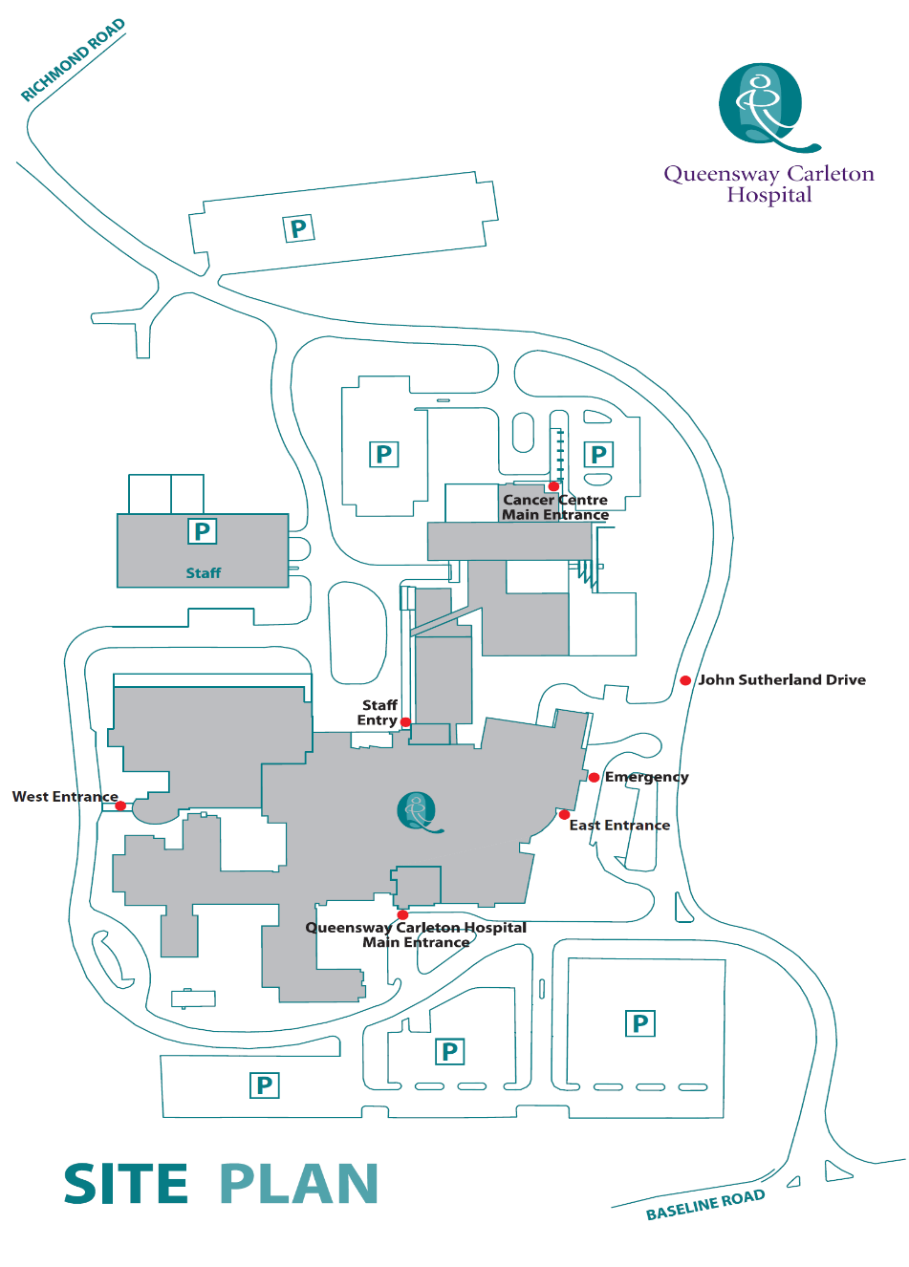

**James Beach Health Care West Entrance (patient pickup)**

**Main Entrance** **(patient drop off)**

Post-operative dressing

If you are a Day Surgery patient, you will probably need some sterile dressings and tape at home after your surgery.

* We advise you to purchase these supplies before your surgery.
* We suggest that you get a small package of sterile 4” X 4” gauze pads and a roll of tape at the drugstore before your surgery.
* Other: ______________________________________________________

If you have any questions about the dressing type to purchase, please check with your Nurse in the Pre-Operative Assessment Clinic.

Pain scale ruler

What is a pain scale ruler?

A pain scale ruler is a simple tool to measure how much pain you are having. Each Nurse will use this ruler to measure your pain.

Why do we measure your pain?

We measure your pain frequently so that we can be sure your pain medication is working.

What does a pain scale ruler look like?

One side of the ruler has numbers from 1 to 10. The other side has colors from white to deep red (shown here in shades of grey).

How does our pain scale ruler work?

Our ruler measures pain in two ways – by number or colour.

**By number:** the ruler is numbered from 0 to 10, with 0 being no pain and 10 being the most severe pain you can imagine.

**By colour:** the ruler is coloured from white to deep red, with deep red being the most severe pain you can imagine. (Shown in this example as shades of grey).

The Nurse will show you the ruler and ask you to choose a number or colour.

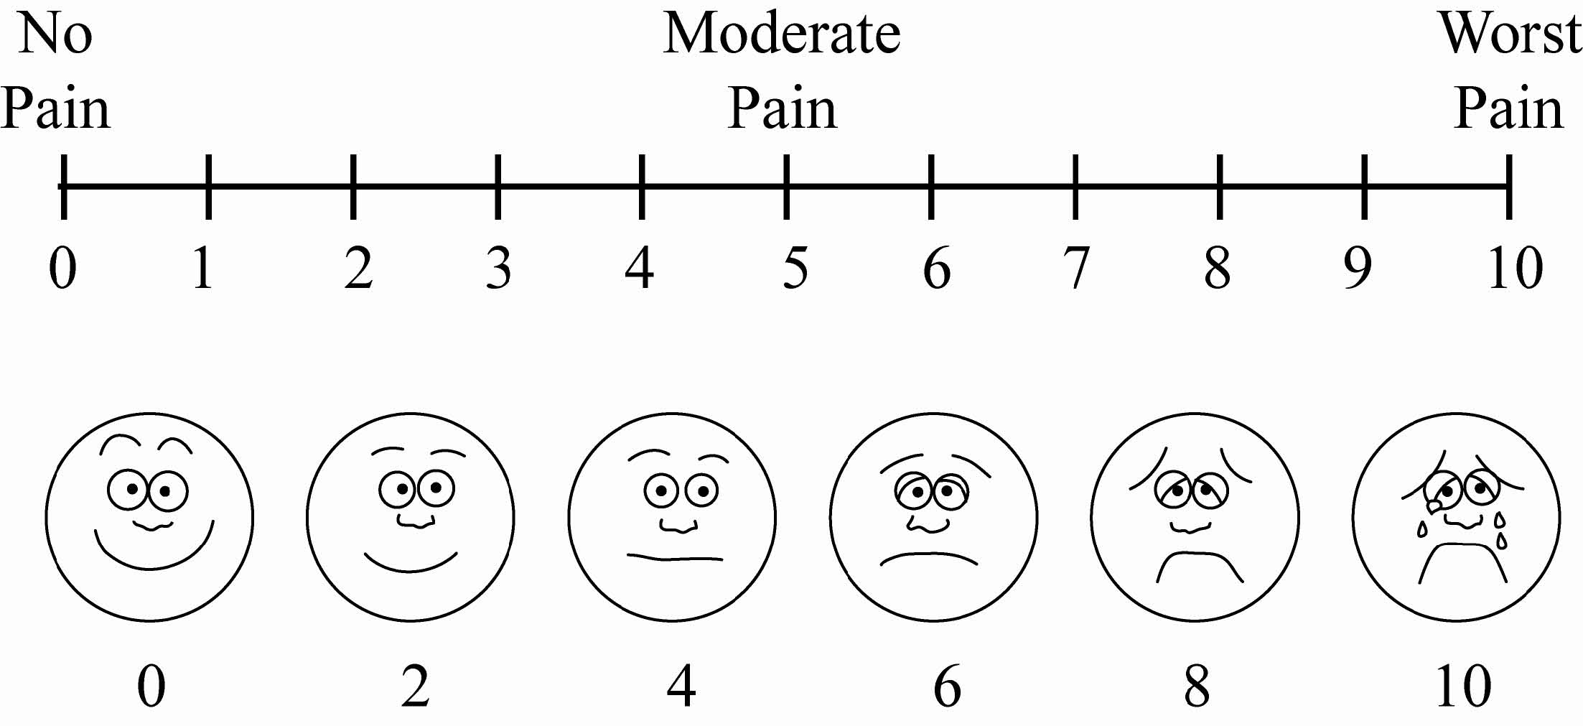

Pain:

Upon discharge, you will be given a prescription for pain medication(s). Please take the pain medication with food and as directed. Elevate the leg and apply ice pack or cold gel pack regularly (keeping dressing dry). Do not drink alcoholic beverages or drive if you are using pain medications.

Operative site:

A dressing has been applied to your incision which consists of bandage, gauze, and skin tapes next to the skin itself. Keep the dressing dry. You may shower 2 days after your surgery, during which the outer dressing may be removed. Do not remove the tapes on the skin. Rewrap the tensor bandage snugly after showering.

Follow the activity directions below UNLESS OTHERWISE SPECIFIED BY YOUR SURGEON:

Activity:

Put as much weight on the leg as is comfortable unless otherwise specified by your surgeon.

Additional activity information:

* Crutches are for comfort only. Stop using them as soon as you are comfortable walking without them unless specified otherwise by your Surgeon
* Gently bend and straighten the knee as often as possible
* Gentle stationary biking (low resistance) is a good way to rehabilitate your knee
* Avoid high impact activity (jogging) until allowed by your Surgeon
* Other: _______________________________________________________________________________________________________________________________________________________________________________________

Diet:

Restrict yourself to a light diet as tolerated on the day of your surgery. The next day resume your normal diet as tolerated with extra fiber and fluids as pain medications have a tendency to cause constipation.

Follow up:

Your follow-up appointment will be made approximately one to two weeks after your surgery. Physiotherapy may be started prior to your appointment depending on swelling, pain, and surgery performed. Your Surgeon will advise you regarding physiotherapy.

Additional information:

Call your Surgeon immediately or go to the nearest Emergency Department if you have any of the following:

* Excessive drainage through your bandage
* Severe pain not relieved with your pain medication
* Signs and symptoms of infection
* the incision is red
* the knee is hot and swollen
* yellow/green or foul-smelling discharge from the incision
* Fever greater than 38oC or 100.4oF lasting more than 24 hours

Notes:

______________________________________________________________________________________________________________________________________________________________________________________________________________________________________________________________________________________________________________________________________________________________________________________________________

Post-operative exercises

Half-leg prop

Elevate your leg by placing a cushion underneath your lower leg or heel. While the leg is elevated, you may also bend your ankle, so your foot moves up and down or in circles. Do this 4-8 times per day for 15-20 minutes. You may also sleep with your leg elevated.

Quad set

Squeeze thigh muscles tightly, as if pressing the back of your knee into the surface you are lying on top of. Hold contraction for 10 seconds, repeat 30 times. Do this 4-6 times per day.

Straight leg raises, flexion

Squeeze thigh muscles tightly, then lift leg from the surface. Raise and lower your leg slowly. Repeat 15-30 times. Do this 4-6 times per day.

Straight leg raises, adduction

Squeeze thigh muscles tightly, then lift leg from the surface. Raise and lower your leg slowly. Repeat 15-30 times. Do this 4-6 times per day.

Straight leg raises, abduction

Squeeze thigh muscles tightly, then lift leg from the surface. Raise and lower leg slowly. Repeat 15-30 times. Do this 4-6 times per day.

Straight leg raise, extension

Squeeze thigh muscles tightly, then lift leg from the surface. Raise and lower leg slowly. Repeat 15-30 times. Do this 4-6 times per day.

Assisted knee flexion

When seated in a chair, allow your knee to bend a comfortable amount. Use your other foot to control how your knee bends, and to straighten it. The time you keep your knee bends depends on your level of comfort. This may be done periodically during the day.

Calf stretch

Using a towel or a belt, gently stretch your calf muscles as pictured. Keep your knee straight. Hold stretch for 20-30 seconds. Do this 4-6 times per day.