PATIENT CARE SERVICES
Epidural Analgesia Patient Information Sheet

Part of your pain management for your upcoming surgery may involve the use of an epidural. An epidural (or epidural analgesia) is a form of pain control that is often used because pain relief can be targeted to the surgical site - which controls pain well, has fewer side effects, and shortens recovery time.

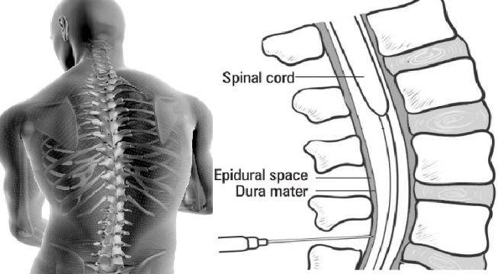
What is an epidural?
An anesthesiologist (a physician who
Used with permission from Pasero & McCaffrey ©

Pasero, C, McCaffrey, M, Pain Assessment and Pharmacologic Management, Elsevier Mosby, 2011.

specializes in the care of patients
undergoing and recovering from surgery)
inserts a very thin needle into an area
in your back called the epidural space.
A thin plastic tube called a catheter is
then threaded through that needle. The
needle is removed and the catheter is
secured into place with a dressing.

The catheter is then used to deliver pain medication and local anesthetic into the epidural space. The local anesthetic, commonly called “freezing”, soaks the nerves in the epidural space blocking nerve signals, including pain. The location of catheter placement will determine the area where the pain will be blocked.

What are the side effects?
- Common side effects of epidural pain medication could include nausea and vomiting, itching, or a drop in your blood pressure. These side effects can be treated with additional medication or adjusting your epidural dosing.
- Less commonly, you may experience either dizziness, difficulty breathing, change in bladder and bowel habits,or numbness or weakness in your legs and feet. Often lowering the amount of epidural medication being given will relieve these symptoms.
- Rarely, people may experience headache, a metallic taste in their mouths, or numb lips or tongue. These are signs that you’re getting more epidural medication than your body can handle.
Make sure to tell your nurse if you are having any of the above warning signs.

CONTINUED ON OTHER SIDE
Information is available in alternate formats upon request

In order to monitor you for these side effects, your nurse will be checking on you frequently. They will measure your vital signs and screen you for problems.

How does epidural analgesia work?
- Pain medication is given through the catheter at a steady rate using a pump at your bedside. The right dose of medication will block the pain but will preserve your ability to feel and move your arms and legs. Too little medication will not manage your pain.

What are the benefits of having an epidural?
Pain can be managed for longer periods of time and can be targeted more precisely. Overall, you will need less pain pills and injections, which will reduce their undesirable side effects. Epidurals also help reduce risk for people with heart and lung problems.

What are the risks for having an epidural?
Serious complications are rare. Infection or bleeding may develop where the needle has entered into the epidural space. This can cause pain at the site of the epidural due to pressure on the spinal cord, which could lead to changes in your bowel or bladder habits and numbness or weakness in your legs and feet. Inform your nurse immediately if you experience any of these symptoms.

When can I start moving?
- After your surgery, and provided your pain is managed, your nurse will assess if you are ready to get up and move. You epidural should not stop you from your typical after-surgery activities.

Who will look after my epidural?
Your nurse will check on you often to look for any of the mentioned side effects.
Part of their routine is to:
- Ask you about your pain levels to make sure you are comfortable
- Check your vital signs (blood pressure, temperature, heart rate, oxygen levels)
- Check the area on your back at the epidural site to look for any swelling or leaking
- Test your arms and legs to ensure you are able to move
- Test your sensations of hot, cold, sharp and dull
An anesthesiologist will be available if any changes in your medicine need to be made and can be called by your nurse.

How long does the epidural stay in?
Your epidural can stay in for 2-4 days
- Once your pain is well controlled and you are ready to try drinking, eating and moving around your epidural can be removed.

- Your epidural pain medication will be slowly reduced and you will be given pain medication by mouth and through injections instead.
- The nursing team will be responsible for removing your epidural catheter - it slips out easily once the dressing is removed.
- An adhesive bandage may be placed on the spot where the epidural was inserted.

