

**SHOULDER SURGERY**

**Total Shoulder Arthroplasty**

**Partial Shoulder Arthroplasty**

**Reverse Arthroplasty**

**Shoulder Arthroscopy**

**Bicep Tendon Repair**

**Rotator Cuff Repair**

**Patient Information Booklet**

**Please bring this book with you to your admission to the Hospital and to all appointments**

**TABLE OF CONTENTS**

Welcome to Queensway Carleton Hospital 4

Shoulder Anatomy and Shoulder Replacement Surgery 5

Preparing for your Shoulder Surgery 8

QCH’s Pre-habilitation Program 8

Pre-Operative Assessment Clinic 9

When is my pre-operative appointment 11

Equipment List 11

Will I need to see a social worker? 15

Care Partner & Visitor Policy 15

Health tips before surgery 16

Pre-Surgery home set-up 16

Final check list: One day before surgery 18

Preparation for surgery 19

What should I bring to the hospital 20

Day of Surgery 21

After Surgery 22

Recovery Room/Post Anesthetic Care Unit (PACU) 22

Length of your hospital stay 23

Pain Management after Surgery 23

General post-operative instructions 24

Return appointment reminder 25

Pick up information 26

What happens when I go home 27

Operative site 28

Caring for my incision 28

Diet 28

Activity 29

Restrictions to Follow After Your Surgery 29

Sleeping 31

In the kitchen 34

Personal care 35

Physiotherapy 35

Physiotherapy home exercises 36

Complications 36

Follow-up 39

Shoulder Care Plan 40

Appendix 1 42

Neck Exercises 42

Shoulder & Elbow Exercises 42

Forearm, Wrist and Hand Exercises 44

Appendix 2 46

Peri-Care Assist Options 46

Appendix 3 50

Sling 50

Appendix 4 52

Putting on a front buttoned shirt 52

Putting on a t-shirt or knit shirt 53

Taking off the shirt 56

Putting on socks 56

Putting on shoes 57

Appendix 5 58

Bathing/Showering 58

For information call

Before your surgery:

Contact your surgeon’s office or Pre-Operative Assessment Clinic

613-721-2000 ext. 2920 between 8:00 a.m. to 4:00 p.m. Monday to Friday

After your surgery:

Contact your surgeon’s office

# Welcome to Queensway Carleton Hospital

Queensway Carleton Hospital (QCH) is a patient and family-centered hospital providing a broad range of services through the dedicated care of healthcare professionals. We look forward to helping you throughout your hospital stay. Please be sure to ask any questions you may have at any time.

Please refer to our Patient Handbook for more information about QCH and what you need to know as a patient while you are here. This booklet will focus specifically on your upcoming soft tissue shoulder surgery.

**IMPORTANT: If your surgeon or healthcare team gives you different recommendations than what has been provided in this booklet, please follow directions from the surgeon or healthcare team.**

This booklet is intended to provide you with information to prepare you for your hospital stay and discharge. Your safety and recovery is our priority following your surgery. For this reason, we ask you to follow these instructions. **PLEASE USE THIS BOOKLET AS A REFERENCE TOOL FOR ALL DATES AND TIMES AND BRING THIS BOOKLET WITH YOU TO ALL YOUR APPOINTMENTS AND ON THE DAY OF YOUR SURGERY.**

Your hospital stay will follow a plan of care called a “Standardized Care Plan”. In this booklet you will find information about your surgery and the patient version of the soft tissue shoulder surgery. It has been prepared so that you, your family, and all members of your healthcare team know your plan of care, including what tests, treatments and diet you require as well as the education and planning necessary for discharge.

The patient version of the soft tissue shoulder surgery booklet gives you an idea of what to expect from surgery until discharge.

# Shoulder Anatomy and Shoulder Replacement Surgery

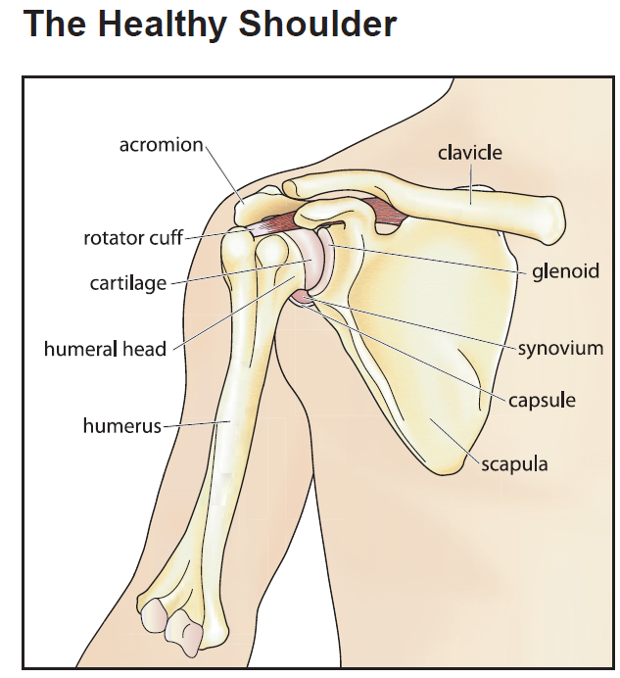

Used with permission by Allina Health System

Your shoulder is one of the most mobile joints in your body. This flexibility allows you to move your arm in many positions: to the front, above, to the side and behind your body.

Your shoulder has a lot of flexibility because it is a ball and socket joint. It is made up of three bones:

* upper arm bone (humerus)
* shoulder blade (scapula)
* collar bone (clavicle)

The ball at the top end of the arm bone fits into the small socket (glenoid) of the shoulder blade. This forms the shoulder joint (glenohumeral joint).

The ball and socket are covered with a smooth surface called articular cartilage. This surface allows the smooth motion of the shoulder joint.

The shoulder joint is also made up of ligaments, muscles and tendons.

The **joint capsule** is a group of ligaments. It surrounds the shoulder joint. The joint capsule allows a wide range of motion and helps hold the ball in the socket.

The **rotator cuff** is a group of four muscles and tendons that attach the ball to the socket. The muscles of the rotator cuff surround the shoulder joint and sit just outside of the joint capsule. The muscles attached to the rotator cuff help you to lift and rotate your arm, reach overhead, and take part in activities such as throwing or swimming.

The **bursa** is a sac-like membrane found on top of the rotator cuff. It cushions and helps lubricate the motion between the rotator cuff and surrounding bones.

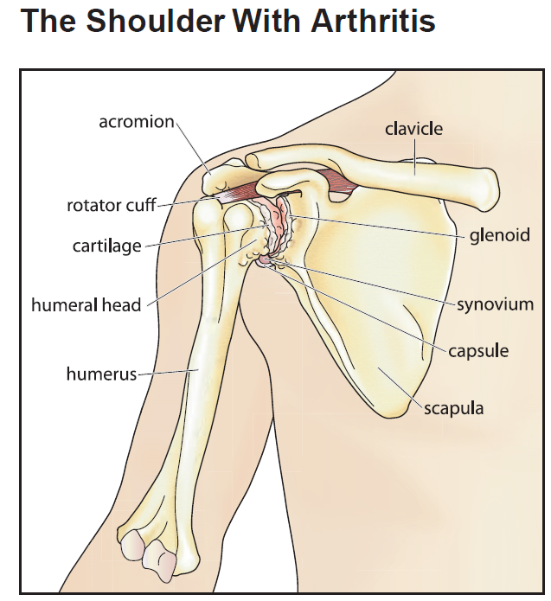

Used with permission by Allina Health System

Arthritis is a common cause of shoulder joint pain and loss.

“Arthritis” is a name used to describe a number of diseases that affects joints. Arthritic joints suffer from stiffness, pain and swelling.

In an arthritic joint, the cartilage is worn away from the ball and socket. This causes the bones to rub together, which causes pain and loss of motion.

Shoulder arthritis develops slowly. You may feel pain, stiffness and loss of motion over many years.

You can help control symptoms by:

* changing your activity.
* taking medicines or having cortisone shots to decrease inflammation (swelling).
* going to physical therapy.
* When treatments no longer help, you may want to think about a shoulder replacement.

A shoulder replacement is an option to relieve the pain from arthritis and restore your range of motion.

There are different types surgery:

**Total shoulder replacement**: This surgery replaces both the ball and the socket.

**Partial shoulder replacement (hemiarthroplasty)**: This surgery replaces only the ball of the joint.

**Reverse shoulder replacement**: This surgery replaces both the ball and the socket in a way that allows the shoulder to move even without a healthy rotator cuff.

**Shoulder Arthroscopy/Bicep Tendon Repair /Rotator Cuff Repair**: is a minimally invasive procedure for torn or diseased rotator cuff, labral tear, or tendon repair.

SKELETAL ANATOMY OF THE SHOULDER

The anterior view of the skeletal anatomy consists of the inter-tubercular groove, glenoid cavity, greater tuberosity, lesser tuberosity, head of the humerus, acromion, coracoid process, supraglenoid tubercle, clavicle, scapular notch, infraglenoid tubercle, and the lateral border. 
The posterior view includes the scapular notch, scapular spine, clavicle, acromion, head of humerus, greater tuberosity, anatomical neck, humerus and the infraspinous fossa.

Anderson, James E. M.D. (1978) *Grant’s Atlas of Anatomy* 7th ed.

TOTAL SHOULDER ARTHROPLASTY

|  |  |
| --- | --- |
| Total shoulder replacement | Reverse shoulder replacement |
|  |  |

# Preparing for your Shoulder Surgery

QCH’s Pre-habilitation Program

The Queensway Carleton Hospital Rehabilitation Department provides a pre-habilitation program designed to educate both patients and their care partners. This program is one education class. After seeing a surgeon and it has been determined that you require surgery, you will be registered or be contacted by phone to arrange your “education class” appointment.

It is mandatory to attend the class or your surgery will be postponed or cancelled. We encourage you to bring a friend or relative for additional support. Please record the times of these appointments.

Education Session

The education is a group information class. It lasts approximately 1.5 hours. You will learn about the surgery, what to expect in the hospital, what you need to prepare in advance for your return home, physiotherapy options post-surgery and how to manage at home post-surgery.

Appointment date and time:

_________________________________________

Pre-Operative Assessment Clinic

This important appointment will help prepare you for your surgery. This visit takes place two to three weeks before your surgery. The Operating Room Scheduling Department will call you to schedule an appointment with the Pre-Operative Assessment Clinic. Your visit may take approximately 4-6 hours to complete.

On the day of your appointment, come to the hospital with your health card. Ask at the Information Desk in the Main Lobby for directions to the Patient Registration Department where you will be registered and then directed to the Pre-Operative Assessment Clinic.

It is mandatory to attend this appointment, or your surgery will be postponed or cancelled. In the clinic, you will be officially registered for your hospital admission and a health assessment and pre-operative tests will be performed.

Some tests that may be performed include:

* X-ray
* Blood and urine tests
* ECG (electrocardiogram)

You will be given information about your hospital stay. The nurse will take your health history. Please pay special attention to:

* When to stop eating and drinking before surgery
* Medication management before and after surgery
* Date and place for your hospital admission
* How to prepare for your surgery
* Deep breathing exercises and ankle exercises

You may meet with other healthcare professionals during your visit if requested by your surgeon. These may include:

* Anesthetist -Bring any questions you have about your anesthetic to your pre-operative appointment
* Medical Doctor - To discuss other medical conditions you may have
* Pharmacist or Pharmacy Assistant
* Social Worker
* Dietitian

**Please bring the following to your Pre-Operative Assessment Clinic appointment:**

* All of your current medications in their original package including vitamins and herbal products. Please include prescription and non-prescription medication like inhalers, sprays, ointments and eye drops.
* If your pharmacy prepares a dossette or blister pack, bring one that contains a week’s supply of medication and ask your pharmacist to prepare a list with dosing instructions of the medications contained within the pack.
* A list of medication allergies and all other allergies including the type of reaction.
* Provincial health insurance card and proof of any additional health insurance.
* Your substitute decision maker if they have signed the consent for you.
* Your reading glasses, if required.
* A translator if you have difficulty understanding or speaking English.
* We recommend that you bring one family member or friend with you to your appointment. This person can be your designated Care Partner. This person has to be able to accompany you to your various appointments in the hospital and there is quite a bit of walking involved.

You will be asked if you smoke, consume alcohol, use recreational or street drugs on a regular basis. Please be honest, as this may affect your surgery and recovery time.

When is my pre-operative appointment

The Pre-Operative Scheduling Department from QCH will notify you at the number your provided of your appointment at the Pre-Operative Assessment Clinic.

My pre-operative appointment is on: ___________________at:___________

If you have any questions about your appointment, please call the Pre-Admission Department: Monday to Friday 8 a.m. to 4 p.m. at 613-721-2000 ext. 2614.

**On the day of your pre-operative visit we advise you to purchase two soap sponges of Chlorhexidine soap. They should be purchased at the QCH Gift Box on the main floor next to the front lobby. Other sources may not be the correct strength.**

QCH Gift Box Hours

Monday to Friday 9 a.m. to 8 p.m.

Weekends 12 p.m. to 4 p.m.

**Antibiotic Resistant Bacteria**

If you have ever been told you had or have an antibiotic resistant bacterium such as MRSA (Methicillin Resistant Staph Aureus) or ESBL (Extended Spectrum Beta-Lactamase producing bacteria) please tell the pre-operative staff.

Queensway Carleton Hospital is taking steps to prevent and control antibiotic resistant bacteria. This bacteria does not usually cause problems in healthy people, but it can cause infections in people who have weakened immune systems or have had major surgery. If you have stayed overnight in a healthcare facility within the last year, you will be screened for resistant bacteria at the time of your pre-operative visit.

# Equipment List

We suggest having this equipment in place up to one week before your surgery.

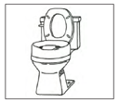

A raised toilet seat will make it easier for you to get on and off the toilet

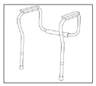

A toilet safety frame will make it easier for you to get on and off the toilet.

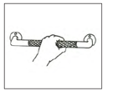

Grab bars around your toilet, bathtub or shower will increase your safety during transfers.

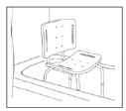

A tub chair lets you sit while taking a shower or bath.

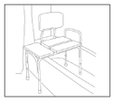

A tub transfer bench can help you get in or out of the shower or tub. You can also sit on it while taking a shower or bath.

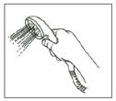

A hand-held shower head allows you to control the spray of water while sitting.

Dressing supplies for home: You will have to put a fresh bandage on your incision after showering. You can use a strip – type (Island™) dressings or 4x4 gauze (1 box) and tape for your dressings.

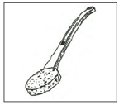

A long-handled sponge can be used to wash your feet when you cannot bend and to wash your back so you avoid twisting.

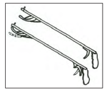

A reacher helps you get things from higher and lower levels. It can also help you put clothes on the lower part of your body.

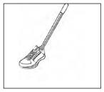

Elastic laces let you slip in and out of your shoes easily while keeping them tied. The long-handled shoehorn helps you guide your foot into an already-tied or slip-on shoe.

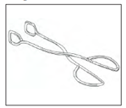

Tongs can be used in place of a reacher. Or they can help you with your hygiene care after you use the toilet.

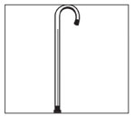

A cane may help with balance. Balance issues can happen because you have limited movement in your surgical arm. Do not use a cane with your surgical arm until your surgeon says it is ok.

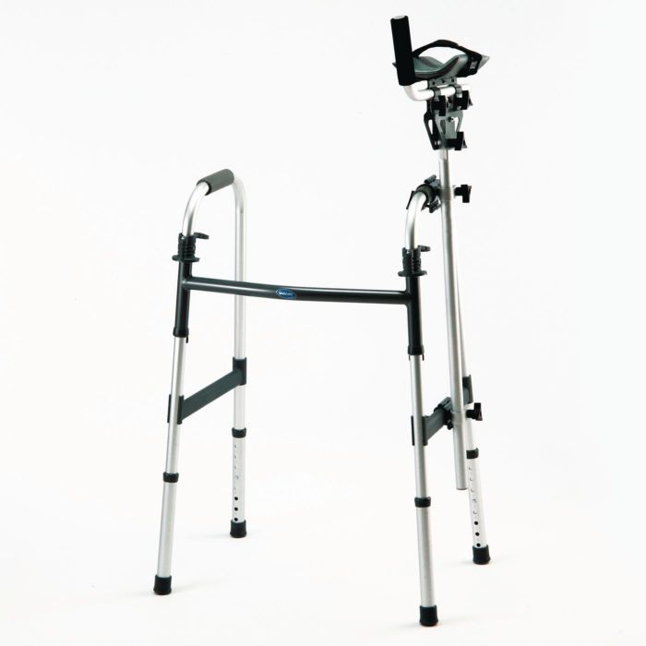

If you ambulate with a walker, you will need a gutter (an attachment for the un-operated arm) on your walker so that you can push it/guide it safely.

* Please be sure that the equipment fits in your home and is in good working order before you have your surgery.
* Walkers, crutches and canes must be adjusted to your height.

Equipment is available at medical supply stores in our community

* Equipment may be able to be rented and/or purchased.
* Suppliers may deliver to your home and/or install.
* Costs may be covered by extended health plans – check your plan.

**Friends/Family**

Check with friends and family who may have equipment you can borrow.

# Will I need to see a social worker?

It is your responsibility to arrange for any needed help following surgery. Things to consider are meal preparation, housekeeping, equipment and transportation to follow up appointments.

If you are worried about being alone, you may want to consider having a family member or friend stay with you or make arrangements for private convalescent care in a retirement home. Staff can provide you with a package of resource information that includes private care services and a list of retirement homes offering convalescent stays.

If there are any issues that may make it difficult for you to make these

arrangements or you have other concerns, a social worker is available to meet with you during your pre-operative visit or may contact you by phone. We can offer support and assist you with your plans as needed.

If you are already receiving home care through the Local Health Integration Network Home and Community Care (LHIN HCC), please make sure that your Care Coordinator knows the date of your surgery.

If you are a caregiver for someone else (care for another member in your household) please let us know at the time of your pre-operative visit.

If you have financial concerns that interfere with your discharge plans or other worries/stresses, please let us know. We can offer support and connect you with other services that you may not know about.

# Care Partner & Visitor Policy

Please refer to the QCH Patient Handbook for detailed information about our Care Partner and Visitor Policy while you are at QCH.

**Please ensure that visitors are aware of the Queensway Carleton Hospital scent-free policy. Please do not bring scented flowers to the hospital.**

# Health tips before surgery

**Dental Work**

We recommend that dental work be done six weeks in advance of surgery (including cleaning and any dental procedure). Having dental work done closer to surgery may result in your surgery being cancelled due to risk of infection.

**After your surgery, you must inform your dentist and other doctors if you have had a joint replacement surgery. You may need to take antibiotics prior to certain procedures. We do not recommend dental work, unless it is an emergency, for 3-6 months after surgery.**

**Infections or illness before your surgery**

We ask that you check your temperature regularly during the three days before your surgery date. If you feel feverish and/or have an elevated temperature (temperature 38°C or 100.4°F or higher) or develop a respiratory or any other infection during this period, you should notify the surgeon who is performing your surgery by calling their office. Should your surgery be delayed, every effort will be made to have you rescheduled as soon as possible.

We encourage all patients to get the flu vaccine. The vaccine takes at least two weeks to take effect. To avoid illness during your recovery period, it is preferable to have the vaccination prior to your surgery.

**Note: Notify your surgeon by calling their office before your surgery if you develop a cold, have any open wounds, have an active virus (e.g. shingles), or have any other illness.**

# Pre-Surgery home set-up

It is important to set up your home before your joint surgery. This will allow you to safely move around your home.

**Outside your home**

* Move items you use a lot in the garage or workshop to tabletop-height surfaces or to middle shelves.
* Check stair railings to make sure they are secure. It is best if all stairs have railings.
* Be aware of uneven ground around your home and in your yard.
* Be sure your driveway and walking paths are uncluttered.

**Inside your home**

* Have clear pathways and remove clutter around your home.
* Pick up all throw rugs in your walking or standing path. Consider using double-sided tape to secure carpet edges.
* Check stair railings to make sure they are secure. It is best if all stairs have railings.
* Make your phone accessible to your main sitting area and bed. Cordless phones or cell phones are helpful. Carry a cordless phone or cell phone when you are home alone in case of an emergency.

**Living room**

* Move low-height tables away from the couch and chairs.
* Pick out a chair to sit in when you come home. A good chair is firm with arms.
* The seat height of your chair should be at the level of the back of your knee or higher.
* Do not sit in overstuffed chairs and sofas, or chairs with wheels or gliders. A firm chair with a straight backrest is best.

**Kitchen**

* Move items you use a lot in the kitchen to tabletop-height surfaces or to middle shelves.
* Prepare and freeze a few meals before your surgery.

**Bathroom**

* Move items you use a lot in the bathroom to tabletop-height surfaces or to middle shelves.
* Consider putting grab bars in the bathtub, shower or both. Also consider other key areas for grab bars such as by the toilet. (Grab bars should be installed into wall studs to ensure they are secure. Using a towel bar or rack for a grab bar is not a safe option).
* Apply adhesive slip strips or a bathmat to the tub or shower floor.
* Consider a hand-held shower head.
* Consider using a soap dispenser with liquid soap in the bathtub or shower rather than using hand-held soap. Otherwise, place a bar of soap in a nylon stocking and tie it onto a soap dish.

**Arrange for Help with Household Tasks**

Make plans to have someone help with the following household tasks.

* Find someone to do your yard work and snow removal.
* Have your paper and mail delivered to your door instead of curbside.
* Have someone drive you to the grocery store (or ask him or her to do your shopping for you), community events, family activities and appointments.
* Find someone to help care for your children or pets if needed.
* Find someone to do your house cleaning, vacuuming and bed changing.

This is important for your well-being and the safety of others because there is a risk for everyone if you go to surgery with an infection.

# Final check list: One day before surgery

By now you should have picked up your medical equipment and set up your home. Here is a final checklist of things you need to do before coming to the hospital:

* Label all of your equipment with your name and **bring these items to the hospital** (e.g. long-handled reacher, long-handled shoehorn).
* If you have sleep apnea and are using a CPAP/BiPAP machine at home, please bring in the machine, tubing and mask (all labeled with your name) the morning of your surgery.
* Make arrangements for transportation to and from the hospital.
* Make arrangements for someone to stay with you or be nearby for at least the first 72 hours after you leave the hospital.
* Perform your skin preparation as explained by the POAC staff.
* If you are being admitted overnight, pack your bag for the hospital. Bring only the minimum personal belongings necessary with you to the hospital. Your planned stay will be short, patient rooms are small, and there is limited storage.
* Bring all current medications in original bottles or boxes. Bring dossette (1 complete week) if it is prepared by your pharmacy.
* Ice, frozen gel packs or cryocuff to be applied 3-4 times per day at home to control swelling.

My date of surgery is: ______________________________________

Call the Queensway Carleton Hospital Patient Scheduling Department the weekday (Monday to Friday) before surgery to determine the time of admission.

The number to call is 613-721-4840 between 11 a.m. and 3 p.m.

Call for your admission time on: ________________________________

# Preparation for surgery

You must follow these rules, or your surgery may be cancelled:

1. **Do not eat any solid food after midnight the night before your surgery.**
2. **If you are thirsty, you may drink clear fluids either apple juice, water or ginger-ale™, until you leave to come to the hospital.**
3. **Please drink one cup (250 mLs or 8 oz) clear fluid either apple juice, water or ginger-ale™, before leaving to come to hospital.**

You should take your regular prescription medications (no vitamins or herbal products) with water the morning of surgery as advised by the nurse or doctor you spoke with in POAC.

You muststoptaking all supplements except vitamin D, calcium, or iron/iron supplements one week before surgery.

If you are taking Aspirin or other blood thinners, please inform your surgeon or nurse. You will be given specific instructions.

* **Skin preparation**:

Stop shaving in the operative area one week (7 days) before your surgery date. Shaving can cause tiny nicks in the skin that may allow germs to enter your body and cause an infection. Do not use bath scents, powders or body lotions.

1. The night before surgery bathe or shower and wash your entire body using the Chlorhexidine soap sponge. Pat yourself dry with a fresh clean soft towel, put on clean pajamas or clothes and put freshly laundered bed linens on your bed if you are able.

Shape of a body with the area from the neck down shaded

1. The morning of surgery repeat your bath or shower using Chlorhexidine 4% soap sponge.

**(Chlorhexidine 4% soap sponges are available at the QCH Gift Box)**

* If you are a smoker, stop smoking at least 24 hours before your surgery. We can provide you with smoking cessation support to prevent nicotine withdrawal during your hospitalization.
* Do not drink alcohol for at least 24 hours before surgery.
* On the day of surgery do not wear make-up, any jewelry, body piercings, nail polish, deodorant or contact lenses. If you are unable to remove rings from operative site you must have them removed by a jeweler. Remove body piercing and replace with plastic plugs.
* QCH is scent-free. **Please do not wear any scented products to the hospital.**
* Arrange for someone to drive you to the Hospital the day of surgery and drive you home on your discharge day.

What should I bring to the hospital

* Your health card.
* All current medications in their original bottles, boxes, dossettes or blister packs. Please bring a current list of all medications in a printout from your pharmacy. If not needed after surgery, your family can take your medications home once you have been admitted.
* A list of allergies, including the type of reaction.
* Walking shoes that tie on and wrap around your heel.
* Your equipment as outlined on page 13-14, labeled with your name
* If you have sleep apnea and are using a CPAP/BiPAP machine at home, please bring in the machine, tubing and mask (all labeled with your name) the morning of your surgery.

If you are being admitted:

* Bring in your personal bag on the day of your surgery. Please bring one set of comfortable clothing like jogging pants or shorts and a loose shirt/blouse that you can dress in during the day and a pair of loose-fitting pants to wear home.
* Your own reusable water bottle.
* Toothbrush, toothpaste, soap, deodorant, shaving cream, razor, brush or comb and Kleenex™.
* Do not bring valuables to the hospital.

# Day of Surgery

****When you arrive at the hospital****

* From Patient Registration, you will be directed to the Day Surgery Unit (DSU). One Care Partner can accompany you and stay with you once you are admitted. You may designate this Care Partner to be the person to call after surgery.
* The surgeon, anesthetist and operating room (OR) nurse will see you and answer any questions that you may have. The surgeon will mark the limb that they will be operating on.
* You may receive a local anesthetic block. Medication is injected around the nerves which numb the area in the arm, so that you cannot feel anything from the shoulder to your fingers. You will go to the “block room” and not directly into the Operating Room to have your anesthetic started. You will be cared for by a nurse or an anesthetic assistant while in the block room. You will then be transferred to the Operating Room.
* You will be given an anesthetic medication through your intravenous.
* Your anesthesiologist will discuss this with you prior to your surgery.
* The anesthetist will make sure you are comfortable throughout the surgery, giving you medication through your IV that makes you relaxed and sleepy so you will not be aware of the procedure.
* Some people receive general anesthetic. This is a combination of drugs that will make you unconscious during the surgery.

# **After Surgery**

Recovery Room/Post Anesthetic Care Unit (PACU)

Your surgery will usually last about 1 to 2 hours.

* You are moved from the Operating Room to the Post Anesthetic Care Unit (Recovery Room).
* Your nurse will monitor your vital signs, including your pulse and blood pressure and will look at your incision dressing frequently.
* The nurse will check the circulation, sensation and movement of both arms. Your arm will feel heavy and will be difficult to move for a few hours after the anesthetic block. This will slowly return to normal within 8-24 hours.
* You may wake up with a sling on your arm after surgery. There is fee for the sling (approximately $20, which you will be billed for). If you already own a sling bring it in on the day of surgery. Your surgeon may use this instead.
* If you feel any pain and/or nausea tell your nurse. You will be given medication to help you feel better.
* You may be drowsy after the surgery, as you become more alert, we will encourage you to do ankle exercises and deep breathing exercises (see below). These exercises will help to prevent post-operative complications.
* If you are being admitted to the hospital, you will be transferred to your room when your nurse determines it is safe to move you and when your room is ready. Sometimes there are delays due to the late discharge of other patients.
* If you have sleep apnea, you may be required to be monitored in the PACU for a longer period of time. If you have your own CPAP machine, you need to bring it with you to the hospital.
* If you are being discharged the same day as your surgery, you will go to the day surgery unit to complete your recovery.

**Ankle exercises:**

Point your toes toward your head, then toward the foot of the bed. Make your feet go around in circles 5 times. This exercise should be done at least every hour while you are awake.

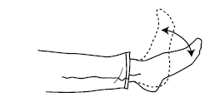

**Deep breathing exercises:**

Take a deep breath in through your nose, and slowly blow out through your mouth. Repeat these 3 times. This should be done every hour while you are awake for the first day, then every 2 hours for the next 1-2 days.

Length of your hospital stay

You may be admitted to Hospital on the day of your surgery and remain overnight. Your surgeon will determine if you require an overnight admission.

If admitted, your hospital stay will follow a plan we call a “Standardized Care Plan”. Your care is organized so that you, your family, and all members of your Healthcare Team know exactly what tests, treatments and diet you require as well as teaching and planning necessary for discharge. Your Care Plan, which shows what to expect from admission to discharge, is included at the back of this booklet on page 49.

Pain Management after Surgery

Please see the booklet “Pain Management after Surgery”.

Adequate pain management is very important for your quick and speedy recovery. Good pain management is needed in order for you to be able to participate in physiotherapy and early walking. It is very important to take your pain medication in order to be comfortable enough to move about as required. The exact amount of pain medication needed will vary between individuals.

Your anesthetist is responsible for pain management during the first 24 hours after surgery if you are admitted overnight. Your pain regimen may consist of several parts. Your anesthetist will determine with you what type of pain management you will receive.

Some side effects of pain medicines are constipation, nausea, vomiting, drowsiness and being itchy. Tell your nurse if you have any of these symptoms.

Ask your nurse for pain medication if you are uncomfortable. Your nurse will ask you to rate your pain according to a scale as outlined below. You will be discharged home with a prescription for medication to manage your pain.

**Pain scale**

Your nurse will ask you to rate your pain on either the number or FACES scale (see below). Pain is rated from 0 (no pain) to 10 (worst pain).

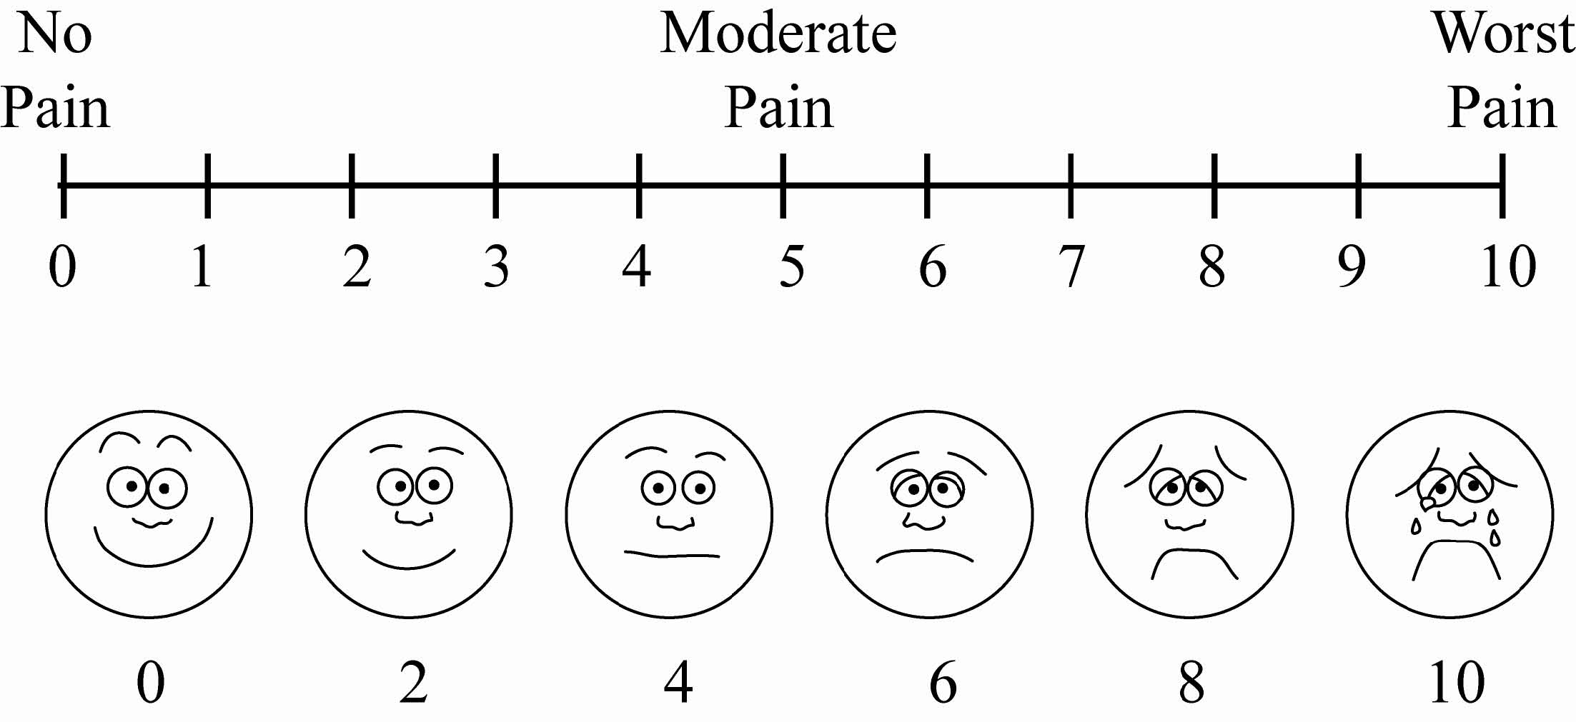

General post-operative instructions

**(Day Surgery patients)**

We want your recovery to be safe and as comfortable as possible. For this reason, we suggest that you comply with the following advice:

* You should have someone available to stay with you overnight upon returning home.
* Your surgeon will instruct you as to when you can drive a car or operate machinery but in the absence of such instructions, not for at least 24 hours after the procedure.
* You should limit activity requiring full concentration for at least 24 hours (e.g. making important personal or business decisions), as full mental alertness may not return for several hours.
* You should not drink any alcoholic beverages for at least 24 hours following your procedure as alcohol may influence the effects of the drugs you have been given.
* Consider eating a light first meal following your surgery.
* You should take it “easy” for a day or two.
* If you have any problems or are concerned about your condition for any reason, please contact your surgeon through his/her office or follow the directions on your surgeon’s message machine regarding reaching another surgeon.
* If you are unable to contact your surgeon or the surgeon covering his/her practice, come to the Emergency Department of the hospital where you will be seen by an emergency physician.

Return appointment reminder

DATE:

TIME:

LOCATION:  Doctor’s office

Other:

**Post-operative dressing**

* If you are a Day Surgery patient, you will probably need some sterile dressings and tape at home after your surgery.
* We advise you to purchase these supplies before your surgery.
* We suggest that you get a small package of sterile 4” X 4” gauze pads and a roll of tape at the drugstore before your surgery.
* Other:

If you have any questions about the dressing type to purchase, please check with your nurse in the Pre-Operative Assessment Clinic (POAC).

**Day Surgery Patients**

**Please give these instructions to your designated driver.**

Please remind your designated driver they must be available for the entire day of your surgery and ensure they keep their phone on and are ready to receive the call from the Day Surgery Unit (DSU) informing them of the time to pick you up.

Pick up information

The care partner/family members are encouraged to remain at the hospital. You and your care partner will receive your post-operative instructions together for your discharge preparation. If partner/family are not able to stay, please ensure that they are within 10 minutes of the hospital.

For those who cannot remain and are collecting a patient, please drive to the James Beach Health Care Centre entrance door. Inside the building there is a wall mounted telephone on the right-hand side with the phone number to the Day Surgery Unit (DSU) posted.

Please pick up the phone and dial 2912 to let them know you have arrived. You will then be given further instructions.

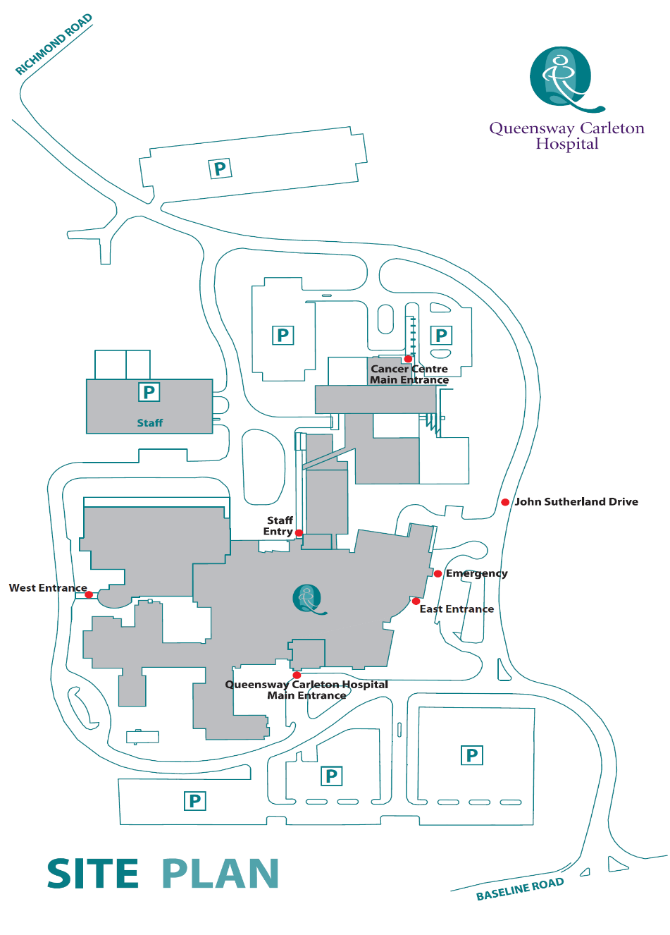

**James Beach Health Care West Entrance (patient pickup)**

**Main Entrance** **(patient drop off)**

# What happens when I go home

Arthroscopy and Shoulder Arthroplasty are day surgeries and you will go home on the same day. If your surgeon decides you need to be admitted overnight, you will be discharged home according to the Care Plan the next day after your operation. You are responsible for your own transportation home. You may require help to do your shopping and house chores from a family member or friend for 4 to 6 weeks after surgery. **Arrangements for convalescent care, if desired, should be made before you are admitted to hospital.** The social worker is available through the Social Work office 613-721-4723 to help with the arrangements if necessary.

You will need to continue your physiotherapy exercises for at least 3–6 months and an outline of the home exercises program is shown in the physiotherapy section of this booklet.

Operative site

A dressing has been applied to your incision. The goal is to leave the original dressing on your incision until the 4th day after surgery. This dressing may be removed after 4 days. Your incision should be kept clean and dry. Metal clips are usually removed in 10-14 days. You may shower after the dressing has been removed.

For patients having a shoulder arthroscopy no clips are used and your sutures are dissolvable.

Caring for my incision

You will need 4” x 4” sterile gauze pads and a role of surgical tape to care for your incision at home. You should purchase these items before your surgery at the drugstore or the QCH Gift Box.

When to change your dressing:

* If there is less than 30% (1/3) drainage on your dressing, leave it on until the 4th day after your surgery.
  + If there is no more drainage from your incision after four days, you may leave it open to the air or for your comfort you may continue to use dressings, unless your surgeon has advised you differently.
  + If your incision is still draining, even a small amount, after the fourth day, put a new gauze dressing (single layer as needed) over it. Change this dressing every day until it has stopped draining.
* If there is greater than 30% (1/3) or more drainage on your dressing or it is coming loose, the dressing should be changed. Reinforce with more dressings as needed.

How to change your dressing:

* Wash your hands with soap and water for 30 seconds and dry with a clean towel.
* Remove the dressing and avoid touching the incision if it is still draining.
* Apply gauze and tape.

Diet

Resume your usual diet the day after surgery. Increase fiber in your diet and drink lots of fluids as stronger prescription narcotic pain medication (for example opioids) and immobility can cause constipation.

Activity

Restrictions to Follow After Your Surgery

Your shoulder replacement surgery should decrease discomfort and pain and help you return to doing activities you have not been able to do.

For the first 4 to 6 weeks after your surgery, you will wear an immobilizer on your shoulder to restrict motion and support your shoulder. You will need to wear your immobilizer all the time except when:

* doing your exercises
* showering or taking a bath
* getting dressed
* eating
* doing tabletop activities such as writing or typing.

|  |  |  |
| --- | --- | --- |
| How not to lift out of a chair  Do not push up with your surgical arm to get out of a chair. | How to not get out of bed  Do not use your surgical arm to get out of bed. | How not to open a door  Do not use your surgical arm to open/close a door. |

To help the healing process with your new shoulder, your surgeon recommends that you avoid certain movements for several weeks after your surgery.

* Do not lift anything that weighs more than 1 to 2 pounds for 6 weeks after surgery.
* Do not drive until your surgeon says it is okay and when you are no longer taking prescription (narcotic) pain medication.
* If you use a walker, rest the hand of your surgical arm on the walker for balance only. Do not lean on the surgical arm for 2 months after surgery.
* Do not reach behind your back with your surgical arm to cleanse your genital or anal areas after using the toilet for 3 months after surgery.
* For 3 months after surgery, **do not** use your surgical arm to: push yourself up and of out of a chair or wheelchair.

**Mobility Guidelines**

After shoulder replacement surgery, you may need to move differently until your shoulder heals. Follow these instructions on how to move the right way after surgery.

**Getting off a chair with arms**

Slide forward to the front edge of the chair.

Put non-surgical hand on the arm rest.

Push up with your non-surgical arm and your legs.

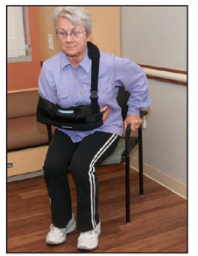

Use your non-surgical arm to get off the chair.

**Getting out of bed**

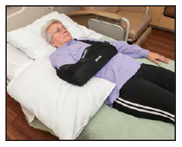

* You will need to get of bed on your non-surgical side.

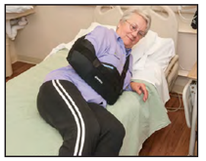

* Do a log roll toward your non-surgical side. Turn to your side, keeping your body in a straight alignment. Your shoulders, hips and knees should all move together.

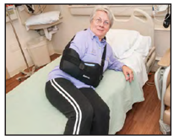

* Swing your legs over the edge of the bed as you push your upper body up with your non-surgical arm.
* Stand up slowly, pushing off with your non-surgical hand on the edge of the bed.

Sleeping

One of the greatest challenges is getting a good night’s sleep after shoulder surgery.

* It is very important to keep the sling on while sleeping.
* Use a recliner or extra pillows on bed to help you get a comfortable sleep’s position
* You may choose to sleep on your back initially and put an extra pillow under the operated arm for support.
* Patients with rotator cuff surgery may find it more comfortable to sleep in a semi- upright position
* A semi-sitting position might be comfortable for you too.
* Ask your doctor if you need to get a sleep aid medication besides your pain control medications.

**Driving/Riding in a car**

If you can, sit on the side of the car so the seatbelt crosses over your non-surgical shoulder.

You cannot drive for the first 2 weeks for sure. You should not drive until your surgeon indicates your sling can be removed. If you drive a standard, you cannot drive if you are wearing a sling. You need to be off the narcotics before driving. You need to call your insurance company and advised them that you have a sling. They will let you know if you can drive or not.

**Using a reacher**

Use a long-handled reacher to pick up low or dropped items.

**Opening and closing a door**

Get close to the door.

Open or close the door with your non-surgical arm.

**‘Box of Safety’**

You can safely do light activities within the “box of safety” without hurting your new shoulder.

Light activities include eating, knitting, reading and tabletop activities such as writing.

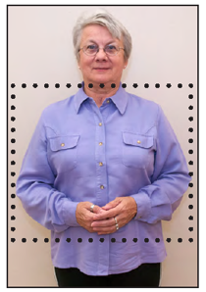

Keep your hands in front of your body.

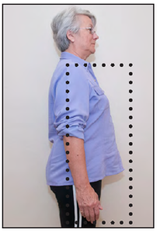

Keep your elbows at your side. Do not move them behind your body.

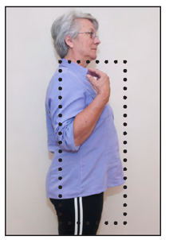

Keeping your elbows at your side, you may bend your arm at your elbow. Do not reach above your head.

A sling, if ordered is worn for your comfort and protection. You must wear it at all times until you return for your follow-up visit with your surgeon. Wear it while you sleep. It may be removed to shower or for your exercises 3 times daily unless otherwise directed by your surgeon. The sling will be used for up to 6 weeks (see Appendix 3 for sling information).

Check with your surgeon about what sports and activities are okay for you as you recover.

For your comfort, elevate your head upon 2–3 pillows or sit in a reclining/comfortable chair. You are reminded to keep your shoulder down and relaxed. When lying down, your shoulder should rest on a small pillow or rolled up towel for 6–8 weeks.

* Make sure to follow any movement precautions for your shoulder or arm given to you by your doctor or physiotherapist.
* Avoid lifting anything with your operated arm until your doctor tells you it is okay.
* Use a cane in your non-operated hand (no weight-bearing or leaning through your operated arm) if required for balance. If you use a walker, you will need to get a gutter for the non-operated side so that you can guide the walker safely. You may ***not*** use crutches.
* As it is not possible to elevate the shoulder, swelling into the elbow, forearm, and hand are common. You are encouraged to move your fingers and rotate your wrist to prevent stiffness and swelling.
* Gradually increase your mobility as you are able. Short walks will help to promote lung function, circulation and will help you to feel better overall.
* You may return to sexual activity when you feel ready and comfortable.
  + - * A firm mattress is recommended
      * Be the passive partner for the first 6 weeks after surgery
      * Use the missionary position or less dominant position
* Cold Therapy - You may apply ice to your shoulder several times a day for 10 minutes at a time to help reduce pain and swelling.

**Doing daily activities with one hand**

If your shoulder surgery is planned, it is recommended that you practice doing daily activities with one hand before surgery. This will help you to feel confident after your surgery.

In the kitchen

* To open jars, use a piece of waffle-weave shelf liner to help grip the jar on the counter or between your knees.
* Use rocker knives to help with one-handed cutting or use pre-cut foods.
* Deep-sided dishes or containers can help keep food on the plate.
* Put the bread or bun inside a container or against the side of a deep pan to keep it still while you put spread on it.
* Keep heavier items on the counter so that you can slide them from place to place.
* Only put lightweight items above eye level in cabinets.
* Store items in easy-to-open containers.
* Store liquids in small containers.

Personal care

* Use a shampoo bottle with a pump.
* Use liquid soap with a pump instead of bar soap.
* Use a long-handled sponge with a bendable handle to reach your back and opposite side. Wrap the sponge head with a towel after bathing to help you reach the same areas to dry.
* Use pop-top toothpaste instead of screw-on cap. Rest your toothbrush on the counter to put on the toothpaste.
* Put on deodorant by leaning forward and let your operated/injured arm dangle or swing away from your body. Spray deodorant may be easier.
* Use a gooseneck clamp to hold the hair dryer while you use your one hand to comb.
* Use clips to hold hair back instead of rubber band.

# Physiotherapy

You are to do the exercises that are in this booklet after your surgery. The same exercises will be reviewed during the shoulder replacement education class. **WHEN YOU RECEIVE YOUR PHYSIOTHERAPY REFERRAL, PLEASE CALL TO BOOK YOUR POST-OP PHYSIOTHERAPY APPOINTMENT AS SOON AS POSSIBLE.**

You can also access physiotherapy at any other hospital from QCH that has an out-patient department. You can also go to OHIP funded clinics (clinic to confirm eligibility) or some other private physiotherapy clinics. The integrated care coordinator can help you find physiotherapy in your area that is covered.  You can contact the integrated care coordinator by email [bundle@qch.on.ca](mailto:bundle@qch.on.ca). You are responsible for contacting the hospital or private clinic to schedule your appointment. We encourage you to attend the same physiotherapy clinic for your entire postoperative period in order to maintain continuity of care. Physiotherapy options will be discussed by the Integrated care Coordinator during your Prehab program education session.

Physiotherapy home exercises

* If you are a patient of Dr. Young you may start all of these exercises the day after surgery 3x/day with your sling off.
* If you are a patient of Dr. Prihar you may start exercises 1 & 4 - 5 - 6 the day after surgery with your sling on. Add in exercises 2 & 3 two weeks after surgery once you are allowed to remove your sling 3x/day.
* See Appendix 1 for exercises

# Complications

After surgery, a few people have complications and need more medical treatment. Here are some possible complications:

Constipation

Deep Vein Thrombosis/ blood clots

Swelling

Infection

Pressure injury

**Constipation**

Constipation can be a problem after surgery. A change in your diet, less activity and taking pain medicine (narcotics) may make your constipation worse. It can be very uncomfortable and may be a problem after your discharge from hospital. Here are some ways to have regular bowel movements at home:

* Drink 6 - 8 glasses of water or low-calorie fluids a day
* Eat fiber such as prunes, bran, beans, lentils, fruits and vegetables
* Move around as much as you can – do your exercises!

You may need to take laxatives or stool softeners at home. If you have constipation, talk to your doctor or pharmacist. Constipation can be a serious problem - do not ignore your symptoms.

**Deep Vein Thrombosis**

Deep Vein Thrombosis (DVT) is a blood clot in a deep vein and is a major health concern that should be discussed with your physician.

You may be at risk for developing a DVT for any of the following reasons:

* Recent surgery
* Immobility
* Previous DVT
* Problems with circulation
* Obesity
* Increasing age
* Acute medical illness

DVT’s most commonly occur in the legs, usually the calf. Signs and symptoms to watch for include calf pain or tenderness, swelling, redness or discolouration, a knot in the calf that you can feel and that is warm to touch, fever, shortness of breath, rapid heart rate, chest pain or light headedness.

If you experience any of these symptoms go to the Emergency Department or call 911 for immediate assistance.

**To reduce the risk of DVT/blood clots:**

* Remember to take your blood thinner medication exactly as prescribed and instructed by your doctor, nurse and pharmacist
* Walk short distances at least once an hour (except when you are sleeping)
* When you are sitting or lying in bed, pump your ankles and flex your leg muscles

**Swelling**

It is normal to have some swelling in your arm and hand after surgery and during your recovery. Swelling may increase as you become more active. To help reduce swelling:

* Wiggle your fingers and rotate your wrist frequently to increase circulation and to prevent stiffness and swelling
* Apply cold packs/ice to your shoulder several times a day for 10 minutes to reduce pain and swelling
* Do short periods of activity. Walk a few steps. Rest. Repeat
* Place an ice pack wrapped in a towel on your joint. For some people, a “cryocuff™” may be used after shoulder replacement surgery. This is a type of ice pack/compression device for the arm. For more information, talk to your physiotherapist about using ice at home

**Infection**

Less than 1% of people have an infection around their new joint. An infection in the body can reach the new joint through the bloodstream. People who develop joint infections need antibiotics and, on rare occasions, further surgery. To prevent infection or incision problems, it is important to keep the incision and dressings dry. Do not touch or pick at the incision and be sure that the surrounding skin is always clean. Wash your hands often.

Artificial shoulders can become infected at any time, even several years after your surgery. It is important that if you have any skin infection or any other type of infection, at any time, you need to see your doctor for treatment right away.

**Call your surgeon or go to the nearest Emergency Department if you have any of the following.**

* Sudden pop or change in range of motion of your shoulder.
* Shoulder feels loose.
* Fingers of affected hand feel cold or numb.
* Any concerns about the freezing in your arm.
* Excessive pain, no relief with pain medication.
* Any sign of possible infections:
* Fever, chills, elevated temperature greater than 38˚C or 100.4˚F lasting for more than 24 hours
* Incision becomes red, hot, or swollen
* Excessive drainage or foul-smelling drainage–for example, greenish-yellow discharge

Advise your doctors, including dentists of your shoulder replacement. For 1 year after your replacement it is recommended for any dental work, including teeth cleaning, that you are put on antibiotics before your dental work.

**Call 911 immediately if you have:**

* Shortness of breath
* Sudden chest pain

**Protecting your skin from pressure injuries**

During and after your surgery, you are at risk for developing a pressure injury (bed sore, pressure ulcer). A pressure injury is skin breakdown that develops, usually over the tailbone and the heels, from sitting and lying in the same position for long periods of time or from sliding down in bed.

Some key things that can be done to protect your skin are: Avoid direct pressure over your tailbone for more than 1-2 hours at a time, whether you are in bed or reclining in a chair. To relieve pressure, go for a walk, put a pillow under your hip on your operated side or lie on your non-operated side.

# Follow-up

Your surgeon will tell you when to make a follow up appointment after your operation.

A shoulder replacement relieves pain and stiffness for most people. You should be able to return to most activities in 6 months. If you had an uncomplicated Shoulder Arthroplasty, you should be able to resume full activities within 6 months. Your surgeon will discuss with you the type of Arthroplasty you have had and the restrictions. With normal use, most shoulder replacements last 10–20 years.

**DISCHARGE SUMMARY**

**APPOINTMENTS:**

**Clip Removal Date:**

Approximately 2 weeks post-op

**Time:**

**Location:**

**Outpatient Physiotherapy Date:**

Queensway Carleton Hospital

**Time:**

**OR**

**Location:**

CALL THE PHYSIOTHERAPY CLINIC WHERE YOU HAVE BEEN REFERRED **AS SOON AS YOU RECEIVE YOUR PHYSIO REQUISITION**,

**Follow-up Appointment with Date:**

6 weeks post-operative **Time:**

**Location**

**OR**

Call his/her office to book:

**On Discharge you should receive:**

* Clip remover if going to your Family Doctor for clip removal
* Prescription for pain medication
* Receipt for payment of appliances (Sling)
* Other

Please pick up your blue QCH card at the front desk when you leave.

# Shoulder Care Plan

|  |  |
| --- | --- |
|  | **Pre-Admission** |
| **Consults** | * Referral to Medicine, Anesthesia, Social Work/Discharge Planner as needed |
| **Assessments /Treatments /Tests** | * Complete Admission Assessment Profile * Assess weight and blood pressure * Review medications and food allergies   **Teaching**   * Review Booklet/Care Plan and pain management * Diet – Increase protein, iron, and fluids   **Tests (if applicable)**   * Shoulder/Chest X-ray, ECG, blood tests as needed |
| **Medication** | * Review medication as taken at home |
| **Nutrition** | * Nothing to eat, no solid food after midnight the evening before your surgery |
| **Discharge Planning** | * If required, discuss arrangements for help at home after surgery with your nurse or family * Social Work/Discharge Planner if needed |

|  |  |
| --- | --- |
|  | **OR Day** |
| **Consults** | * Referral to Social Work, Dietitian, as needed |
| **Assessments /Treatments /Tests** | * Temperature, pulse, blood pressure, O2 saturation are checked * Deep breathing exercises every hour while you are awake * Intravenous fluids/ saline lock   **Teaching**   * Pain management/discomfort * Deep breathing exercises * Leg & ankle exercises * Moving fingers every ½ hr * No lifting * Arm in sling at all times   **Tests**   * Blood tests taken as ordered * Blood Glucose test (if applicable) |
| **Medication** | Medication for   * Pain/discomfort * Nausea (upset stomach) |
| **Nutrition** | * Clear fluids to DAT (increase diet as tolerated) * Increase fiber (fruits, vegetables and whole grains) |
| **Mobility Hygiene** | * Stand at side of bed with help * Ambulate with help * Up walking |
| **Discharge Planning** | **Teaching**   * Moving fingers * No lifting * Moving/repositioning in bed * Arm in sling at all times * Confirm plans you have made for discharge (ride, destination, prescriptions) |

# Appendix 1

Neck Exercises

**1.** Neck Side Flexion AROM

Sets:1 Reps:10 Hold: 5 seconds Frequency: 3 x a day

Preparation:

* Sit with good posture

Execution:

* Slowly lower left ear to your left shoulder as far as you comfortably can
* Hold where you feel a gentle stretch
* Raise your head up, then lower you right ear to your right shoulder as far as you comfortable can
* Hold where you feel a gentle stretch

|  |  |  |
| --- | --- | --- |
| Neck straight | neck bent to right side | Neck bent to left side |
| Start Position | Bend neck right | Bend neck left |

Shoulder & Elbow Exercises

**2.** Shoulder Flexion PROM

Sets:1 Reps:10 Hold: 5 seconds Frequency: 3 x a day

Preparation:

* Sitting in a chair rest your unoperated arm on the table or on your lap.
* Let you operated arm hand loose by your side, upper shoulder and neck muscles relaxed

Execution:

* Slowly bend forward from your waist while your operated arm continues hanging loosely. Make sure neck and shoulder muscles stay relaxed
* Hold at the bottom for 5 seconds

|  |  |  |
| --- | --- | --- |
| Sitting in chair with arm straight | Sitting in chair starting to bending forward | Sitting in chair bent forward |
| Let your operated arm hang loosely at your side | Slowly bend forward from your waist | Hold at the bottom for 5 seconds |

**3.**Elbow Flexion & Extension PROM

Sets:1 Reps:10 Hold: 5 seconds Frequency: 3 x a day

Preparation:

* Sitting in a chair

Execution:

* Straighten elbow down
* Bend elbow up

If you have had a bicep tendon repair do not start this exercise until your surgeon tells you to.

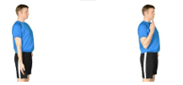

Arm straight Bend elbow

Forearm, Wrist and Hand Exercises

**4.**Forearm Pronation & Supination AROM

Sets:1 Reps:10 Hold: 5 seconds Frequency: 3 x a day

Preparation:

* Sitting in a chair with elbow bent

Execution:

* Turn your hand so that your palm faces upwards
* Turn your hand so that your palm faces the ground

If you have had a bicep tendon repair do not start this exercise until your surgeon tells you to.



Turn hand down Turn hand up

**5.** Wrist Flexion & Extension AROM

Sets:1 Reps:10 Hold: 5 seconds Frequency: 3 x a day

Preparation:

* Sit comfortable, elbow supported on something soft
* Fingers relaxed and wrist bent forwards

Execution:

* Raise your wrist upwards
* Keep your fingers relaxed
* Bend your wrist forwards back to the start



Bent wrist fingers Move wrist up, fingers

relaxed relaxed

**6.** Hand Opening & Closing AROM

Sets:1 Reps:10 Hold: 5 seconds Frequency: 3 x a day

Execution:

* Spread fingers wide
* Now make a fist



Spread fingers wide Now make a fist

# Appendix 2

Guide to using equipment

Peri-Care Assist Options

|  |  |
| --- | --- |
| **Portal Bidet Options** | **Photos** |
| Hygienna Solo  <http://hygienna.myshopify.com>  Approximate cost: $20 | Hygienna Solo |
| Brondell Go Spa  Approximate cost: $20  <http://brondell.com/spa-suite/travel-bidets.html/>  <https://www.homedepot.ca/> | Brondell Go spa |
| Self Wipe Options  Buckingham Easy Wipe  Approximate cost: $75  Contact local vendor | Buckingham Easy Wipe |
| Bottom Buddy  Approximate cost: $85  Contact local vendor | Bottom Buddy |
| Self Wipe Toilet Aid  Approximate cost: $85  Contact local vendor | Self wipe toilet aid |
| Toilet Aid  Approximate cost: $20  Contact local vendor | Toilet aid |
| Other options:  Tongs  Dollar Store  Approximate cost: $2-3 | Tongs Tongs |

Speak with your occupational therapist for more details

**Going to the bathroom**

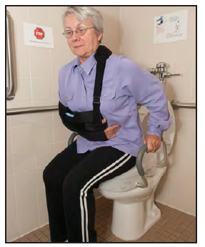

* Use a raised toilet seat or a grab-bar on the non-operated / uninjured side to help you sit and stand.
* To help with wiping, try long-handled tongs to reach. You may purchase a commercial bathroom aid.

# Appendix 3

Sling

* The purpose of the sling is to allow the arm to rest, the shoulder muscles loose and relaxed, and provide comfort. When seated, it is important to loosen the strap around your neck and allow your arm to rest comfortably on your lap. This will help to avoid neck discomfort and/or pain from the sling.
* Unless told otherwise by your surgeon, wear your arm in the sling at all times for the first 2 weeks (except while exercising or bathing).
* Your doctor will tell you how long you need to continue to wear your sling. This could be up to 8 weeks.

**How to put on your sling:**

|  |  |
| --- | --- |
| 1. Relax your operated / injured arm on your lap or hold it close to your stomach. Lay the sling on your lap with the opening toward you and the closed, curved elbow end toward your surgical side. Make sure the straps are attached to this end only. | Arm bend close to front of your body |

|  |  |
| --- | --- |
| 2. Using your non-operated / uninjured arm, gently bring the sling over your hand and forearm until your elbow fits snuggly into the closed end. Gently adjust the sling upward to take up the slack. Place your thumb into the thumb loop. | Sling on arm |
| 3. Place the strap around your upper back and over the opposite shoulder. Secure the end of the strap into the top ring of the sling. Adjust the strap until your forearm is horizontal. Your operated hand should not be hanging down. | Place strap around shoulder |
| 4. Place the waist strap around your waist and secure it to the lower ring on the sling. This should be comfortable; not tight. | Bring strap around back |

# Appendix 4

**Dressing yourself**

Begin with the operated arm when putting clothes on. When removing clothes, start with the non-operated arm.

Putting on a front buttoned shirt

|  |  |
| --- | --- |
| 1. Place shirt on your lap with the inside of the shirt facing you and label up. The collar should lie close to your stomach and the tail or bottom of the shirt at your knees. | Shirt on lap |
| 2. Allow your arm to dangle. Loosen and relax the shoulder muscles. Place your operated hand and arm into the sleeve and slowly draw the sleeve up past your elbow. | Place arm in shirt |
| 3. Hold the collar of the shirt on your non operated side. Lean forward and bring your non-operated arm over and behind your head. Now you can pull the shirt over to your non operated/ uninjured side. | Holding collar bring shirt behind body |
| 4. Put your non-operated arm into the sleeve opening. | Place non operated arm in sleeve |

|  |  |
| --- | --- |
| 5. To straighten out the shirt, lean forward, allow your shoulder muscles to relax and loosen, bring the shirt past your shoulders, reach back and pull the tail or bottom down. Button as usual. Make sure to not move your operated arm away from your body. | Button up front of shirt. |

Putting on a t-shirt or knit shirt

|  |  |
| --- | --- |
| 1. Place the shirt on your lap with the front of the shirt face down and the collar or tag at your knees. | **Place shirt on lap** |
| 1. Roll the bottom edge of the shirt back to expose the sleeve for the operated/injured arm. | **arrange shirt so arm opening is accessible** |
| 1. Move the sleeve opening for the operated arm between your knees and open it as large as possible. |  |
| 1. Use your non-operated hand to grab your operated arm and place the operated hand into the sleeve opening. Make sure your fingers do not get caught in the sleeve. Allow your shoulder muscles to relax and loosen, lean forward and let your operated arm drop down into the sleeve. | **Place operated arm in sleeve** |
| 1. Pull the shoulder seam up the arm past the elbow. | **Raise shirt up on the arm** |
| 1. Put your non- operated arm into the other sleeve opening. | **Put other arm in shirt** |
| 1. Pull the shirt on the operated side up to the shoulder as much as you can. | **Raise shirt as high as you can** |
| 1. Gather the back of the shirt up in your non- operated hand. | **Gather shirt** |
| 1. Lean slightly forward, lower your chin and pull the shirt over your head. |  |
| 1. Use your non-operated hand and push the bulk of the shirt material over your operated shoulder towards your back. | **Pull shirt down in the back** |
| 1. Pull the shirt down over your stomach on both sides. Pull to adjust as needed. | **Pull shirt down in the front** |

Taking off the shirt

|  |  |
| --- | --- |
| * + - * 1. Reach back with your non-operated hand behind your neck and start to gather the shirt up in your hand | **Gather the shirt** |
| * + - * 1. Lean slightly forward, lower your chin and pull the shirt over your head | **Pull over your head** |
| * + - * 1. Pull your non-operated arm out of the sleeve |  |
| * + - * 1. Use your non-operated hand to pull the other sleeve off the operated arm. |  |

Putting on socks

* Put your non-operated hand inside the sock, just over the fingers, not up to the palm.
* Cross your leg resting your ankle on the opposite knee or prop your foot up on a stool if you are able to lean forward.
* Slide your toes into the sock, opening the sock by spreading your fingers.
* Pull the sock up to your ankle.

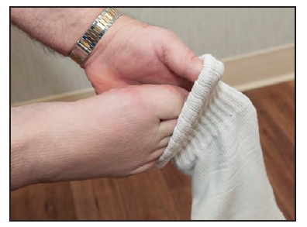

Putting on shoes

* Use shoes that slip on or use Velcro™ closures. Avoid shoes that are too loose or flip-flops that may cause you to slip or trip.
* Replace standard shoelaces with elastic laces.
* A long-handled shoehorn may be helpful but not necessary if you can manage without.

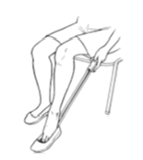 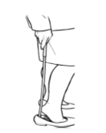

# Appendix 5

Bathing/Showering

When allowed to shower or bathe, follow these instructions:

* You may have a bath but keep your incision out of the bath water for two weeks.
* Wash your hands and remove any dressing before showering. It is okay to get the incision wet and to wash the area gently after the first dressing change, or as ordered by your surgeon.
* Ensure you follow your restrictions for your shoulder movement while bathing.
* Before showering check your incision to ensure there is no drainage.
* After showering, check your incision to ensure that there are no signs of infection (see page 49). Gently pat the incision with a clean towel. Do not rub the area.
* Apply a new dressing (See “Caring for my incision” page 32).
* Keep your armpit clean and dry. A folded dry face cloth works well.

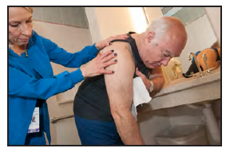

Gently lean forward. Rest your non-surgical arm on a sturdy surface. Let your surgical arm hang away from your body.

* Wash the underarm of your surgical arm.
* Gently pass a soapy washcloth from the front to the back. Rinse and dry the same way with a clean towel.

Find something sturdy to lean on when washing your underarm

**NOTES AND QUESTIONS:**