

**Patient Information Booklet**

🞎 Day Surgery Patients

🞎 Admitted Inpatients

**Preparing you for your surgery**

**Please bring this book to all of your appointments and to your admission to the hospital**

For information call

Before your surgery:

Contact your surgeon’s office or Pre-Operative Assessment Clinic 613-721 2000 ext. 2920 between 8:00 a.m. to 4:00 p.m. Monday to Friday

After your surgery:

Contact your surgeon’s office

# Welcome to Queensway Carleton Hospital

Queensway Carleton Hospital (QCH) is a patient and family-centered hospital providing a broad range of acute care services through the dedicated care of healthcare professionals. We look forward to helping you throughout your hospital stay. Please be sure to ask any questions you may have at any time.

Please refer to our Patient Handbook for more information about QCH and what you need to know as a patient while you are here.

**IMPORTANT: If your surgeon or healthcare team gives you different recommendations than what has been provided in this booklet, please follow the directions from the surgeon or healthcare team.**

**DO NOT bring any valuables to the hospital.**

**My date of surgery is:**

Call the Queensway Carleton Hospital Patient Scheduling Department the weekday (Monday to Friday) before surgery to determine the time of admission.

The number to call is 613-721-4840 between 11 a.m. and 3 p.m.

Call for your admission time on: ________________________________

**Antibiotic Resistant Bacteria**

**If you have ever been told you had or have an antibiotic resistant bacteria such as MRSA (Methicillin Resistant Staph Aureus)/ESBL (Extended Spectrum Beta-Lactamase producing bacteria), please tell the Pre Operative Assessment Clinic (POAC) staff.**

Queensway Carleton Hospital is taking steps to prevent and control antibiotic resistant bacteria. This bacteria does not usually cause problems in healthy people, but it can cause infections in people who have weakened immune systems or have had major surgery. If you have stayed overnight in a healthcare facility within the last year, you will be screened for resistant bacteria at the time of your pre-operative visit.

**Will I need to see a social worker?**

A social worker may call if you feel there are any issues that make it difficult for you to manage at home on discharge. If you are already on Home Care through the Local Health Integration Network Home and Community Care (LHIN HCC), please make sure that your Care Coordinator knows the date of your surgery.

If you live alone, you should plan to have someone stay with you overnight and to help make meals for a few days. You could also make meals ahead of time and freeze them. If you are worried about being alone, you may want to think about convalescent care in a retirement home. You can make these arrangements yourself or we can guide you to do it when you come to Pre-operative Assessment Clinic (POAC).

If you are the caregiver for someone else, please let us know at the time of your pre-operative visit.

If you have financial concerns that interfere with your discharge plans or other worries/stresses, please let us know. We can offer support and connect you with other services that you may not know about.

# Care Partner & Visitor Policy

Please refer to the QCH Patient Handbook for detailed information about our care partner and Visitor Policy while you are at QCH.

**Please ensure that visitors are aware of the Queensway Carleton Hospital scent-free policy. Please do not bring scented flowers or wear scented products to the hospital.**

# Care Partner Contact

Please discuss and decide with your family who will be the primary “contact” person. This should be the only person to phone the hospital staff regarding your condition. This person can then further contact the rest of your family and/or friends. The name of this person will be written on the chart. Please let your family and friends know who this person will be.

My family contact is:

Phone number: Home:

Work:

Cell:

**What should I bring to the hospital?**

■ Your health card.

■ All current medications in their original bottles, boxes, dossettes or blister packs. Please bring a current list of all medications in a print out from your pharmacy. If not needed after surgery, your family can take your medications home once you have been admitted.

■ A list of allergies, including the type of reaction.

■ Comfortable walking shoes.

If you are being admitted:

* Bring in your personal bag on the day of your surgery including one set of comfortable loose fitting clothing, like jogging pants or shorts and a shirt that you can dress in during the day and wear home.
* Your own reusable water bottle.
* Toothbrush, toothpaste, soap, unscented deodorant, shaving cream, razor, brush or comb and Kleenex™.
* If applicable you will be asked to bring your walker and/or any equipment that you use at home with name labels.

**Preparing for your surgery**

You must follow these rules or your surgery may be cancelled:

1. **Do not eat any solid food after midnight the night before your surgery.**
2. **If you are thirsty, you may drink clear fluids apple juice, water or ginger-ale™, until you leave to come to the hospital.**
3. **Please drink one cup (250 mLs or 8 oz) clear fluid apple juice, water or ginger-ale™, before leaving to come to hospital.**

You should take your regular prescription medications (no vitamins or herbal products) with water the morning of surgery as advised by the nurse or doctor you spoke with in POAC. **Bring your medications including any inhalers with you to the Hospital.**

You **must** stoptaking all supplements **except** vitamin D, calcium, or iron/iron supplements one week before surgery.

If you are taking Aspirin or other blood thinners, please inform your surgeon or nurse. You will be given specific instructions.

Other pre-operative instructions:

**We will advise you to purchase two scrub brushes of Chlorhexidine 4% soap. They can be purchased at the QCH Gift Box on the main floor next to the front lobby.**

QCH Gift Box Hours

Monday to Friday 9 a.m. to 8 p.m.

Weekends 12 p.m. to 4 p.m.

* **Skin preparation:**  Stop shaving in the operative area one week (7 days) before your surgery date. Shaving can cause tiny nicks in the skin that may allow germs to enter your body and cause an infection. **Do not use bath scents, powders or body lotions**

Skin preparation:

1. The night before surgery bath or shower and wash your entire body using the Chlorhexidine sponge. Pat yourself dry with a fresh clean soft towel, put on clean pajamas or clothes and put on freshly laundered bed linens on your bed if you are able.

Shape of a body with shading from the neck down.

1. The morning of surgery repeat your bath or shower using the Chlorhexidine 4% soap sponges.

**(Chlorhexidine 4% soap sponges are available at the QCH Gift Box)**

* If you are a smoker, stop smoking at least 24 hours before your surgery. We can provide you with smoking cessation support to prevent nicotine withdrawal during your hospitalization.
* Do not drink alcohol at least 24 hours before surgery.
* On the day of surgery, **do not** wear make-up, any jewelry, body piercings, nail polish, deodorant or contact lenses. If you are unable to remove rings from operative site you must have them removed by a jeweller. Remove body piercing and replace with plastic plugs.
* QCH is scent-free. **Please do not wear any scented products, to the hospital.**
* It is advisable to have someone drive you or come with you to the hospital on the day of your surgery so that they may take your car home for you. You will not be able to drive your car yourself when you are discharged from the hospital.

YOUR DRIVE HOME ***MUST*** BE AVAILABLE FOR THE ENTIRE DAY OF YOUR SURGERY

Please indicate the name and phone number of the person taking you home below: **(Day Surgery Patients Only)**

**Name**:

**Home phone #:**

**Work phone #:**

**Cel phone #**:

**Note: Notify your surgeon by calling their office before your surgery if you develop a cold, have any open wounds, have an active virus (e.g. shingles), or have any other illness.**

This is important for your well-being and the safety of others because there is a risk for everyone if you go to surgery with an infection.

**Protecting your skin from pressure injuries**

During and after your surgery, you are at risk for developing a pressure injury (bed sore, pressure ulcer). A pressure injury is skin breakdown that develops, usually over the tailbone and the heels, from sitting and lying in the same position for long periods of time or from sliding down in bed. Some key things that can be done to protect your skin are: avoid sitting in bed with the head of the bed higher than 30 degrees for long periods of time, reposition yourself or ask for help, about every 2 hours, when you turn on your side, put a pillow between your legs and when you lie on your back, use pillows under your lower legs, so your heels “float” off the bed.

**During Your Hospital Stay**

**Arrival at Hospital**

* Report to Patient Registration Desk on the main level. Please bring your health card, insurance cards and this booklet. Please do not bring valuables to the hospital.
* From Patient Registration, you will be directed to the Day Surgery Unit (DSU). One care partner can accompany you and stay with you once you are admitted. You may designate this care partner to be the person to call after surgery.
* Staff will show you where to change into a hospital gown. You will then lie down on a stretcher. Your clothes will be placed in a bag. If you are being admitted, your bag of clothes will be transferred with you to your room.
* Your nurse will start an IV and will give you any needed medications.
* The surgeon, anesthetist and operating room (OR) nurse will see you and answer any questions that you may have.
* In DSU, you will be covered with a special blanket to keep you warm. This will be removed before taking you to the OR. Keeping you warm helps to prevent post operative infections and helps to manage your pain.

**During surgery:**

* You may be offered a spinal anesthetic depending on your surgery (freezing medicine that is put into your back) or a general anesthetic.
* You may be offered a nerve block which is a long lasting sedation for pain management.
* You will be given an anesthetic medication through your intravenous.
* Your anesthesiologist will discuss these with you prior to your surgery.

**After surgery: Post Anesthetic Care Unit (PACU)**

**(Admitted Inpatients)**

You will be admitted to Hospital the day of your surgery and will remain at least one night. Your surgeon will determine the length of stay in Hospital.

* You are moved from the Operating Room to the Post Anesthetic Care Unit (Recovery Room).
* Your nurse will monitor your vital signs, including your pulse and blood pressure and will look at your incision frequently.
* You will have an intravenous (IV).
* You may have an oxygen mask on temporarily.
* If you feel any pain, nausea or itchiness tell your nurse. You will be given medication to help you feel better.
* You may be drowsy after the surgery, as you become more alert we will encourage you to do ankle exercises and deep breathing exercises. These exercises will help to prevent post-operative complications.
* You will be transferred to your room when the nurse determines it is safe to move you and when your room is ready. Your personal belongings will accompany you to your room.
* If you have sleep apnea, you may be required to be monitored in the PACU for a longer period of time. If you have your own CPAP machine, you need to bring it with you to the hospital.
* You will then be transferred in your stretcher/bed to your room on the inpatient unit. Your family will be able to visit you after you are admitted to your room

**After surgery: Post Anesthetic Care Unit (PACU)**

**(Day Surgery Patients)**

* You are moved from the Post Anesthetic Care Unit (Recovery Room)to the Day Surgery Unit (DSU).
* Your nurse will monitor your vital signs, including your pulse and blood pressure and will look at your incision frequently.
* You will have an intravenous (IV).
* You may have an oxygen mask on temporarily.
* If you feel any pain or nausea, tell your nurse. You will be given medication to help you feel better.
* You will be transferred to the Day Surgery Unit (DSU) when the nurse determines it is safe to move you.
* You may have one designated care partner stay at your bedside in the DSU. You and your care partner will receive your post operative instructions together for your discharge preparation.
* If your care partner has not remained at the hospital, they will be notified when you are ready for discharge. You may give a phone number to the DSU clerk for the surgeon to contact your designated care partner after your surgery.
* The nurse will ensure you have all your post-operative instructions before you leave the hospital.

**Leg exercises**

You may be drowsy after the surgery, as you become more alert we will encourage you to exercise. **The following leg exercises will help to prevent complications.**

Point your toes towards your head, then towards the foot of the bed. Make your feet go around in circles 5 times.

**Deep breathing and coughing exercises**

Take a deep breath in through your nose and blow out through your mouth. Repeat this 3 times. On the third breath, cough 2 to 3 times.

**This is done every 2 hours for the first day and then every 4 hours for the next 1-2 days.**

**Pain scale**

Your nurse will ask you to rate your pain on either the number or FACES scale (see below). Pain is rated from 0 (no pain) to 10 (worst pain).

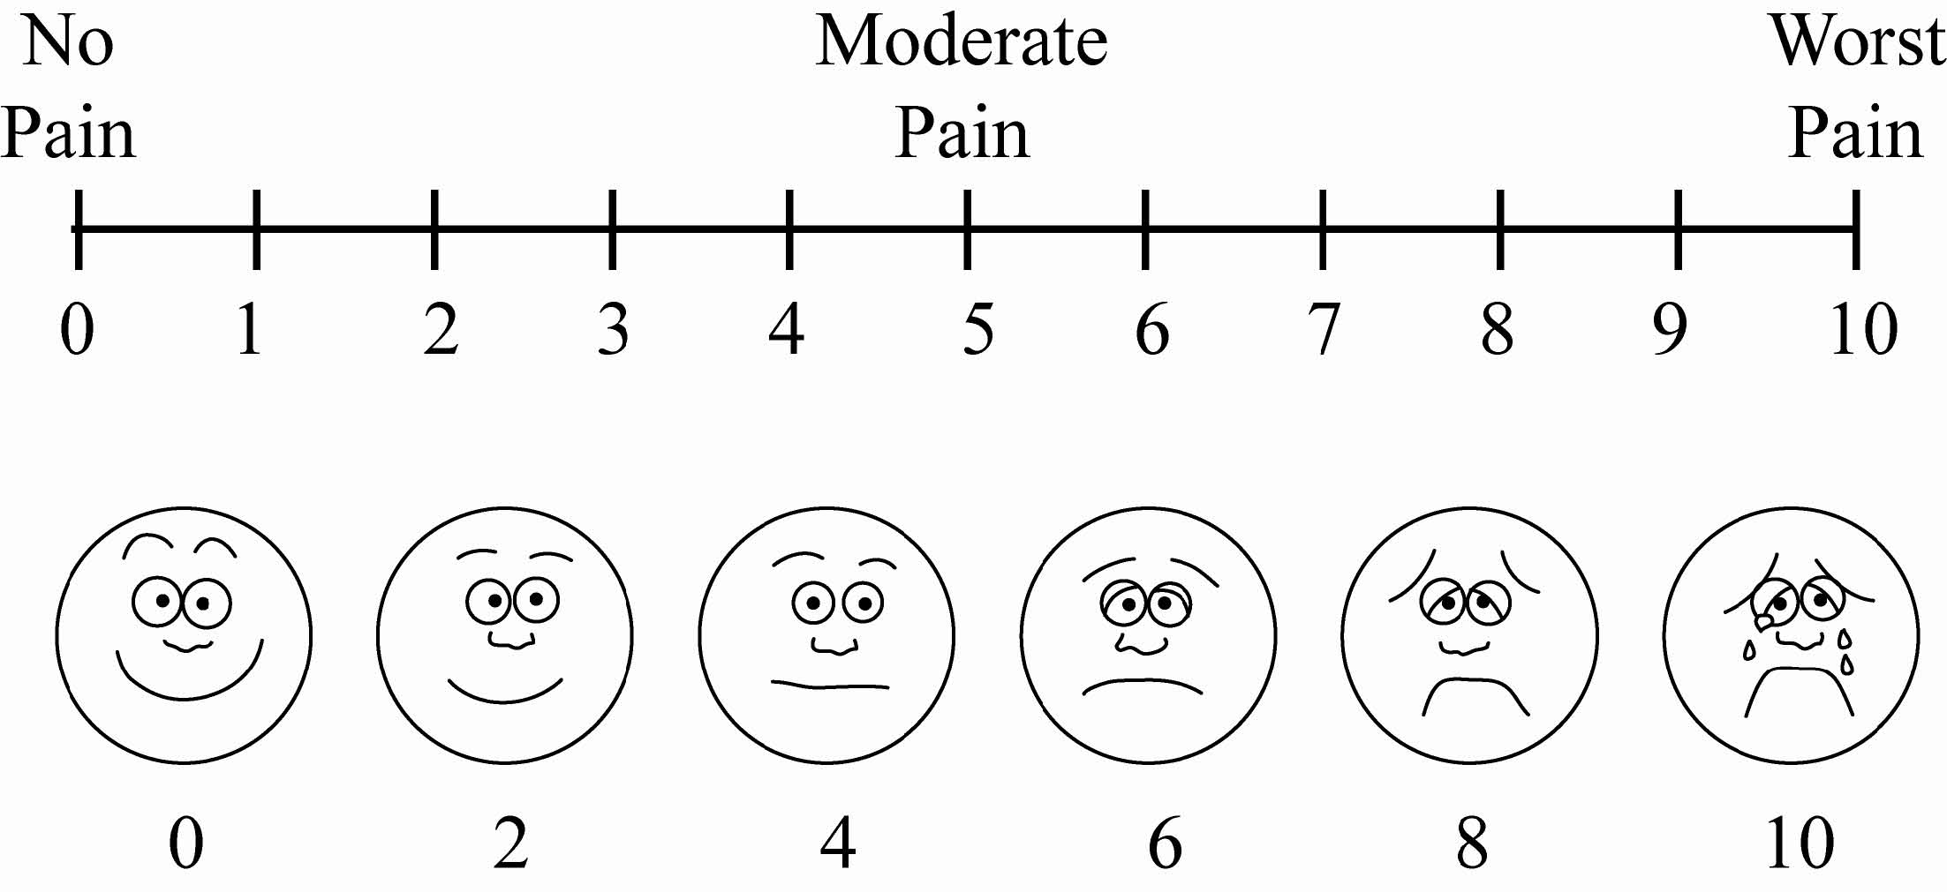

**General post-operative instructions**

**(Day Surgery patients)**

We want your recovery to be safe and as comfortable as possible. For this reason, we suggest that you comply with the following advice:

* You should have someone available to stay with you overnight upon returning home.
* Your surgeon will instruct you as to when you can drive a car or operative machinery but in the absence of such instructions, not for at least 24 hours after the procedure.
* You should limit activity requiring full concentration for 24 hours; e.g. making important personal or business decisions, as full mental alertness may not return for several hours.
* You should not drink any alcoholic beverages for at least 24 hours following your procedure as alcohol may influence the effects of the drugs you have been given.
* You should eat lightly for the first meal following your procedure.
* You should take it “easy” for a day or two.
* If you have any problems or are concerned about your condition for any reason, please contact your surgeon through his/her office or follow the directions on your surgeon’s message machine regarding reaching another surgeon.
* If you are unable to contact your surgeon or the surgeon covering his/her practice, come to the Emergency Department of the hospital where you will be seen by an emergency physician.

Deep Vein Thrombosis (DVT) is a blood clot in a deep vein and is a major health concern that should be discussed with your physician.

You may be at risk for developing a DVT for any of the following reasons:

* Recent surgery
* Immobility
* Previous DVT
* Problems with circulation
* Obesity
* Increasing age
* Acute medical illness

DVT’s most commonly occur in the legs, usually the calf. Signs and symptoms to watch for include: calf pain or swelling, redness or discolouration, a knot in the calf that you can feel and that is warm to touch, fever, shortness of breath, rapid heart rate or chest pain.

If you experience any of these symptoms go to the Emergency Department or call 911 for immediate assistance.

**Return appointment reminder**

DATE:

TIME:

LOCATION:  Doctor’s office

Other:

**Post-operative dressing**

* If you are a Day Surgery patient, you will probably need some sterile dressings and tape at home after your surgery.
* We advise you to purchase these supplies before your surgery.
* We suggest that you get a small package of sterile 4” X 4” gauze pads and a roll of tape at the drugstore before your surgery.
* If you are having a gynecological procedure, you should buy some sanitary pads for when you return home.
* Other:

If you have any questions about the dressing type to purchase, please check with your nurse in the Pre-Operative Assessment Clinic (POAC).

**(Day Surgery Patients)**

**Please give these instructions to your designated driver.**

Please remind your designated driver they are to be available for the entire day of your surgery and to ensure they keep their phone on and ready to receive the call from the Day Surgery Unit (DSU) informing them of the time to pick you up.

**Pick up information**

The care partner/family members are encouraged to remain at the hospital. If partner/family are not able to stay, please ensure that they are within 10 minutes of the hospital.

For those who cannot remain and are collecting a patient, please drive to the James Beach Health Care Centre entrance door. Inside the building there is a wall mounted telephone on the right hand side with the phone number to the Day Surgery Unit (DSU) posted.

Please pick up the phone and dial 2912 to let them know you have arrived. You may then return to your car.

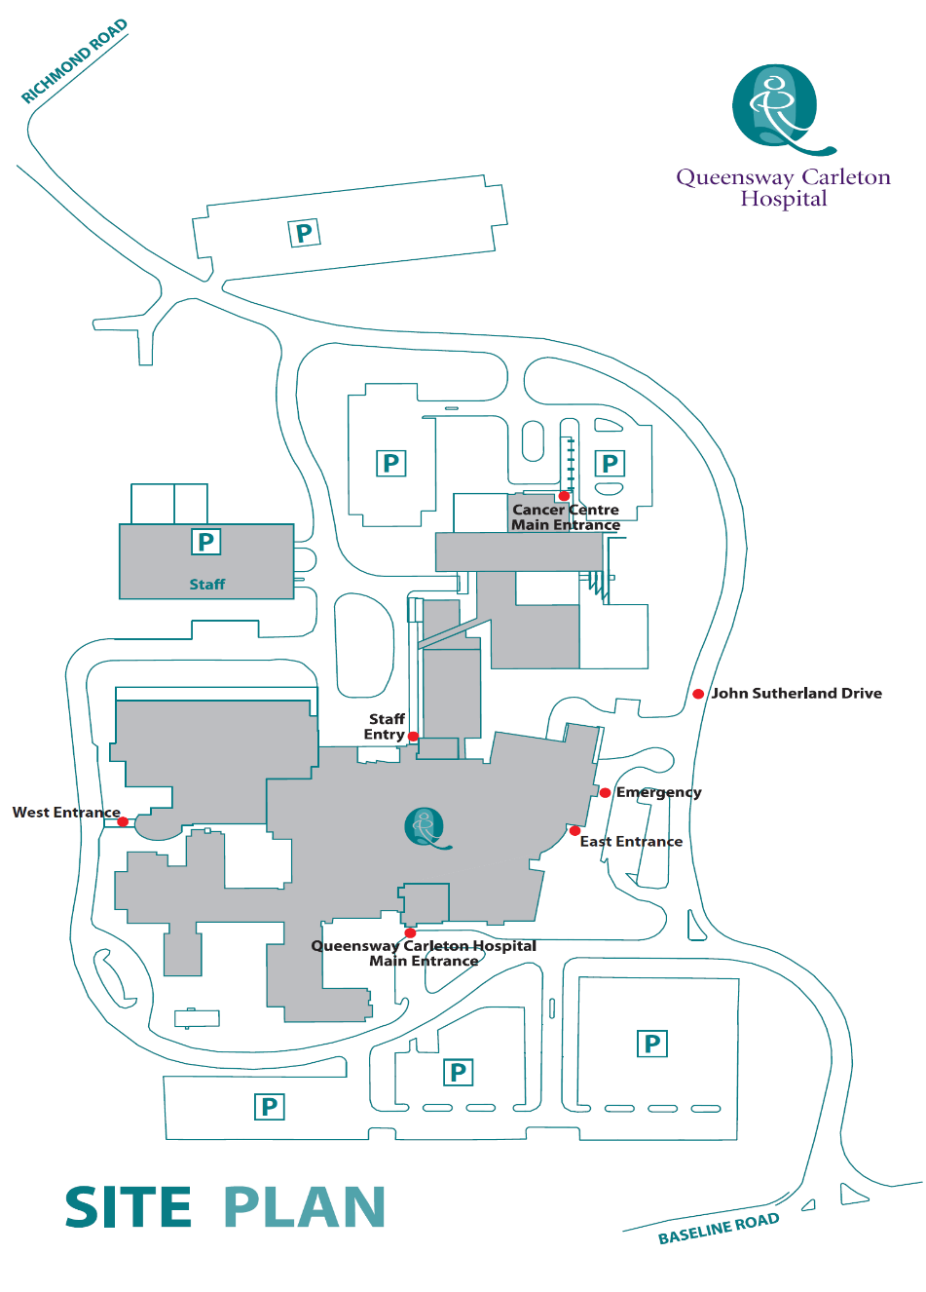

**James Beach Health Care West Entrance**

**(patient pickup)**

**Main Entrance**

**(patient drop off)**