PERI-OPERATIVE SERVICES
Post-Operative Instructions for Cane Walking

A cane is used to improve your balance and stability or to take some of your weight off of your affected leg.

Fit yourself for the cane while wearing your shoes.

- Stand up straight and relax your shoulders.
- Let your arm on your strong side hang down by your side.
- Have someone place the cane next to that arm and measure it so handgrip of the cane is at the level of your wrist when your arm is hanging by your side.

Technique For Walking With A Cane

- Hold the cane in the hand opposite to the affected extremity (the cane should be on the good side).
- Advance the cane at the same time the affected leg is moved forward.
- Keep the cane fairly close to the body.
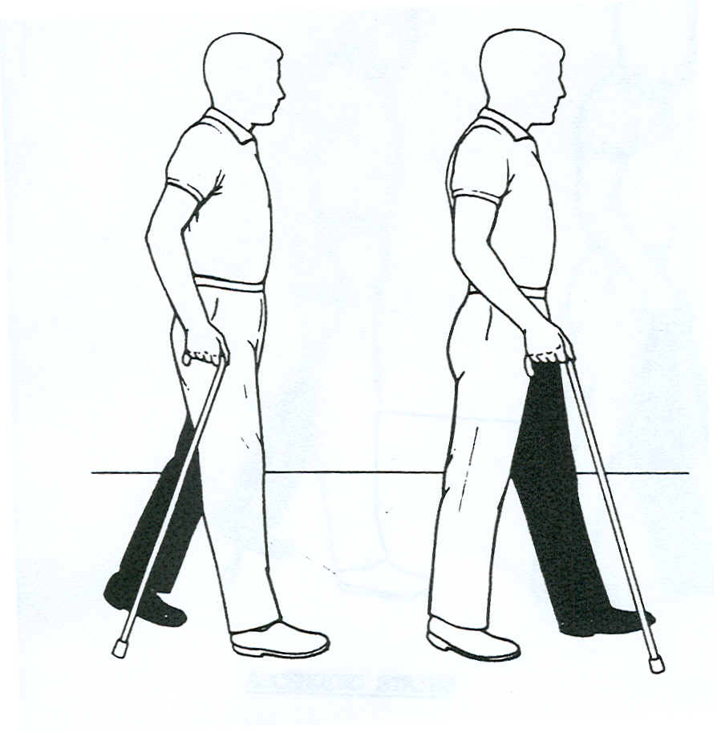

CONTINUED ON OTHER SIDE

Ascending stairs
Always hold the handrail if there is one available

- Face the stairs and place the cane close to the first step.
- Push on the cane, straighten the elbow and then place the strong leg on the first step.
- Straighten the strong knee and lift the cane and the weaker leg on the same step.

Descending stairs
Always hold the handrail if there is one available

- Stand with the toes of the stronger leg placed close to the edge of the step.
- Lower the cane and the weaker leg on the next step while bending the knee of the stronger leg as much as possible.
- Lean on the cane and lower the body by placing the stronger leg on the same step.
N.B. The strong leg goes up first and comes down last.

Patient safety is very important to Queensway Carleton Hospital and this information is provided to patients/families to help inform you of your essential role in your own safety.

The information contained in this booklet is not specific medical advice, nor a substitute for medical advice. For your safety, it is advised that you speak with your doctor and healthcare team about your particular healthcare needs.

Protect yourself! Clean your hands frequently and ask your healthcare providers and visitors to do the same. Clean hands save lives.

